Completing your Year 9 History endeavour badge: Read through the story of Woodland Through Time, completing all activities as you go. Email the final concluding activity to Mrs Lobo to claim your badge!

How have humans and woodlands shaped each other over time?

The Mesolithic woodland home of Star Carr in 9300 BC

Fire and water

It is 9300 BC. We stand on the marshy edge of a lake. We are surrounded by trees. The emerald leaves of tall aspen tremble in a slight breeze. The burnished branches of beech trees stretch over still water. Tall stems of reed hide fish from predators.
The strongest stems of reed at the lake’s edge will be chosen to thatch the roofs of houses nearby. Other plants will fill hungry bellies. The people living here, on the lakeside, know the sweet flavour of chickweed, the earthy taste of nettle, the nutty seeds of water lilies.
A large wooden platform runs along the edge of the lake. This platform, made of split timber trunks, allows easy access to the water. A woman stands here quietly. She holds the taught string of a bow.
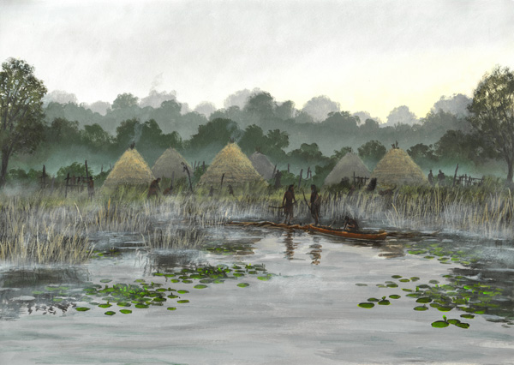
This bow is light, fast to use and easy to carry. Made of willow, the springy sapwood allows the bow to bend. It is ideal for shooting wooden arrows at small animals living on the forest floor, or at birds and fish. Perhaps the bowwoman will paddle onto the lake on a reed canoe to hunt perch in the deep water.
Mesolithic people like the bowwoman rely on trees, plants and water. Near the lake, outside small wooden houses, a community of people are making tools. They carve needles from bone, harpoons from deer antler. They shape pieces of flint into arrowheads, spear points, and axes.
With these tools, plants can be crushed and animals killed and butchered: hares, boar, deer and elk. Inside the houses, under waterproof roofs made of reed and bark, children eat fish and chatter by the fire.
Fire offers protection and warmth. Fire allows people to manage the land. Using torches made of birch bark, people use fire to clear reeds from the lakeside, keeping fishing pools clear. They use fire to clear plants and trees, creating open grasslands where deer and elk can graze, ready for the kill. They use fire to extract tar from birch bark: a perfect glue for joining tools and weapons.
At the edge of the woodland, we find people weaving the pliable shoots of willow trees, called withies, into baskets. Now, edible nuts and plants can be collected. Now, branches and twigs can be carried easily from woodland floor back to the fire, back to the heart of the settlement of Star Carr in Yorkshire.

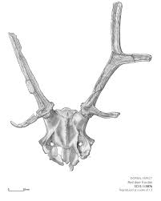
Wood and bone
The people of Star Carr do not stray far from water or woodland. Trees provide food and building materials. Leaves provide bedding and animal fodder. Wood is durable, strong, bendy, and easily worked by hand. Even tiny children can grab a carved digging stick in their pudgy hands and kneel down to grub out edible roots and tubers from the ground.
It is now twilight at Star Carr. As hunting dogs lie down to sleep, men and women gather around a fire. They wear deer antler headdresses [right]. Perhaps, today, they will celebrate the bowwoman’s kill. As the light fails, we return to the lake, where one of the headdresses is placed carefully in the water. It is an offering. May more good fortune come to the people of Star Carr.

Finding out about the woodland settlement of Star Carr in Yorkshire

Historians can make tentative claims about people’s lives in the Mesolithic era because of extensive archaeological excavations carried out at Star Carr in 2004-2015. Star Carr is famous worldwide for the rare and exciting discoveries that archaeologists have been made here.
Star Carr was probably inhabited for 800 years in the Mesolithic era. The platforms at the lake edge provide the earliest evidence of carpentry in Europe. A 11,000-year-old digging stick excavated at Star Carr is perhaps the oldest digging stick ever found. A bow discovered here is possibly the oldest complete bow in the world.
In this enquiry you will study how humans have used wood and managed woodlands across hundreds of years. You will also study how woodland environments have shaped human lives. At the end of your enquiry, you will learn how archaeologists carried out the excavation at Star Carr.

Britain’s new landscape emerging from ice and snow

In c.9300 AD, Britain was waking up. A Mesolithic community could live for many years on the shore of a glacial lake at Star Carr because temperatures in Britain were rising. The mile-deep ice sheets that once covered northern Europe had melted. A rich new landscape of open grassland had emerged as glaciers retreated. And then the trees came, spreading their seeds on the wind.
When the last ice age ended, Britain was connected to Europe by a land-bridge. Historians call this bridge Doggerland. This land-bridge now lies beneath the North Sea. But, in 9300 BC, hunters and foragers crossed the bridge to stalk deer and wild boar through Britain’s forests. The old prey, mammoths and reindeer, had left with the ice.
Historians place 9300 BC in the Mesolithic era, or ‘middle’ stone age. Great swathes of Britain were covered in woodland. Birch trees clad the steep banks of rushing streams. Squirrels built homes in the tall canopies of pine trees. Foxes found shelter among willow trees that pointed their branches towards warming skies.
As we saw at Star Carr, migrant peoples found shelter and resources in Britain’s vast freshwater lakes and wooded hills. Migrants travelled great distances to hunt game and to fish in Britain’s rivers and lakes.

Step 1: Copy out this table. Record how people living in Star Carr managed woodland and what people used wood for by completing both columns.
Time and place | How woodland was changed and managed | What people used wood for
Star Carr in c.9300 BC

9300 BC 6000 BC 4000 BC 55 AD 400 AD 700 AD 1700
Star Carr settlement Britain cut off Farming begins Romans arrive Romans leave Viking invasions begin Industrial Revolution

Trees shape the Viking world of Medieval Jorvik in c.900 AD

It is 900 AD. We are in Yorkshire again. This time, we stand by a river. We notice ripples first, then more disturbance in the dark water. Above the treeline, a thin dark shape appears. It looks like a dead tree. As it moves closer, we hear the pulse and splash of oars. Currents swirl. Finally, the sleek line of a ship appears, long and low in the water. At the head of the longship is a carved prow. The prow is shaped like a dragon.

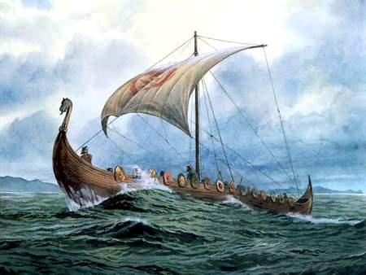
Sailing the North Sea
The ship has made a long journey, across the North Sea, to the Norse kingdom of York in Britain. Without a map, how did the Vikings know where they are going? How can the Vikings trust their lives to a wooden boat in the grey vastness of the open sea?
Viking sailors look for clues in stones and in their surroundings. In the day, a sunstone helps Vikings locate the sun’s position. On clear nights, the Pole Star lights the way. The oldest sailors study the flight of birds, shifts in the sea’s currents, the curve of waves. These clues help the Vikings plot a steady course from Scandinavia to Britain. Nearing land, familiar forests and sandbanks guide the Vikings to the river Humber and on to Jorvik.
The shallow hull of a wooden longship allows Vikings to travel not just seas but estuaries and rivers. The longship allows Vikings to penetrate deep inland, to explore new opportunities for raiding or trading. Vikings trust their lives to their deep knowledge of wood’s strengths and weaknesses. Overlapping oak planks form the longship’s hull. Tall masts of pinewood support a square sail. Wooden oars are mounted on a rigid gunwhale. Each oar-stroke along the River Humber brings traders and warriors closer to Jorvik.

Trading and feasting

In 900 AD, Vikings from Scandinavia control huge areas of England. Now it is merchants, not raiders, who have the run of Jorvik. Many ships arrive into the Viking city of Jorvik in 900 AD carrying goods: ivory, fur, slaves, wine.
Jorvik is a bustling city of wooden houses and workshops for carpenters and boatwrights. Turners craft wooden chairs, combs and chopping boards on lathes, barking orders at apprentices to load waste chips and sawdust onto warming fires. Market stalls, crafted from timber, are run by traders selling wooden cups and bowls. Wood lies at the centre of the Viking world.
When Viking building projects exhaust the supplies of local forests, timber is hauled across the continent on wagons and shipped across the North Sea. The Vikings need oak to build ships, houses, furniture and weapons. The Vikings will strip the entire island of Iceland of its forests. Iceland will depend on driftwood and timber exports. Control of wood and woodland brings status and power in the Viking world.
In a Viking hall in Jorvik, warriors wrapped in red cloth sit on wooden benches around a long fireplace. This hall, dim and smoky, is supported by great oak pillars, richly carved. The men listen to tales of war as they sip wine from wooden cups, their gold buttons catching the firelight. Cuts of smoked meat, once hung on hall rafters, now sizzle on wooden platters.
In the hall entrance lie wooden horns and shields of elm-wood, iron-tipped wooden spears and ornate swords. Laid carefully at the front, with a gold ring locked in its hilt, is a ring sword. This sword is a symbol of loyalty, a mark of a war commander. The sword lies ready for the next fight.

Finding out about the Viking world in c. 900 AD
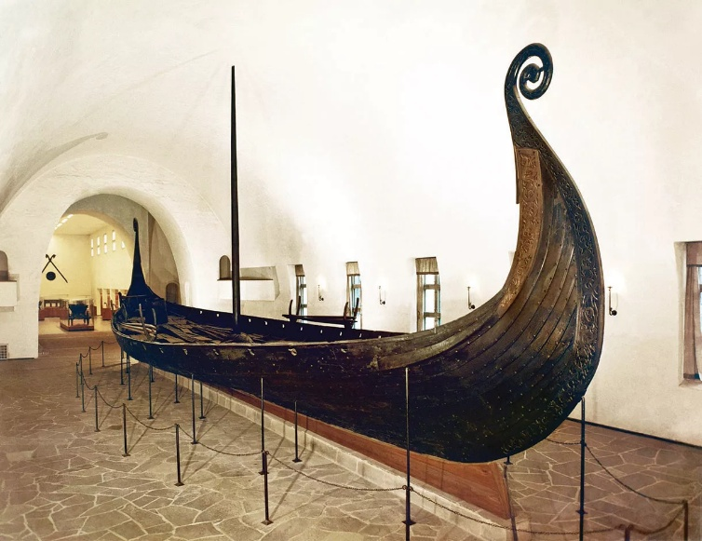
Historians can make claims about life in Viking Britain after excavations were carried out in Jorvik (now York) in the 1970s. Over 40,000 artefacts were recovered, from deep layers of soil, providing evidence of Viking woodworking and other craftsmanship.
A famous ship burial, discovered at Oseberg in Denmark, allows archaeologists to study Viking boat-building. Using carbon dating and tree-ring analysis, archaeologists estimate that the Oseberg ship [right] was buried in c.834. The Oseberg ship was 21.5 metres long, richly decorated, made of oak with a pine mast.

A new British landscape for Vikings to farm and manage

How had Britain’s landscape changed in the ten thousand years between 9300 BC, when Mesolithic people lived on the edge of vast lakes, and 900 AD, when Vikings lived in Britain?
As we saw at Star Carr, stone-age humans were forest-dwellers who relied on woods for year-round resources. Humans were nearly always on the move at this time, because local foraging opportunities were soon exhausted.
By the end of the Mesolithic era, Doggerland had flooded. Further global warming had led to rising sea levels. Look at the timeline. By 6000 BC, Britain was cut off from the continent. Insects had allowed new tree species to spread across Britain’s isles: elm, holly, ash, hornbeam, maple. By 4000 BC, people had begun farming the land, clearing woodland to plant crops and rear sheep.
When the Romans sailed across the channel in 55 BC, Britain’s woodlands had been managed for centuries. When the Romans left in the 400s, the invading Angles, Saxons and Jutes relied on Britain’s fields and woods to survive in their new home. Finally, in the 700s, the Vikings came.

Step 2: Add a new row to your table to record how Vikings managed woodland and what they used wood for. Underline any notes that show that wood was managed and used in the same way in both Mesolithic and Viking Britain.

Living a wood-framed life in Tudor Yorkshire in c.1540

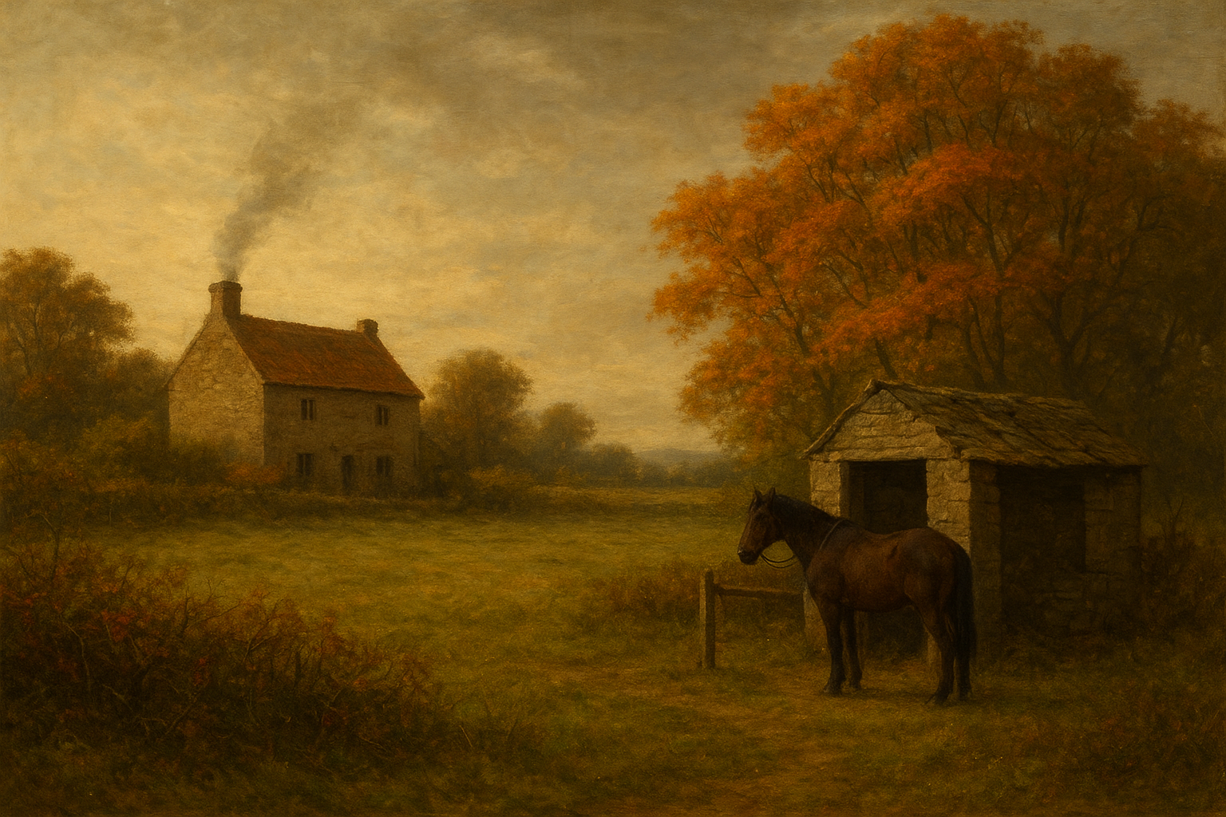
It is 1540. We have returned to Yorkshire. This time, we stand in a small field, bounded by brambly hedgerows and a small tree grove. The tree leaves show hints of orange. We see a farmhouse in the distance, its chimney smoking, and a horse tied to a roofless shed.

Ploughing and building in the autumn
In September, we find farmers’ sons sweating over a wooden plough. The family must break up the soil to sow wheat before the first frosts arrive. After throwing handfuls of seed into grooves made by the plough, the eldest son ties a branch to his horse. The scratchy, thorny hawthorn will harrow the soil: rake it quickly to stop birds scoffing the seeds.
The farmer tends to his animals. Tar, made from pinewood, must be brushed onto sheep’s hoofs to heal sores. The pig must be driven into the wood to gorge on hazelnuts and acorns. Branches of bendy green hazel must be collected to weave a new roof for the cow shed before the snow comes.
In the farmhouse, mother tends a bread oven stacked with seasoned branches of oak. Wearing a corset stiffened with thin rods of ash, she pours strong beer into wooden cups for her family to drink around the fire. As the light fails, she calls in her daughter, who has been climbing trees all day to collect apples and pears in baskets woven from willow.

Hedge-laying and coppicing in winter
Now the cattle are safe in their shed, the family can repair the hedges that stop them roaming beyond the farm. Trees are notched and laid horizontally, so spring buds will emerge vertically. With the trees bare, coppicing can begin: trunks are sliced off to encourage new shoots to emerge from the tree’s base. Other trees are pollarded: their upper branches cut back to encourage new bushy growth. Coppicing and pollarding provide the family with a sustainable crop of timber for building and firewood.

Spring cleaning and sowing
It’s time to clean the farmhouse. Wooden chairs are taken outside to dust in the sunshine. The farmer drags a holly bush through the chimney with rope. Now the spring calves are here, the cows’ milk is thick and creamy: perfect for the girls to make butter and cream in the dairy. Outside, the farmer sows crops in his fields: peas, barley and oats.

Summer shearing and harvesting
The year ends in a blaze of sunshine. Sheep are washed in the stream and sheared with scissors. The wool is packed onto a wooden wagon to be sold. After the peas and wheat are harvested, the family celebrates around a large bonfire. Another year is over. Plans must be made for the next one. With wool prices so high, more trees will be felled next year to graze more sheep.

Vanishing forests in Britain’s landscape
What had changed between the Viking and Tudor eras? Viking control of northern England had grown weaker in the late 900s. Viking influence then faded in 1066 with the defeat of Viking king Harald Hardrada. Never again would the Vikings control large swathes of England.
For many ordinary farmers in Yorkshire, the demise of the Vikings, the rise of the Normans, and the change from one medieval monarch to another did little to change their daily lives. What was changing was Britain’s forests. Our Yorkshire family were lucky to have easy access to woodland.
In the Tudor period, demand for timber supplies to build ships and homes grew fast. In 1500-1600, timber prices in England trebled. Many wealthy landowners fenced off their woodland.
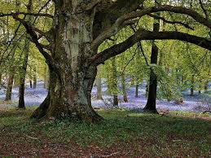
Deep in Britain’s woods a battle was being fought. The rights to cut underwood for fencing, firewood, craft and building were jealously defended in the 1500s. Potters, glassmakers, bakers, brewers, ironworkers, farmers and town dwellers: all needed wood for industry and for living. Cries for more trees to be planted grew louder.
Government leaders worried about dwindling timber supplies. They placed restrictions on felling trees. In 1543, Henry VIII enacted a new law to preserve British woodland. One historian estimates that 7% of England and 4% of Scotland was covered in woodland by 1600, although smaller pockets of trees dotted the landscape.

Step 3: Add another row to your table for our Tudor family. Underline notes that show continuity in the use of wood and management of woodland across time.

Wood and empire, c.1600-1900

The Virginia Company, 1609
It is 1609. We stand in a wood-panelled office in a timber-framed building in London. Clerks sit at desks, scratching letters to sea captains and investors. Quills, inkpots, wax seals, and ribbons lie strewn across wooden tables. Underneath, oak chests reveal ledgers, letters and charters. In the corner, a treasurer sits with a counting cloth, scales and receipt book in front of him. The treasurer ignores all of them. He picks up his quill and begins to write.
Welcome to the offices of the Virginia Company. Three years ago, in 1606, King James I had given a royal charter to the Virginia Company to establish a colony in North America. Since then, the company has grown.
A black-cloaked merchant walks through the company office door. His face is grim. A new letter from the company’s colony in Virginia confirms the earlier reports. Famine and disease has struck the new colony. A new captain must be found quickly and shipped over to support the struggling English colony. Hearing the merchant’s news, the treasurer in the corner writes faster.
In 1609, Robert Johnson was deputy treasurer of the Virginia Company. Johnson desperately wanted the struggling colony of Virginia to survive. Johnson thought that Virginia could provide a solution to one of Britain’s problems: wood scarcity.
“Tall oaks and elms grow in Virginia”, wrote Johnson, “along with beech, birch, spruce, walnut, cedar, and fir trees in great abundance.”

Britain’s desire for natural resources helps build an empire
As Britain’s empire grew in c.1600-1900, expanding colonies far beyond North America, to West Africa, India, Australia and beyond, England’s appetite for wood grew too.
Wood continued to dominate Britain’s economy into the early 1700s. The waterwheels and weaving frames of Yorkshire’s early textile mills were crafted from heavy timber. Wooden barges, pulled by horses along Yorkshire’s canals, transported goods like coal and cloth. Wood charcoal still fuelled iron production.
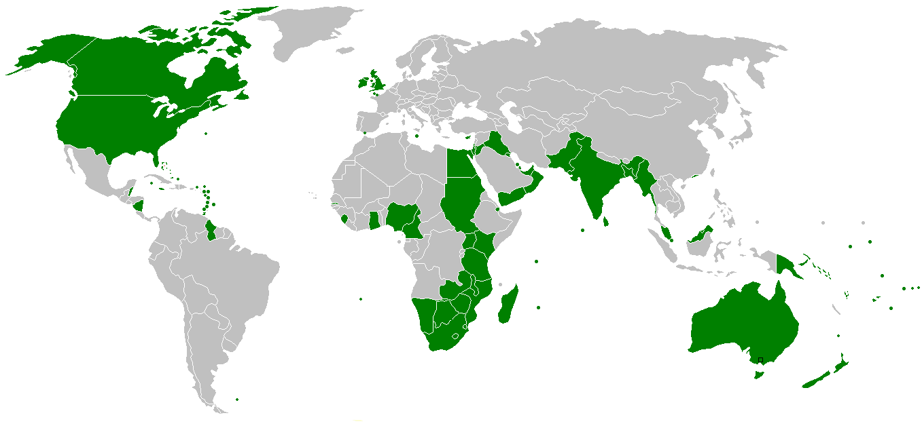
By 1800, however, steam powered the more advanced textile machines, now made from cast iron. Coal replaced wood in many factories and homes. Coal powered new steam trains, now made of iron and steel. Coke, made by heating coal, now fuelled iron production. Coal was cheaper than wood. Coal was the new king.
But the need for timber continued. And now, Britain had a much larger empire to supply it.
British colonies are shown in green on this map.

Wood for war
In 1800, there was not enough wood within Britain to wage war with Napoleon at sea. Old warships were sent to Canada and the Baltic to bring back oak and pine to make new ships. Thousands of jobs were created in Canada in logging, sawmills and shipyards.

Conserving wood
Rot-resistant teak was imported from India by British shipwrights. British furniture-makers, however, preferred the beautiful grains of Indian rosewood and golden tones of satinwood. Demand for wood resulted in massive deforestation of teak forests in Central and South India. The forests were converted into managed reserves, displacing Indian communities, whose access to forests was now restricted. Efforts began to be made to conserve India’s woodland.

Wood for industry
Durable, fire-resistant eucalyptus was imported from Australia to build railway sleepers, docks and bridges across the British empire. Demand for Australian timber displaced aboriginal communities. The piles of branches, bark, and sawdust left by loggers increased the risk of bushfires.

Wood for luxury and status
Rich, red-brown mahogany, glossy and easy to carve, was imported from Caribbean islands like Jamaica to make fashionable cabinets to fill grand Yorkshire houses. Clearing Jamaica’s forests altered ecosystems: soils grew dry and thin. When enslaved Africans were emancipated in 1838, they struggled even to buy the poor-quality land that remained.

Changing human landscapes
African mahogany and hard, dense ebony was imported from West Africa to create furniture and piano keys. Mahogany and ebony logging in West Africa led to deforestation, while roads and ports were built to serve timber export, not local needs.

Step 4: Add a final row to your table for the British Empire in c.1700-1900. Don’t forget to underline notes that show continuity in the use of wood and management of woodland.

Archaeologists helping to protect today’s forests
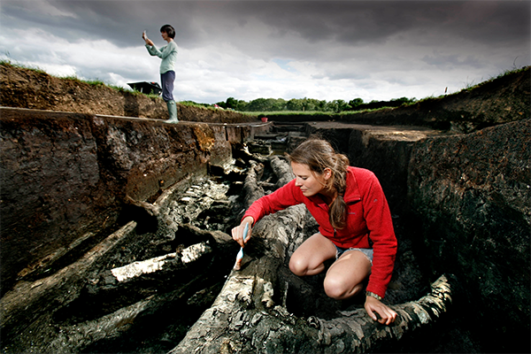
It is 2015. We stand on the marshy edge of a lake. A woman stands here quietly, holding a bow. Behind her, people are busy with tools and brushes. Wearing waterproofs and grubby boots, a group of people scrape gently at the boggy soil. The scratch-scratch of trowels murmurs across muddy trenches as the earth is slowly loosened. A dull clink breaks the rhythm, followed by a cry of joy. Another exciting discovery has been made.
In her hands, Professor Nicky Milner holds an ancient bow. Milner, Head of Archaeology at the University of York, leads the archaeological excavation here at Star Carr. ‘We think this is the oldest known complete bow in the world’, she says. ‘The extraordinary survival of wood and plants at Star Carr gives us a very rare and important glimpse into a past world.’
Milner’s team of archaeologists are using trowels to excavate Mesolithic artefacts from peat soil at Star Carr. They balance on planks to protect the delicate artefacts. Milner’s colleagues dig drainage channels and install pumps to extract the water that has preserved the artefacts. The archaeologists call excitedly to one other with every discovery. Sometimes a flint axe, or a bone needle, or a digging stick. Each artefact is carefully cleaned, given a number, placed in a bag, and plotted on a map.

Working together to preserve the world’s forests
Many archaeologists work as conservationists. The archaeologists know that understanding the past can shape how we live in the present. Historians are always telling new stories about the past to respond to issues in the present. As the planet grows warmer, historians ask new questions about human relationships with past environments. The excavations at Star Carr are stimulating new questions about how forests have been used, damaged, conserved and restored over time.
Britain is now the fifth largest importer of timber in the world. The need for wood—like that of the Mesolithic bowmakers and Viking shipwrights—has never gone away. The story of Star Carr does not end with ancient digging sticks. It ends with questions for today: How should we manage our woodlands? What can we learn from those who lived with trees before us? How might planting a tree still change the world?

Shaping your answer
You will now use your table to shape your answer to the enquiry question: How have humans and woodlands shaped each other over time? You will do this by drawing a diagram showing change and continuity.
Draw a tree trunk in the middle of an A3 page to represent a timeline. At the bottom, in the soil, describe the Mesolithic woodland world of Star Carr. Add branches further up the tree to show changes in how humans used wood and managed woodland. In the middle of the trunk, show elements of continuity in humans’ relationship with woodland across time. At the topmost branch, be sure to mention the work of archaeologists and conservationists.
Email your timeline to Mrs Lobo to claim your badge.

