Completing your Year 8 History endeavour badge: Read through both stories, completing all activities as you go. Email the final concluding activity to Mrs Lobo to claim your badge!

Story 1: Sofonisba Anguissola studies the beauty of the Earth

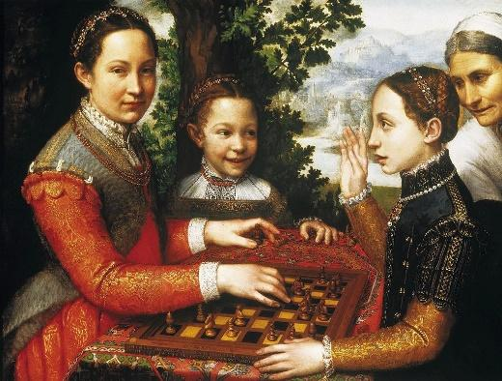
What shaped the art of a Renaissance painter?
Sofonisba puts down her paintbrush. She is pleased. She has shown her three sisters, all delighting in their game of chess, and in one another. The family servant looks on.
Yet something isn’t right. What will bring out the play of light on her sister’s face? Sofonisba thinks about paintings she has seen. She needs darker tones. She will add another tree behind her sister’s head.
It is just what is needed to complete her painting.

Sofonisba Anguissola was an Italian noblewoman. She was born during the Renaissance. The Renaissance is a label that historians give to developments in art and ideas in the fifteenth and sixteenth centuries. Artists and scholars looked afresh at the achievements of the ancient world, and tried to go beyond them.
Like other Renaissance artists, Sofonisba was adventurous. She was drawing on others’ work, but in order to do something new. By studying a great artist such as Sofonisba, we can learn about how ideas moved and connected during the Renaissance.

Your enquiry
Sofonisba did not paint alone. What she painted and how she painted were affected by changes in art before her, by mathematics and astronomy, and by her own experience as a woman at this time. At the end of this enquiry, you will build a visual collage to show the worlds that shaped Sofonisba’s art.

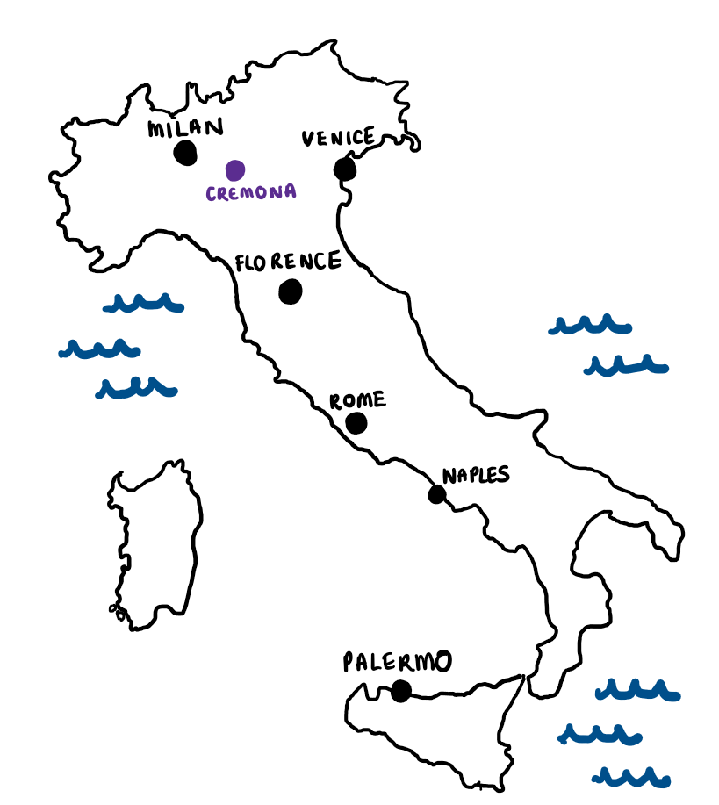
Cremona: a small town full of big ideas
Sofonisba was born in Cremona, in 1532. Find Cremona on the map.
Sofonisba was educated in the Renaissance tradition, studying music, science, Latin and Greek. At the age of 14, Sofonisba’s father asked the artist Barnadino Campi to teach Sofonisba to paint. For three years, Sofonisba experimented with pencils and paints, learning from Master Campi (shown below, painting a portrait of Sofonisba).
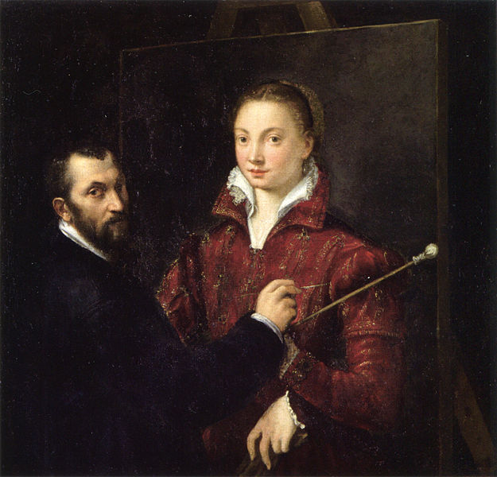
No longer were artists painting flat pictures. Artists in the fifteenth century had begun to portray people and plants as real, rounded and lifelike. Sofonisba sketched her siblings, dogs and trees.
From the 1400s, in the city of Florence, Renaissance artists had set out to break with the past. (Find Florence on the map.) Florentine artists delighted in new techniques. They studied anatomy. They recreated muscles and veins in sculpture and on paper.
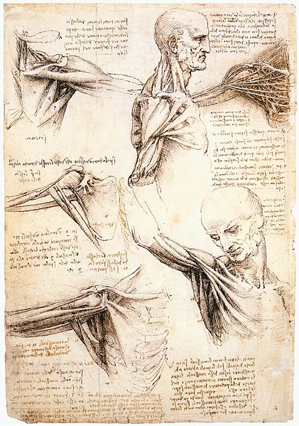
Influenced by these artists, Master Campi would have sketched naked men from different angles, or even dissected corpses.
Master Campi would have encouraged Sofonisba to study the human body. But females were not allowed to study nudes or dissect corpses. So Sofonisba drew her family. Look again at her painting, The Chess Game. Sofonisba made her sisters look lifelike.
But Sofonisba was also experimenting with something new. Artists usually painted formal portraits, or painted scenes from the Bible. But here Sofonisba painted an everyday situation.

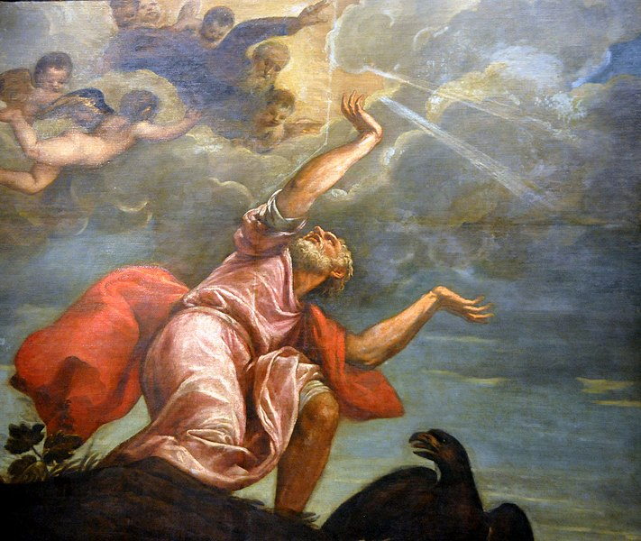
Venice: experiments with colour
In the fifteenth century, Venetian painters such as Titian experimented with colour. Whether in portraits or landscapes, scenes from the Bible or legends, Titian built up layers of colour to create realistic paintings. He captured light and shadow, such as a darkening sky, like in his painting here.
Master Campi encouraged Sofonisba to study Titian’s art, and to experiment with colour herself. Using her new knowledge, Sofonisba made people come alive on paper. She began making money by selling her paintings. Sofonisba became known as Cremona's bright star.

Step 1
What people, places and traditions influenced Sofonisba’s art? Copy and complete the table.
People | Places | Traditions
Master Campi…  Titian… | In Florence…  In Venice…. | The study of anatomy…

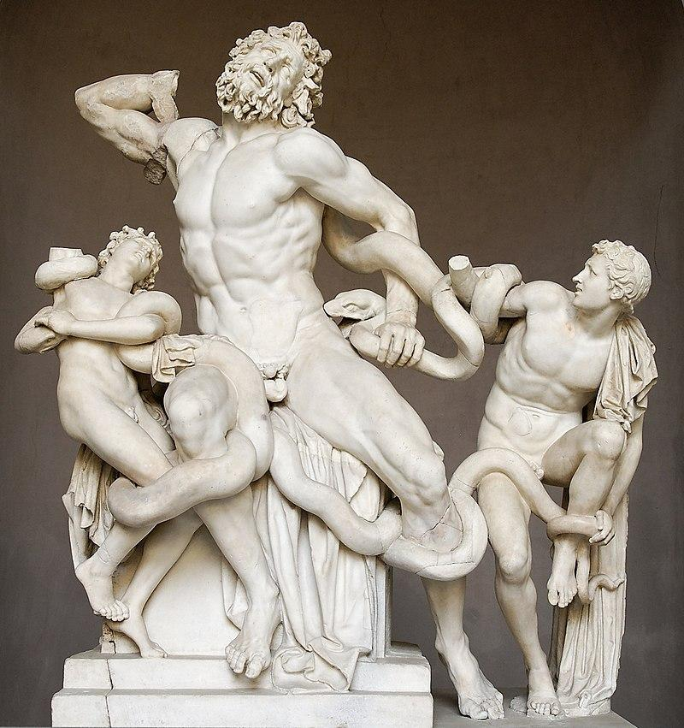
Rome: an ancient city of new ideas
In 1554, aged 22, Sofonisba travelled to Rome. What might have inspired Sofonisba as she wandered around with her sketchbook? Rome was a city old and new. Architects and artists came here to draw ancient buildings such as the Colosseum, and ancient sculptures such as The Laocoön.
The Laocoön was a marble sculpture created between 42 and 20 BCE. It tells the story of Laocoön, a priest for the Greek god Poseidon.

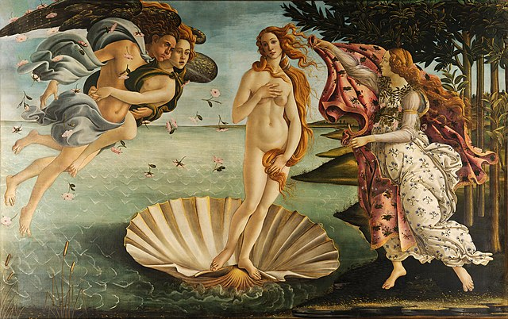
By studying works like The Laocoön, Renaissance artists learnt how to sculpt in the magnificent style of ancient Rome. Renewed interest in ancient Rome changed what artists were painting. Artists like Botticelli became interested in classical themes. Here is the image of the Roman goddess Venus from Botticelli’s famous painting of her:
In this golden age of Italian art, noblemen, merchants and even the Pope became patrons of the arts. They paid artists like Botticelli to beautify their buildings.
One building in Rome was particularly exciting: the Sistine Chapel – a chapel used by the Pope himself. Sofonisba would have admired Botticelli’s frescos. Frescos are murals painted onto freshly-laid plaster. The Pope had invited Botticelli and other artists to paint biblical scenes on the chapel walls.
But it wasn’t the walls that would have made Sofonisba gasp. It was the ceiling. In 1512, about forty years before Sofonisba’s visit in 1554, the artist Michelangelo painted the finishing touches to the chapel ceiling. It had taken him four lonely years to complete his masterpiece.
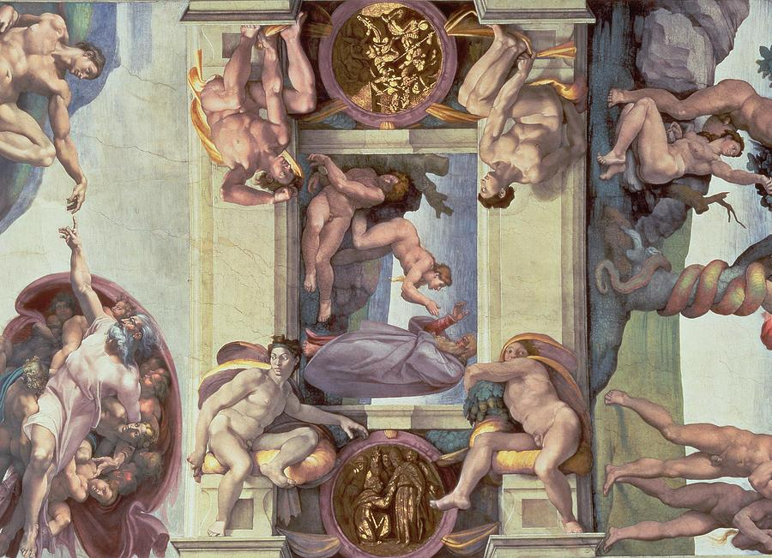
A small part of Michelangelo’s fresco, on the ceiling of the Sistine Chapel, painted for Pope Julius II in 1508-1512
Michelangelo used the laws of perspective to make these figures seem real. Some figures are painted smaller, or are shrouded in shadow, so that they appear further away. Muscles twist and turn in every direction.
In Rome Sofonisba met the 79-year-old Michelangelo. He gave Sofonisba sketches from his notebooks.
In 1554, Michelangelo challenged Sofonisba to draw a difficult subject: a crying boy.
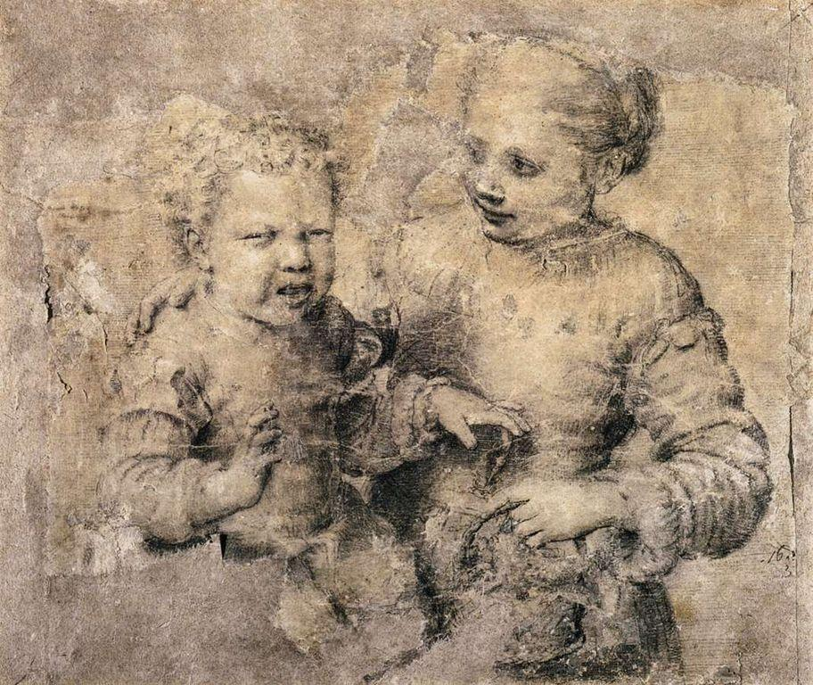
This is how Sofonisba responded to Michelangelo’s challenge. Can you feel the distance between the boy and the girl, the roundness of their bodies and the contrast in their expressions? Under Michelangelo’s guidance, Sofonisba began using new techniques to create a sense of depth.
Asdrubale Bitten by a Crayfish, by Sofonisba Anguissola, 1554

Milan and Madrid: cities connecting new worlds
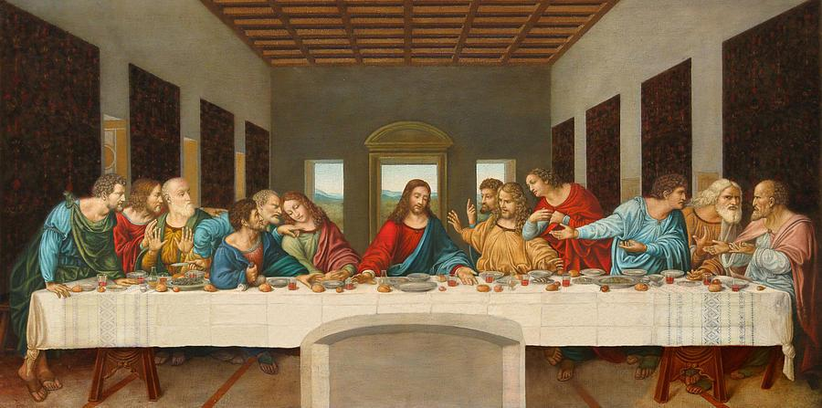
Milan
In 1558, now established as a painter, Sofonisba travelled to Milan. Like Florence, Venice and Rome, Milan was strewn with scaffolding. New marble statues dazzled everywhere. While there, Sofonisba probably saw this painting, The Last Supper, painted by Leonardo da Vinci, at the request of the Duke of Milan, in the 1490s. Notice how all the lines meet in one place, known as the vanishing point. Which figure is Jesus? How does da Vinci’s use of perspective emphasise Jesus’s importance?
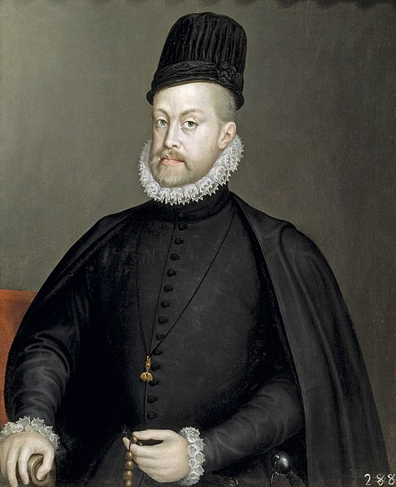
In Milan, Sofonisba was invited to paint a portrait of the Duke of Alba, advisor to King Philip II of Spain. The duke was so impressed that Sofonisba was invited to join the Spanish court in Madrid. Here is a portrait that Sofonisba made of King Philip II after she arrived in Spain in 1559.

Madrid
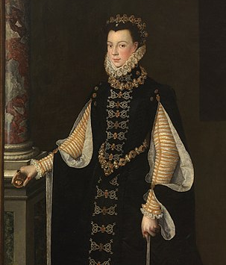
Sofonisba began teaching Philip II’s wife to paint. The queen (shown below right) and Sofonisba became good friends. At the Spanish court, Sofonisba would have heard stories of peoples and lands lying across the ocean. She would have seen the gold and silver flooding into Spain on treasure ships that sailed from the Inka empire. Sofonisba showed Spain’s riches in her portraits of the royal family: a Spanish princess is covered head-to-toe with silver, jewels and pearls.
In 1571, Sofonisba married a Sicilian nobleman, but he died just a few years later. Sofonisba then fell in love with a sea captain and married him in 1584.
People | Places | Traditions
Leonardo da Vinci…. | In Milan…  In Madrid… | Experiments with colour…  The new laws of perspective…
Sofonisba died in 1625, aged 93. She had seen great change, and she had pioneered new ways of studying and presenting the world.

Step 2
Continue your table with more people, places and traditions. We have started you off.

Story 2: Copernicus studies the beauty of the heavens

It is 1484. We are in Royal Prussia, part of the Kingdom of Poland. In a tall brick house on a narrow street in the town of Torun, a merchant has just died. He leaves four orphans. Ten-year-old Niklas Koppernigk, his brothers and his sisters await their fate. The children’s uncle, a powerful churchman, will decide it.
Niklas expects to become a merchant, like his father. The wharves and warehouses by the wide River Vistula are Niklas’s world. Niklas knows the barrels of Baltic Sea herring, the spices from the east, the corn from Poland’s fields and the sheets of burnished copper. It was the copper trade that once gave Niklas’s family its name: Koppernigk.
Now the powerful uncle shatters the orphans’ worlds. He finds a husband for one sister, a convent for the other. The boys will go to a Cathedral school, far away.
Three years’ later, in 1487, Niklas lives in a new world. Boots clatter on floorboards, masters bellow across noisy rooms, classmates recite Latin verbs. Up at 5 for prayers, lessons begin at 7. Niklas learns arithmetic, and Euclid’s geometry. He studies astronomy. From his teachers, he hears how thirteen centuries ago, Ptolemy described the dance of Sun, Moon, planets and stars around an immoveable Earth.
On bright days, Niklas watches shadows shift across a sundial. By night, he tracks planets in their strange paths.
Niklas’s future is set. Niklas must obey his uncle, who pays for his education. Niklas must prepare to serve the Church. In 1491, Niklas begins university in Krakow. He studies humanities, theology, logic, poetry, rhetoric, philosophy and mathematical astronomy. Niklas buys star tables for calculating the position of the stars. He binds them with 16 blank pages for his calculations and notes. “What could be more beautiful than the heavens?”, he writes.

A scholar now, Niklas uses a Latin name: Nicolas Copernicus.
In 1496, 22-year-old Nicolas heads for Italy. At the University of Bologna, he will learn church law, known as canon law. This will prepare him to be a canon. A canon is a senior church official. It is his uncle’s wish that Nicolas becomes one of the 16 cathedral canons who govern the diocese of Varmia. His uncle, now Bishop of Varmia, is well-connected. He will fix it for his nephew.
In Bologna, Nicolas lodges with Novara, a famous astronomy professor. Other astronomers whisper. Novara has shocking views. Novara thinks Ptolemy might have been wrong.
By night, Nicolas and Novara observe planets and stars. Together, they watch the Moon conceal a bright star.
In 1501, Nicolas is allowed to stay in Italy, provided he trains as a doctor. Once trained, he must return to Varmia as doctor to his uncle and the canons. At the University of Padua, Nicolas learns to let blood with leeches. He watches the dissection of corpses, his perfume-soaked handkerchief masking the stench.
He falls in love with Padua’s streets and piazzas, her bridges and barges, the brightness of a burning midday, the moon-soaked nights, the banter with friends about stars. He learns Greek so he can read Ptolemy’s Almagest. An artist teaches him to paint.
This sixteenth-century portrait, by an unknown artist, is based on Copernicus’s self-portrait.
In the sky, the planets seem to advance and then retreat. Ptolemy said they moved in little ‘epicycles’. But in Nicolas’s mind, a better explanation is starting to form. Here, in Padua, a daring idea gains shape. What if the Earth and all the planets travel round the sun? What if the Earth also turns on its own axis? Yes! It now seems so obvious! Why hasn’t he thought of it before?

This is how Ptolemy explained planetary movement in his book known as the Almagest.
Nicolas also grasps something else. The stars are much, much further away than anyone realises. The distance between Earth and Sun is tiny by comparison.
But proving his theory will take Nicolas years. Years of mathematical calculations lie ahead.

Step 3
Make some notes about the people, places and traditions that shaped Nicolas Copernicus’s scientific ideas

By night, Nicolas records positions of Jupiter, Saturn and Mars. In 1509, he watches Earth’s shadow creep across the Moon.
In 1510, his uncle dying, Nicolas moves to Frauenburg Cathedral. The spires and turrets of Frauenburg Cathedral overlook the Vistula bay. Buildings huddle round the cathedral. Here, Nicolas gains a little house. He also gains a friend. A canon called Giese shares his love of astronomy. Giese urges Nicolas to publish his ideas. Nicolas agrees. He
In 1513, Nicolas builds a platform by his house. He calls it his pavimentum. At night, he stands on it for hours. He maps the stars. He traces the planets’ paths. The mists above the Vistula frustrate him. How lucky were the ancient Greeks, he writes in his notes, with their clear skies!
Copernicus had no telescope. He just measured.
- His triquetrum measured a star’s height.
- His quadrant measured the Sun’s height throughout the year.
- His armillary sphere modelled the solar system.
In 1515, a Latin translation of Ptolemy’s Almagest appears. Until now, Nicolas has read only a shortened version. Now he has the whole book! Nicolas plans to write a similar book, but showing Ptolemy was wrong.
In August 1521, Nicolas watches the Moon dip into Earth’s shadow and, bit by bit, immerse itself entirely. He notes the time precisely – 2.48 am. The Moon, soaking up the Sun’s colour, glows fire-pink and rose-gold, reflecting all the light from the evening before and the dawn ahead.
This is an eclipse of the Moon. More than any other drama in the sky, an eclipse of the Moon helps accurate measurement. Nicolas can measure distances of stars and planets from Sun and Moon. He is up all night.
Years pass. By day, Nicolas manages money and land. By night, he watches and records, calculates and writes. In 1529, he makes the last observation to go in his book – the Moon hiding Venus. His book will be called On the Revolutions of the Heavenly Spheres.

Nicolas’s book, On the Revolutions, is the foundation of modern astronomy. The great astronomer Galileo, using his telescope in 1609, confirmed that Nicolas was correct in his calculations.
This is how Copernicus drew the solar system. The outer ring (‘stellarum’) is the stars. Earth is ‘terra’.
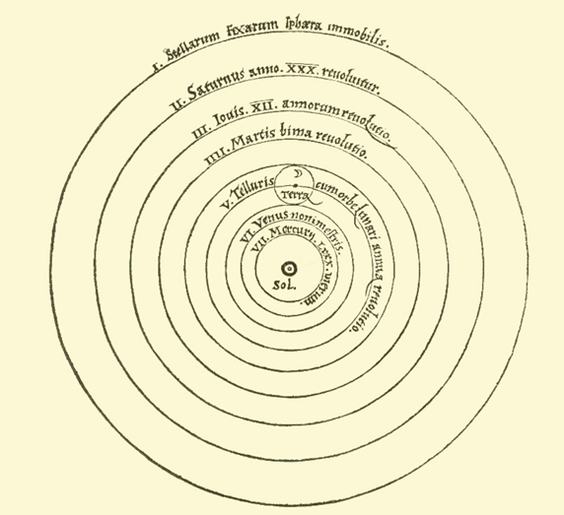

Step 4
Make some final notes about the people, places and traditions that shaped Nicolas Copernicus’s scientific ideas.

Shaping your answer
On a large piece or paper, or on a computer, make a collage showing the worlds that shaped Sofonisba’s art and Copernicus’s book. Decide how you will show the three themes of people, places and traditions, and how you will show their connections.

