Completing your Year 7 History endeavour badge: Read through this enquiry, completing all activities as you go. Email the final concluding activity to Mrs Lobo to claim your badge!

Soldiers on the steppe: How did the Mongols end up destroying Baghdad?

‘Go home to Mongolia, young man!’
In the year 1258, the caliph (Muslim leader) spat out these words. He sent a messenger to relay them to a man called Hulegu, who was right outside the walls of the caliph’s round city. Hulegu was leading the Mongol army now surrounding Baghdad.
The caliph was confident that the soldiers defending Baghdad could defeat the Mongols. Four times in forty years, Mongol armies had approached the city. Four times, they had got no nearer. But the Mongols had ridden thousands of miles from central Asia. This time, they were not going back.
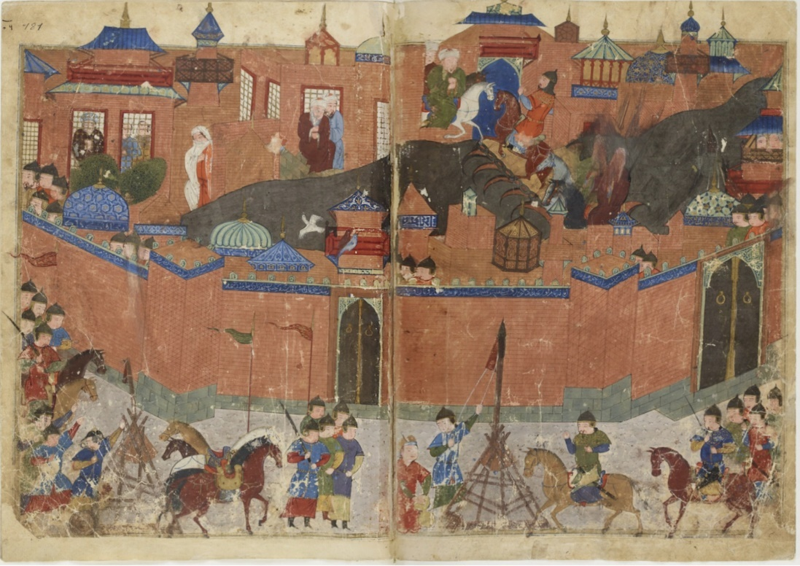
This image shows the siege of Baghdad, from an illuminated manuscript, The History of Chinggis Khan (also known as Genghis Kahn), painted by Khem Karan at the end of the sixteenth century. How has the artist tried to show the roundness of Baghdad and the richness of the culture within it? Can you find a catapult? It is the same as the one used by Crusaders.

Hulegu launched attack after attack. With the blood of his grandfather, Chinggis (Genghis) Khan, in his veins, Hulegu was confident. Baghdad had never seen warriors like the Mongols before. For ten days, the Mongols rode their horses at terrifying speeds. For ten days, Baghdad cried for mercy.
In little over a week, one of the greatest cities ever built was reduced to rubble by Mongol soldiers from a distant corner of Asia.
Centuries of knowledge were wiped out as books were burned or thrown in the river. 90,000 died. Irrigation was destroyed. Baghdad struggled to recover its influence and economic power.

Your enquiry:
Historians have to explain how such extraordinary events happen. You are going to use this chapter to find possible causes. At the end of the enquiry, you will organise these causes into a giant diagram that answers this question: ‘How did the Mongols end up destroying Baghdad?’
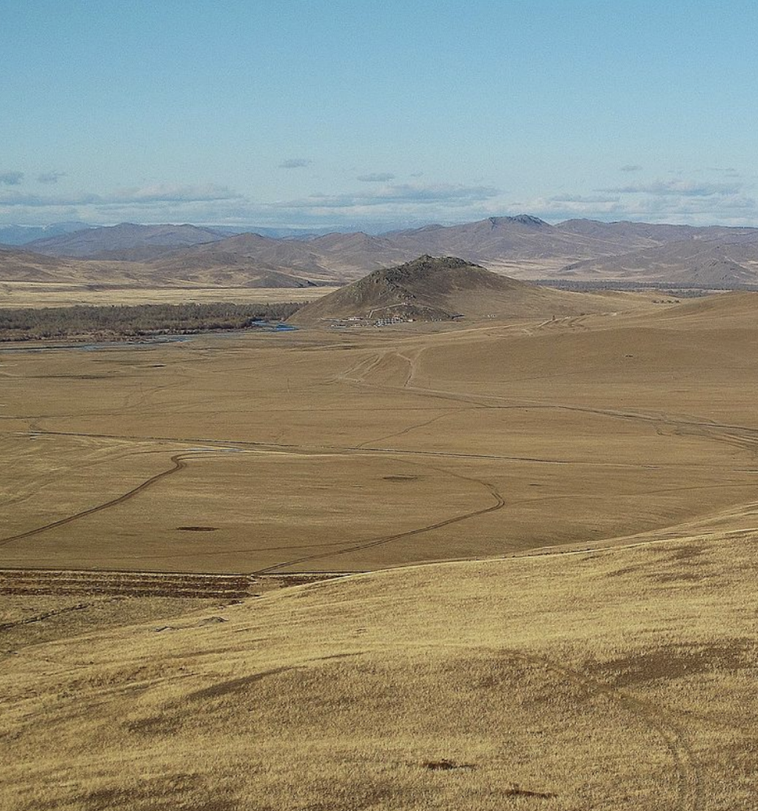
A boy on the steppe
Our story begins with a Mongol boy called Temujin. (It was Temujin’s grandson, Hulegu, who later destroyed Baghdad.) Temujin would become one of the most feared warriors in history. Historians are unsure of most details in his life, but he was born in around 1162.
Before we learn how he made the Mongols a superpower, we need to understand the Mongols. Let us start with the world in which Temujin grew up – the Mongolian steppe. This largely treeless landscape stretched for hundreds of miles across Asia. It shaped every aspect of Mongol life.
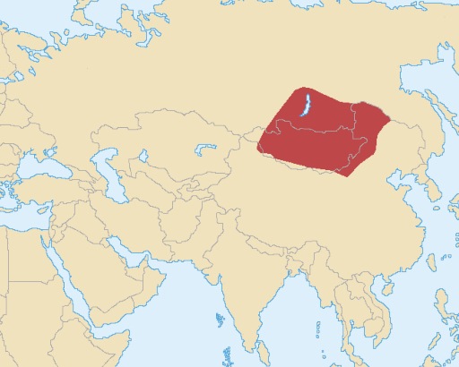
The harsh climate, often with sub-freezing temperatures, toughened the Mongols. Mongols were always on the move, following their animals in search for new grazing. The lack of rainfall caused the Mongols to revere rivers. Mongolia is shown in red on this map of Asia.
Animals, especially horses, were vital to the Mongol way of life. Mongolian horses were smaller than western horses, and their hair grew to the ground. It was said that each Mongol needed five horses just to live on the steppe. Women and men each had roles to play tending to horses. From the earliest age, Mongols like Temujin were trained to shoot arrows while galloping on horseback.
Since everyone wanted the best grass for their horses, tribes formed to compete for land. But there was little loyalty. Mongols could be persuaded to join new, more successful groups. In such a world it was possible for a charismatic person build a band of soldiers very quickly. Once you had built your band, however, you had to keep fighting! And you had to keep winning. Winning was hard without any military bases like castles (such as we saw the Normans had).
Step 1
Our enquiry is about something that happened in 1258, yet we have just described Mongol life nearly a hundred years before. The information on pages 1-2 won’t help you answer the enquiry question yet, but it will become useful later. You need to record it and think about it. You will soon see why it was important. Make notes on:
- the steppe;
- how the Mongols lived;
- how the landscape and Mongol way of life shaped the growth of tribes.

Temujin becomes Chinggis (Genghis) Khan
Historians and the Mongols
Temujin was illiterate, so we have no sources written by him. Historians must find evidence for Temujin’s life from objects or from documents written by non-Mongols. Historians studying the Mongols therefore need to know many languages. Because of these challenges, historians cannot be sure about many Mongol stories. Historians must make cautious suggestions, showing what is likely to be the case, rather than what definitely, happened.
Historians are sure, however, that by the time he was 12, Temujin’s mother and siblings were only just surviving. They lived off berries and plants, with just six horses between them.

Temujin gains followers
The stories that historians have found in the sources suggest that by age 12, Temujin had a ruthless streak. In a childhood prank, he killed his own half-brother. Curious young men started to look up to him. Violent men admired him. Tales of Temujin’s escapades spread across the steppe. Temujin led ambushes and raids. He overcame stronger opponents. And he always shared the spoils of his victories.
Temujin gained social status through the first of his wives Borte, who was from a wealthier family. Stories from early in their marriage add to our picture of Temujin’s character. One day, Temujin’s camp was attacked by a rival tribe: the Merkit. Temujin and his followers fled.
But the sources say, ‘there was no horse for Borte’. He had left his wife behind! Why was this this? We cannot be sure. What we do know is that he returned to take revenge. Temujin slaughtered every single male involved in the raid. He took hundreds of women into slavery. Temujin would have no one stand in his way.
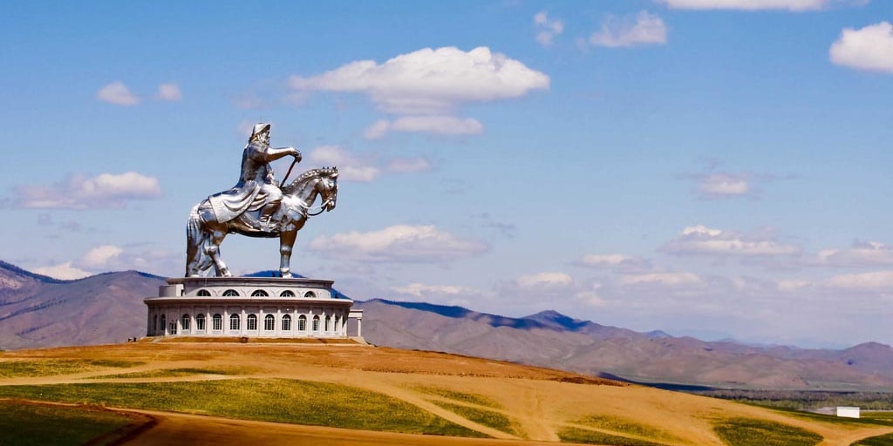
This is a modern sculpture of Chinggis Khan.

Temujin rewarded his growing followers for their skills and contributions. By 1186, his ever-growing band of followers swore to follow him into battle. The more he defeated other tribes, the more they adored him.
Soon Temujin started to dream big. Historians have been able to use the sources to find evidence for Temujin’s big ambitions. It seems likely that Temujin wanted to become more than a local leader. At some point, he started to dream of becoming the most powerful person in Mongolia.

Temujin and Jamuga
A curious quirk of Temujin’s life was that his best friend became his greatest rival. As two small boys, Temujin had made a pact called an ‘anda’ with Jamuga. The anda was a Mongol custom which made two friends closer than brothers. When he grew up, Jamuga became a tribal leader of another powerful tribe, the Naiman. By 1200, Temujin’s new ambitions brought him into conflict with this other tribe, and therefore with his childhood ‘anda’.
In 1203, Jamuga and his friends planned to poison Temujin at a feast. Two of Temujin’s loyal followers uncovered the plot just in time for Temujin to escape. Temujin began to prepare his army for revenge. He promised his followers, ‘I shall share with you the sweet and the bitter’.
After careful preparation and remarkable leadership, 1205 Temujin defeated the Naiman tribe. But during the final battle, a strange thing happened. Jamuga deserted the Naiman tribe. Was it a childhood loyalty to his old anda? Historians are unsure. One thing they are sure of is that Temujin still showed no mercy to his old anda. Temujin had Jamuga executed.
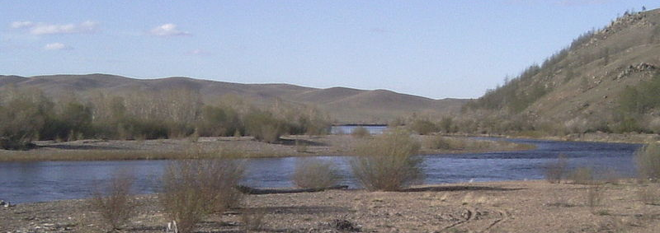Triumphant, Temujin headed to this river. It is the Onon River where he grew up – a fitting site for Temujin’s crowning glory. He had destroyed every other threat to his power in Mongolia. Now, on the banks of the Onon, he received a new title: Chinggis Khan. Historians debate whether it means ‘universal’ ruler or ‘fierce’ ruler. But they all agree that that Mongolia was now united.

Step 2
You can now start to build a picture of why the Mongols ended up in Baghdad. You now know more about Chinggis Khan’s success and Mongol strength. Knowing about the steppe helps you understand how this success and strength grew. Re-read pages 3-4 and try to identify three or four causes which are long-term (causes that happened a long time before the capture of Baghdad). A good way of doing this is to capture a cause in one word or phrase, and then explain it. Here are two examples.
- Environment
Life on the steppe made Mongols used to difficult conditions such as…. This made them good at …

- Chinggis Khan’s character
Stories about Chinggis Khan show that he …

A terrifying empire
The Mongol army
We know the Mongol soldiers were only loyal so long as they received rewards. So Chinggis Khan had a problem: if everyone in Mongolia was under his command, from whom would he take riches? Chinggis Khan decided to do what no Mongol leader had achieved before. He would invade northern China.
China’s population was a hundred times bigger than the population of Mongolia. So Chinggis Khan spent years planning. Women worked tirelessly with the animals. Every male in Mongolia, up to the age of 70, received military training. Chinggis Khan surrounded himself with the best generals in Mongolia. He even started recruiting the great generals from other countries. Chinggis focused on what people could do, rather than their status or wealth.
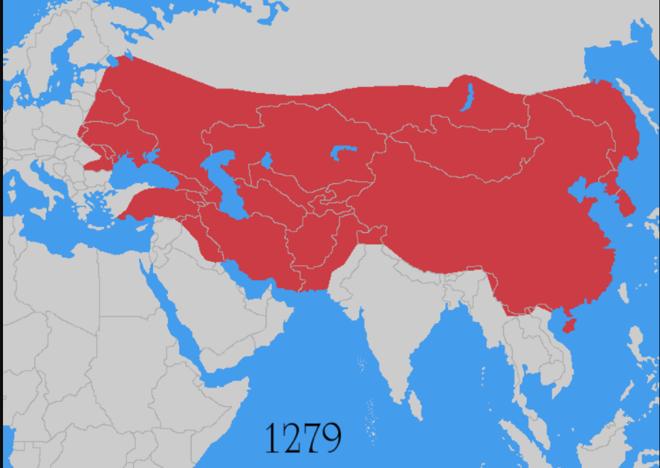
Chinggis Khan made the Mongol army the most disciplined in the world. His army used many methods. They could defeat bigger enemies in pitched battles. They could chip away at enemies through lightning raids. They could confuse enemies with sneaky tactics such as each soldier carrying five lanterns, so it looked as if they were a larger army. And there was always the threat of punishment if soldiers were ill-disciplined.
This army kept winning. China was successfully invaded in 1215. In England, people remember 1215 for Magna Carta. But for the wider world, the Mongol success in northern China has had more historical significance.
The Mongol empire by 1279

Conquering the world
‘Ruthless planning…organisation…strategic objectives’. These are the reasons that British historian, Peter Frankopan, has given for the Mongols’ continuous success. But we need to add something else: the Mongols were simply terrifying. In 1219, Chinggis Khan sent a friendly message to a Sultan who ruled the Khwarazmian empire, a vast Muslim empire by the Caspian Sea, but in response, the Sultan killed 450 Mongol soldiers. To punish this insult to Mongol pride, Chinggis Khan ordered the massacre of tens of thousands of men, women and children.
Hearing stories that travelled down the silk roads, Muslims and Christians soon feared the Mongols more than each other. Even Western and Byzantine Christians tried to patch up their differences.
Even after Chinggis Khan’s death in 1227, the Mongols kept advancing. Look at the map. They did not stop in northern China. Over the next thirty years they invaded Russia. They took parts of what are now Pakistan, India and Tibet. They even moved into eastern Europe.
Step 3
Find some more words or phrases which could become causes (reasons). For example:
- Ruthless planning
Use some facts about each one to explain how it could be a cause of the Mongols’ destruction of Baghdad.

Holding the empire together
Chinggis Khan had to govern his empire. Massive empires are not ruled only on horseback. What can hold an empire together? Chinggis Khan began with shared laws and values. As early as 1206, he introduced an ambitious legal code: the Yasa. The exact contents of the Yasa are disputed by historians, however, because most of it was never written down.
From oral sources and some written sources, historians know that the Yasa included many Mongol traditions. For instance, it was illegal to wash in running water. Remember that life on the steppe meant that rivers were treasured. It was also illegal to eat in front of someone without offering them food. Both offences, like many others, were punishable with death.
Much of the Yasa dealt with military issues. There are many examples of Yasa promoting extreme discipline and high standards amongst the Mongol armies.

Tolerance and diversity
The Mongols could be surprisingly flexible. Sometimes they let conquered people keep their own laws. The Mongols understood the importance of local cultures and traditions. Arts and crafts were encouraged wherever they conquered. In China, the Mongols paid for plays and paintings. In Russia they promoted the skill of goldsmiths and woodcarvers.
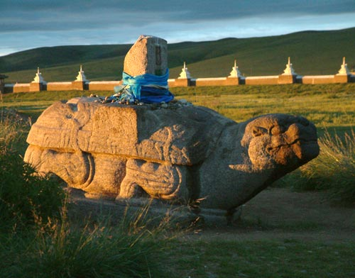
In the 1230s, Chinggis Khan’s son Ogedei ordered a capital city, Qaraqorum, to be built. Qaraqorum has long since disappeared, but the archaeological remains show us that they tolerated customs and religions from around the world. The ruins of a Buddhist temple show symbols from different countries, while coins with Arabic writing can be found in the ground. Look at this huge stone turtle from Qaraqorum, made in the thirteenth century.
The turtle is covered with Chinese motifs. Qaraqorum was a melting-pot of ideas and influences.
Historians have found evidence that Mongol leaders sometimes argued about how far to be tolerant of other cultures. After Chinggis Khan died, two powerful women fought over which of their sons should become the next Great Khan. Sorqaqtani Beki emerged victorious. One Iranian historian described her as the ‘most able woman in the world’.
Like Eleanor of Aquitaine, Sorqaqtani Beki had four sons who all went on to be monarchs. She worked with others to build alliances and allow local customs to exist alongside the Yasa. Her son, Mongke, became the Great Khan in 1251.

Connected by trade
As well as plundering China for booty, the Mongols now achieved control over the silk roads themselves. Mongol rulers loved luxurious textiles. They liked to reward loyal followers with fine fabrics.
Because the Mongols were controlling the silk roads, for the first time in history there were stable connections between east and west. Ideas and goods spread quickly between worlds. Iranian chickpeas found their way into Chinese meals. Chinese designs found their way into Iranian pottery. Medicine improved as information travelled fast.
In the 1250s, the Mongols could have taken western Europe. But the Mongols thought greater treasures could be found further east. The historian Peter Frankopan writes that everything outside Asia was a bit of a ‘sideshow’. The Great Khan, Mongke, told Hulegu, his brother, to focus on west Asia. This brought Hulegu to Baghdad in 1258.

Step 4
As you look for more causes of the Mongol attack on Baghdad, think about how the Mongols made their empire stable enough to expand and survive. Use pages 7-8 to shape two or three more main causes.
End of an era
In 1258, Hulegu, grandson of Chinggis Khan, received orders from the Great Khan to expand and seize riches from the wealthiest parts of the world. It was the ideal time for the Mongols to arrive. The Islamic world was divided. The Caliph was weak. Even though most Muslims feared the Mongols more than they feared Christians, many were secretly pleased to see Baghdad attacked.
Hulegu arrived on the outskirts of Baghdad with a group of talented generals. It was not his plan to destroy the city. He wanted riches and control. But the Caliph’s words on page xx angered him. The Mongols decided to make an example of Baghdad.
Behind Hulegu was the largest and most diverse army the Mongols had ever assembled: 150,000 men from all over the empire. It included Christians, determined to seek revenge on Muslims after the Crusades. It included one thousand Chinese artillery experts. New inventions, such catapults, were used to attack the city walls.

Shaping your answer
You have already found all your big causes and you have supported them with facts. You are now going to make a giant causation diagram to explain how the Mongol attack on Baghdad happened. Make boxes for your own causes around the central box. Make sure your big point for each one stands out, like in the example here. Draw lines to show connections between your causes. Email your diagram to Mrs Lobo.
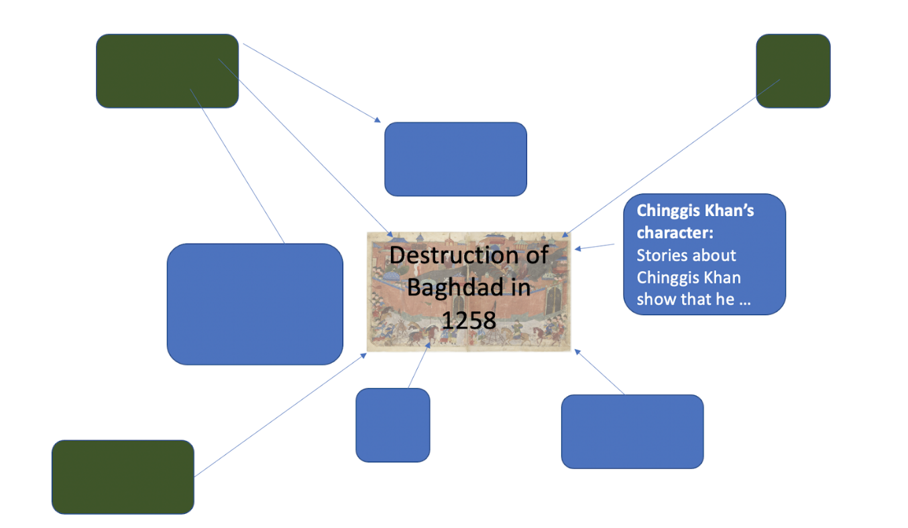

What happened to the Mongols after Baghdad?
Some historians have called the destruction of Baghdad the end of the Islamic Golden Age. The empire had grown too big. In 1260, Hulegu’s army was defeated by Egyptian soldiers – the first military defeat for decades. Chinggis Khan’s successors now found it impossible to stay united. After a century of success, an empire that once ruled vast swathes of Asia was no more.

