Where did Medieval Mali keep its secrets of success?

- Read the story of the Mali empire together as a class, noting down the key geographical features (in bold) on your map of Africa as you go. Use colour, labels and patterns.

- Take it in turns to read the story again with a partner. Discuss: were any of the geographical features on your map key to Mali’s success? If they were, write down how the feature helped to make the medieval Mali empire a success in the outer box.

- Read the story one last time. Can you find reasons for why the Mali empire was a success that were not to do with geography? Write down your ideas at the bottom.

- Now answer the enquiry question: Where did Medieval Mali keep its secrets of success? In the ground? In its people? In its leaders? You decide.
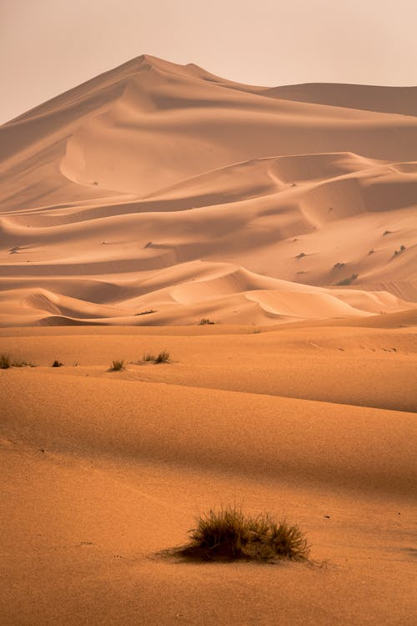
The geography of Africa has shaped its history in dramatic ways. The Sahara Desert (right) is the largest desert in the world. It’s hard to live there and very dangerous to cross it on foot. On the southern fringe of the Sahara is an area called the Sahel. This is where the land changes from desert to savanna (grassy plains with few trees).

The savanna (below left) offered grasslands for grazing animals like sheep and goats, and fertile soil for farming. This meant the people who lived here could grow a reliable food supply. They produced more food than they needed themselves, so they began trading the surplus (extra) with neighbouring peoples. They learned how to use iron to make tools and weapons and they used horses for transportation. These advances made it possible to put together powerful armies to dominate others. Not only did they have weapons, they could feed a larger population who could form a bigger army. This led to the founding of three great medieval empires in this region of West Africa: the Ghana, Mali and Songhay empires.

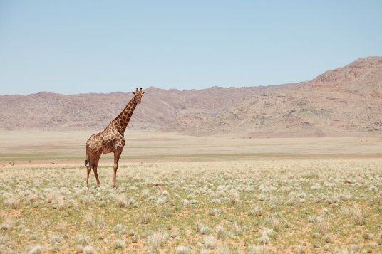
An empire is often formed when one kingdom becomes more powerful than its neighbours. The more powerful king forms an empire by conquering his weaker rivals and adding their lands and wealth to his kingdom. In the 1100s, a large group of Mande chiefdoms (little states run by chiefs) had been created, but these chiefdoms had never been unified under one leader. These chiefdoms were set up in West Africa, around the Niger River, which became the home of the Mali empire.

It can be difficult to find out things about medieval African empires because there are few written records. Most of the writers at the time were Muslim Arabs who had come to Mali to trade. According to oral tradition, the Mande people’s greatest hero was Sunjata Keita. His nickname was the Lion King. He united the Mande chiefdoms in around 1250. Sunjata Keita organised soldiers from all of the smaller chiefdoms into one very powerful army. Then he led them in a war that freed them from the control of a group of people called the Susu people. Sunjata Keita started taking over land in places nearby. This was the beginning of the Mali Empire, which would prosper until the late 14th century.

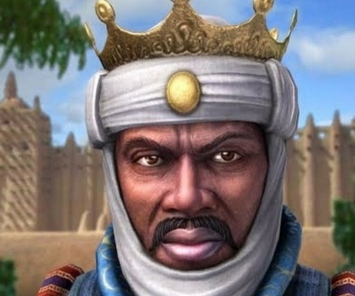
The bringing together of land under Sunjata Keita (right) led to a growth in trade because different lands produced different goods that the Mande people could sell to merchants travelling south from the Silk Roads. Mali soon extended from the dry steppe of the Sahara fringe almost to the rainforest belt of West Africa. Mali became richer because Malian kings could sell cereals from farms, salt from the Sahara, fish from rivers and the ocean, and ivory from elephants. Selling these goods was key to Mali’s success. Mali also sold slaves.

It was a long and very dangerous journey for merchants to travel to the Mali empire to trade because they had to cross the Sahara desert, so there needed to be some very precious produce for the merchants to buy. And there was: gold. There were three goldfields south of the Sahara, including Bambuk and Buré. It was desire for gold that connected Mali to the Silk Roads, and this connection was key to the success of the empire. Africa was isolated from Europe and Asia because of the Atlantic ocean to the west of the continent and the Indian ocean to the east. The creation of a series of oases across the Sahara desert meant sub-Saharan Africa could now be connected to Europe and Asia through a passage north, to Egypt, and from there to the Silk Roads.

Sunjata Keita ruled for 25 years. Then his sons became king after him. Each was given the title ‘Mansa’, meaning king. One of Sunjata Keita’s sons was mad and practised archery by shooting arrows at his own people and killing them. Eventually the people killed him and chose a new leader, a military commander called Sakura. Mansa Sakura made sure there was peace in the Mali empire which meant that trade could continue to grow. He expanded the empire into lands around Mali, taking control of other kingdoms.
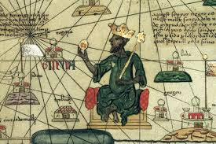
The throne was later passed onto Mansa Musa (left), who ruled 1312-1337. He was the great-nephew of Sunjata Keita. His reign is known as a ‘golden age’. He was very religious and very generous. He was young and handsome when he became Mansa and he ruled over 24 lesser kings. When he met with important people, Mansa Musa carried a bow and arrow made of gold. He sat on an ebony throne with 30 slaves around him. These slaves came from Turkey and Egypt. There were always 2 horses nearby in case the Mansa needed to ride quickly to deal with any problems in his empire. It was Mansa Musa who made the famous pilgrimage to Cairo and Mecca. This made him famous and trade grew even more because of the publicity he created when he gave away so much gold in Egypt.

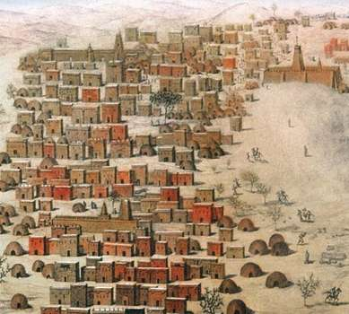
Mansa Musa had many palaces, including one at Timbuktu (below right). This African city grew as trade increased with merchants from the silk roads. A splendid mosque was also built there. Timbuktu soon became home to many scholars, musicians, artists and students.

Mansa Musa was a great ruler, but his descendants were not as powerful. In the late fourteenth century, civil wars broke out between rival leaders. Mali eventually lost control of Timbuktu in 1433. Eventually, the Mali empire was taken over by the Songhay empire towards the end of the fifteenth century.

