Religious conflict and the church in england c1529-c1570

Lancaster Girls' Grammar School
AQA HIS2D: Key characters booklet

Key characters from Henry’s reign (1509-47)
- Anne Boleyn
- Katherine Parr
- Elizabeth Barton
- Desiderius Erasmus
- John Colet
- John Fisher
- John Aske
- Robert Wycliffe
- Stephen Gardiner
- Thomas Cranmer
- Thomas Cromwell
- Thomas More
- Thomas Wolsey
- William Tyndale

Anne Boleyn
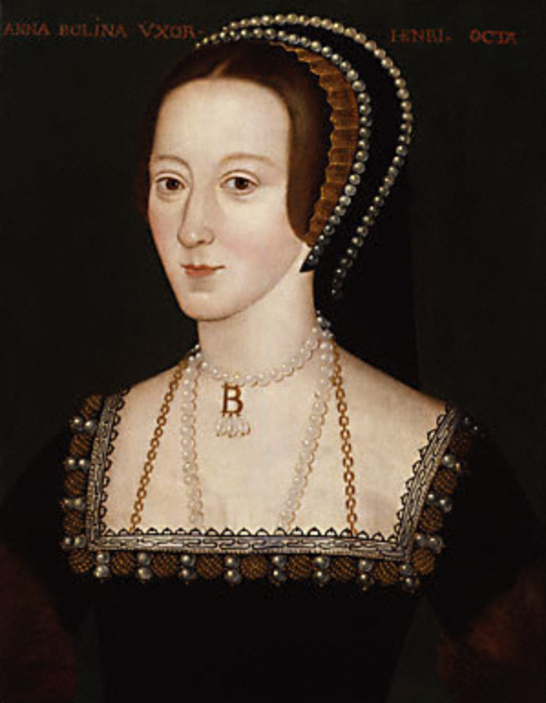
Anne Boleyn (c.1500-1536), queen of England, second consort of Henry VIII, was the daughter of Thomas Boleyn, and Elizabeth, daughter of Thomas Howard. Anne was probably born in Norfolk in about 1500. Her father Thomas was the earl of Ormond and Wiltshire. Boleyn wealth had initially come from a London alderman half a century earlier, but the family had subsequently risen to be able to claim the title of the Irish earldom of Ormond. In no sense did Anne smell of the sop, nor was she in any way a commoner.
In 1512, when Thomas Boleyn was appointed to Margaret of Austria’s court, he took his daughter Anne with him. This was the most prestigious court in Europe, offering the best possible training to any young aristocrat. In August 1513, Anne was moved to France to attend on Henry’s sister Mary, who was to marry the aged Louis XII. A spin of the diplomatic wheel brought England and France to the brink of war and interrupted this promising career at the French court, and at the end of 1521 Anne was forced to return home.
Upon returning to England, Anne was not in want of admirers. After a marriage in Ireland fell through, the most eligible admirer was Henry Percy, later the sixth earl of Northumberland, who wanted to break a prior engagement and marry Anne. According to George Cavendish, he was prevented by the combined opposition of Cardinal Wolsey and Percy’s father. Anne was not a conventional beauty. No contemporary portrait has survived, but a portrait medal shows that she had a long face, her complexion was sallow and she was noted only for her magnificent dark hair, her expressive eyes, and her elegant neck. However, she had a continental polish which was unique to the provincial court of Henry VIII. She could sing, play instruments, dance, and she led female fashion.
It was probably not until 1526 that Henry showed any interest in her. For a king who famously disliked writing, it is remarkable that he wrote her seventeen letters over 1527-8. At first, Henry had no thought of marriage, rather he saw Anne as someone to replace her sister Mary, who had just ceased to be the royal mistress. However, Anne continued to refuse Henry’s advances, and the king realised that by marrying her he could kill two birds with one stone, possess Anne and gain a new wife. The marriage did not take place until January 1533, and the awareness of the passing of time, growing sexual frustration, and the stress of persuading Henry to keep his nerve explain Anne’s occasional outbursts of temper during these years and her increasingly radical attitudes. For example, Anne fed Henry with selected passages from the Obedience of a Christian Man in which Tyndale argued that kings had authority over the church. Anne was finally recognised as queen on Holy Saturday (12 April) 1533. Her coronation ceremonies followed six weeks later and lasted for four days, culminating on 1 June in the crowning ceremony in Westminster Abbey.
Anne was not a popular queen. Katherine was widely respected, and women in particular resented Henry’s treatment of a faithful wife. Much of the hostility to Anne was associated with the dislike of recent royal policies, particularly the king’s interference with the church. Anne was seen as the reason for the unprecedented horrors of the deaths of the Carthusian monks and John Fisher. The execution of Thomas More was also directly attributed to her.
Anne used her position as queen to advance evangelically minded clergy within the Church, and she was not backward in promoting the vernacular English Bible. A Bible was available for her household to use and she owned a personal copy of Tyndale’s illegal translation of the New Testament. However, Anne was not a protestant. Such a label would be anachronistic in the confusion of religious ideas in Henrician England. She was wholly orthodox on what Henry VIII saw as the test of sound belief, the issue of transubstantiations. The last night of her life was spent praying before a crucifix. Nevertheless, traditionalists were correct when they later blamed her for opening the door to heresy in England.
Throughout her marriage Anne Boleyn was the target of religious conservatives and others committed to re-establishing Katherine of Aragon and the now bastardized Princess Mary. Anne’s entourage was lively, flirtatious, and probably less formal than would have been the court of a queen of foreign origin. Anne was subsequently accused of treasonous and adulterous affairs with a number of men, including Mark Smeaton (court musician) and her own brother George. That Anne was innocent of these charges, and so too the others, is clear. However, the jury which tried the defendants was hand-picked by Cromwell. The queen firmly rejected the charges put to her, and on the last night of her life she twice swore on the sacrament that she was innocent. On the morning of Friday 19th May Anne was executed on the scaffold of Tower Green.
Anne’s reputation was blackened in the reign of Mary I as a heretical seductress who had corrupted Henry and let loose all the evils which had then befallen the faith. Historians now see her as a woman of importance in her own right and her destruction as an example of cynical realpolitik. Although not the cause of the breach between Henry and Katherine, Anne had a measurable influence on the direction of the divorce campaign, while the faction which gathered around her put in place the constitutional revolution of royal supremacy.

Katherine Parr
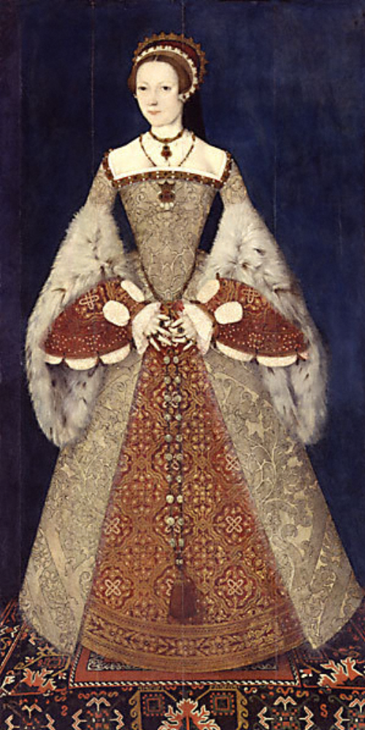
Katherine Parr, the sixth wife of Henry VIII was born in 1512, and was named after Henry’s first queen. Her mother, Maud Parr, was an independent, capable, and unusually articulate woman, who oversaw her children’s education, arranged a marriage for Katherine, and set an example of female independence that was to have a lifelong effect on her elder daughter, and through her, on Katherine’s stepdaughter, Elizabeth Tudor. Katherine Parr was fluent in French, Latin, and Italian, and while she was queen she undertook the study of Spanish.
Katherine was married twice before she married Henry VIII. In January 1537, when she was living in the north with her second husband John Neville, she was taken hostage by pilgrim rebels during the Pilgrimage of Grace. This gave Katherine a lifelong antipathy towards the north. In 1543 when Neville was very ill Katherine hoped to marry Sir Thomas Seymour, brother of Queen Jane, but the king’s interest in her changed the course of her life. It was made clear to her, no doubt by her reform-minded family, that her reluctance to accept the king as her husband was to defy God’s will.
Katherine was of medium height, with red hair and grey eyes. She had a lively personality, was a witty conversationalist with a deep interest in the arts, and an erudite scholar who read Erasmus for enjoyment. She was a graceful dancer, who loved fine clothes and jewels. She married Henry VIII on 12 July 1543. Among her first acts as queen were her efforts to secure the friendship of Henry’s children, by taking an active and personal interest in their education.
During the summer of 1544 Henry VIII led a military expedition to France. In his absence he appointed his queen regent-general, together with a regency council. She made every effort not only to preside over the regency council but to rule in the king’s name. This assumption of power, not merely by a woman but by a woman who only a year before had been a Yorkshire housewife, made the queen enemies, particularly among the religious conservatives who resented her evangelical beliefs.
In February 1546 these conservatives, led by Stephen Gardiner began plotting to destroy her. As Henry’s health worsened, his temper became ever shorter and his wife’s assertiveness began to irritate him. Gardiner, who knew the king could not survive much longer and that a minority regency under her control would give ample scope for a vigorous enforcement of the new religion, joined with Wriothesley, Richard Rich, and Paget, to compromise the queen as a heretic that would lead to her arrest and execution. Gardiner sought to implicate the queen through the interrogation of Anne Askew, but failed.
Terrified of this, Katherine took to her bed, giving it out that she was mortally ill, and when the king rushed to her side she explained that her illness stemmed from fear that she had displeased him. Henry taxed her with her outspokenness in matters of religion and Katherine mollified him by explaining that if she argued it was only to take his mind off his ailments and to learn by his responses. Henry was convinced by this show of submission and cancelled the warrant.
Katherine’s influence on the politics and culture of her time was diverse and wide-reaching, far greater than has usually been appreciated. Politically, she contributed to the re-establishment of her stepdaughters, Mary and Elizabeth, in the line of succession. She was herself the first known Englishwoman to publish a work of prose in the sixteenth century. Her commitment to religious reform in particular made her a singularly important player in the power politics of the last three years of Henry’s reign.
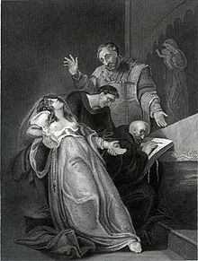
Elizabeth Barton
Elizabeth Barton, Benedictine nun and visionary, is of obscure origins. Nothing is known about her early life or family. She was almost certainly illiterate. In 1525, Barton was afflicted by a disease which lasted for several months and which prevented her from eating and drinking. In the course of this period of sickness and delirium she began to demonstrate supernatural abilities, predicting the death of a child being nursed in the neighbouring bed. This may have been a form of epilepsy, and manifested itself in seizures, alternating with periods of paralysis. During her death-like trances she made various pronouncements on matters of religion, such as the seven deadly sins, the Ten Commandments, and the nature of heaven, hell, and purgatory. She spoke about the importance of the mass, pilgrimage, confession to priests, and prayer to the Virgin and the saints; had revelations concerning the souls of the dead; and saw visions of heaven.
As her reputation for sanctity grew people travelled far and wife to consult her about their lives and sins. Archbishop Warham himself met her several times, and praised her warmly to John Fisher. Wolsey interviewed her at least twice, and it was probably the cardinal who gained Barton admittance to the king. She told Henry about her revelations in person on a number of different occasions.
As early as 1528 William Tyndale wrote critically about her in The Obedience of a Christian Man. By 1530, Barton opposed Henry’s religious policies in relation to the church. However, it was her intervention in the matter of the king’s divorce from Katherine of Aragon which was to bring about Barton’s downfall. She foretold wars and plagues, and other forms of disaster that would follow if Henry divorced Katherine. Although Katherine of Aragon refused to grant her an audience, Barton sent letters to Pope Clement VII, encouraging him to stand against the English king.
In the summer of 1533 Cranmer and Cromwell questioned Barton, and by early November she was imprisoned in the Tower. On 23 November she was forced to do penance at Paul’s Cross in London. On 20th April 1534 Barton was executed by hanging and beheading alongside other convicted of treason. The executions were clearly intended as a warning to those who opposed the king’s policies and reforms. Barton’s head was impaled on London Bridge.
She has variously been characterised as a charlatan, an impresario, a puppet, a hysteric, and a naïve and innocent victim. She was certainly an intelligent, courageous, and extremely charismatic woman, who was able to gain the confidence of even the most sceptical individuals. While most nineteenth- and twentieth-century accounts of this crucial period of English history tend to downplay or dismiss out of hand Barton’s role as a figure-head of the conservative resistance to the Reformation, it is important to acknowledge that almost all the first-hand evidence concerning Barton’s life was destroyed following her arrest, and the surviving image of her is a profoundly hostile one derived from the protestant propaganda. What is clear is that Barton was an English woman visionary whose career might also usefully be compared with that of Joan of Arc.

Desiderius Erasmus
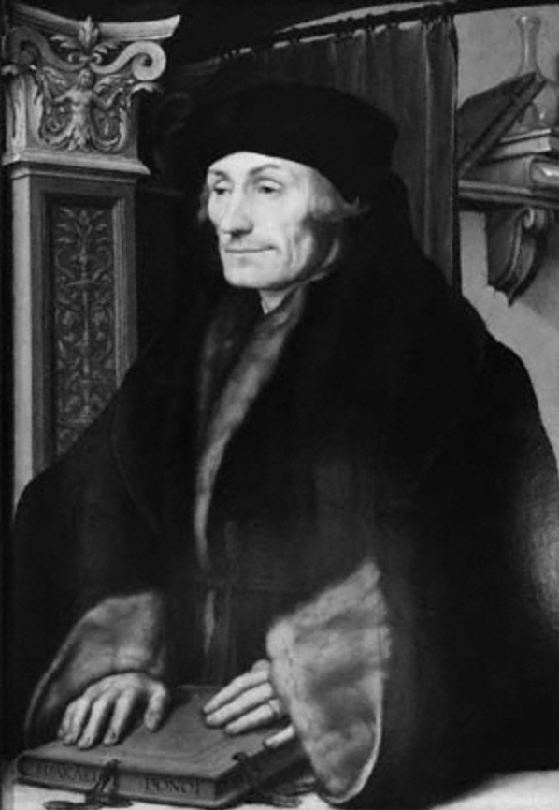
Desiderius was a humanist scholar and reformer, born in Rotterdam, was blessed with a good education. In the course of his first brief visit to England between 1499, he befriended people who would later provide powerful support and congenial society, prominent among them Thomas More, who introduced him to the eight-year-old Prince Henry. Erasmus also met John Colet. The two were near in age, and they formed a relationship which was close and enduring. Erasmus’ personal motto was ‘I yield to no one’.
The most famous – and notorious – of Erasmus’ written works was ‘Praise of Folly’, a complex satire, a distillation of his critique of contemporary Christendom. Erasmus also wrote the Enchiridion. In September 1514, Erasmus for the first time stated that he was publishing a version of the New Testament that was a Latin translation with the Greek notes of Erasmus. The work was supposed to be a purified and updated version of the Vulgate. The work was reprinted 229 times in the course of the sixteenth century alone.
Erasmus collided with Martin Luther, with the two exchanging a series of angry and confrontational writings. Erasmus took up his pen in public opposition to Luther on an issue that was central not only to Luther’s doctrine, but to the humanist’s reform programme: the issue of the freedom of the will. Erasmus was convinced that Luther was resolved to disrupt Christendom, and denounced his reckless arrogance and insolence.
Erasmus’s influence on the generation that came of age under Henry VIII was immense. Many significant individuals were directly or indirectly influenced by Erasmus, including John Fisher, Sir John Cheke, and Cuthbert Tunstall. There was a notable translation industry involving Erasmian works such as Enchiridion (1533) and Praise of Folly (1549), but including works of devotion and, most prominently, the Paraphrases on the New Testament on the initiative of Queen Katherine Parr. By royal injunction of 1547, the latter were to be made accessible in every parish in the realm along with the Great Bible. In England, Erasmus was general regarded as an honorary protestant.

John Colet
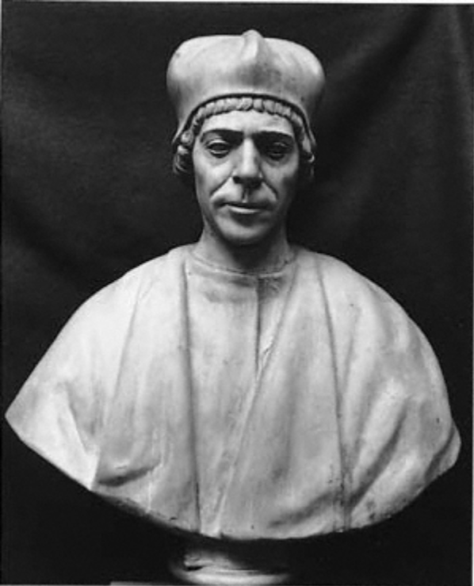
John Colet (1467-1819), dean of St Paul’s and founder of St Paul’s school, was born in January 1467. Colet was almost certainly born in London, and his father was twice mayor of London. Colet was taught the rudiments of Christian belief, good conduct, and Latin at school, and his holy and religious nature impelled him towards divine studies at both Oxford and Cambridge.
Royal favour secured him the important deanship of St Paul’s. The prominence he achieved before being possible robbed of a bishopric by death resulted partly from zealous performance of ecclesiastical duty, including his preaching and his insistence that his chapter mend their ways. His closest English friend was Thomas More, his junior by ten years, to whom he was ‘vitae meae magister’ (‘my life’s overseer’) and who, thinking him more learned and holy than anyone in England for centuries past, praised the bishop of Lincoln as a second Colet. Colet in turn thought More ‘Britanniae unicum ingenium’ (‘the ablest man in Britain’).
Colet was a grave and impressive presence, tall and handsome. Erasmus saw in Colet a quick-tempered but pure Christian with a fertile, powerful, profoundly serious mind, always bent on seeking the moral. He loved chastity, and he delighted in sacred reading and holy conversation. He dressed habitually in plain black woollen, being frugal with food and drink, and not celebrating mass daily. He was intolerant of pilgrimage and particularly of the cult of images and relics as vulgarly practised. Most of Colet’s surviving writings are in Latin. The only Latin work by Colet to have been printed in his lifetime is his convocation sermon.
Colet’s posthumous influence was limited by his reluctance to publish. John Foxe (1563) later described Colet as being among the persecutors of the Lollards. By then Colet had disappeared from English Catholic consciousness and his transformation from a firmly faithful member of the pre-Reformation Catholic Church, unorthodox in opinion and less than discreet in expression, to a reformer was well under way. In 1529, William Tyndale had reported him as in trouble with his bishop for rendering the Pater noster in English; in 1552 Hugh Latimer had him in danger of burning as a heretic; and in 1562 John Jewel attempted to enlist him among the forerunners of Protestantism.

Bishop John Fisher
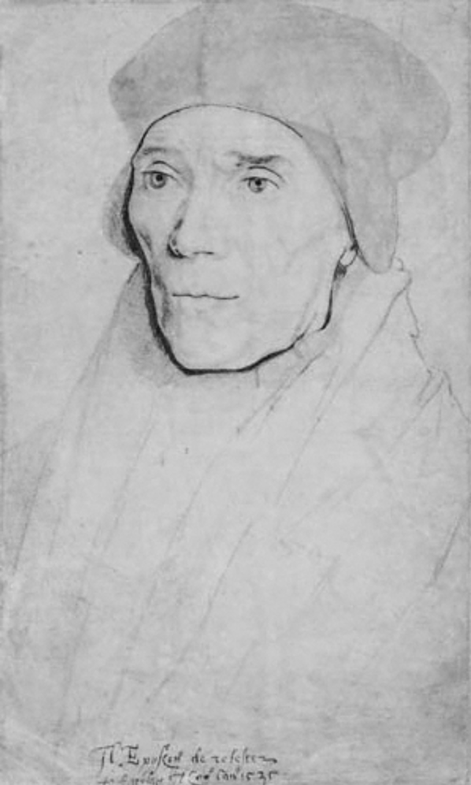
John Fisher (c.1469-1535), cardinal and martyr was born at Beverley, Yorkshire. As a young man he met Lady Margaret Beaufort, the mother of Henry VII. In 1504, Henry VII made him bishop of Rochester and in the same year Cambridge University promptly elected him chancellor for life. Fisher busily fostered the progress at Cambridge of what is now called Renaissance humanism and arranged for Erasmus to teach at Cambridge.
The evidence for Fisher’s pastoral zeal is both anecdotal and archival. He traversed his diocese regularly and held formal visitations every three years, and he personally carried out almost all the ordinations in his diocese. He certainly experienced considerable anxiety over the emergence of protestant heresy, and he preached at the first burning of Luther’s books in England in May 1521. His reputation as a theologian rests on his writings of the 1520s, against Martin Luther, in which he picked apart three fundamentals of Luther’s doctrine: the thesis of justification by faith alone, the ultimate appeal to scripture alone, and the denial of papal authority.
As the realm’s most respected theologian, Fisher was inevitable consulted at an early stage in 1527. Politically, he did not get things right. The case was initially aired as a scruple of the king’s conscience, and Fisher naively set out to allay Henry’s fears. He was unshakeable in his confidence in the scope of papal authority both to resolve doubts about scripture and also to grant matrimonial dispensations. As the extent of Henry’s personal investment in this matter became apparent, Fisher devoted more and more effort to the scholarly questions it raised about scriptural interpretation, divine and natural law, and papal power.
At Blackfriars in summer 1529, Fisher made an outspoken oration in defence of the king’s marriage. Avowing himself willing to die for the sanctity of the marriage bond, and likening himself on these grounds to John the Baptist, Fisher implicitly cast Henry VIII as Herod and Anne Boleyn as Salome. Fisher had a tendency to say exactly what he thought, especially at moments of high emotion.
Fisher was Henry’s most consistent English opponent over the next six years. He came to the fore again in 1531, leading resistance in convocation to the recognition of Henry VIII as supreme head of the church. In February 1531, an attempt was made to poison the bishop’s soup, but it misfired. The ascetic Fisher passed the entire meal straight to his servants and to the poor who were accustomed to be fed at his gates, leaving two dead and the rest sick. There is no reason to believe Henry was involved in this plot. His own horror of poisoning was such that in response he passed a law making poisoning punishable by boiling alive, a mode of execution inflicted upon Fisher’s unfortunate cook, who had been unwittingly tricked into the deed. It is likely that some less scrupulous client of the Boleyns was behind these attempts.
Throughout the early 1530s Fisher was in close communication with Katherine of Aragon’s most determined political supporters, Eustace Chapuys. However, had he been willing to take the ‘oath to succession’ he would doubtless have been restored to full honours. But he was not, and in April he was therefore confined in the Tower of London. When he denied Henry’s status as Supreme Head of the Church of England, he was found guilty of high treason and on 22 June, he was decapitated on Tower Hill, instantly becoming a martyr.
Despite (or perhaps because of) an ascetic and uncompromising disposition, Fisher was evidently a man of considerable personal charisma. But Fisher also kindled loyalty and affection in relatives, colleagues, and friends.

John Wycliffe
John Wycliffe (d.1384) theologian, philosopher, and religious reformer, was, according to the chronicler Thomas Walsingham, a northerner. Wycliffe advocated the teaching of the laity in the vernacular, and is considered responsible for the first complete English translation of the Bible. The claim for Wycliffe’s responsibility for this immense work goes back to the chronicler Henry Knighton. A large team of academic helpers must have been involved, but Wycliffe was the inspiration and the crucial factor in the collaborative labours.
Wycliffe believed in predestination, and believed that no one could be saved who had not been predestined to salvation by God. Wycliffe also believed in the faith of scripture alone. He thought this was the source for men of a model for all aspects of life, and this was the standard by which the contemporary church must be measured. Wycliffe castigated at a length that often seems inordinate the malpractices of the papacy and monasteries, the abuses of indulgences, excommunication, images, and pilgrimages.
English Lollards in the fifteenth and early sixteenth centuries remained aware of their indebtedness to Wycliffe, and during the sixteenth century writers such as John Foxe attempted to reinstate him as the ‘morning star of the Reformation’.

Robert Aske
Robert Aske (1500-1537) was a lawyer and rebel leader of the Pilgrimage of Grace. Aske studied common law as a young man, and left Yorkshire for Lincolnshire in October 1536, ignorant, when he set out, of the rising at Louth in that country. There are no signs that Aske wished to align himself with the commons’ rising when he went to Lincolnshire. He declared himself for the commons and emerged as one of their leaders only after he had seen the articles sent by the Lincolnshire gentry to the king on 9 October.
Aske became one of the key leaders of the Yorkshire risings, and he helped craft the Pontefract articles which were presented to the Duke of Norfolk at Doncaster on 4 December. Norfolk conceded both a pardon and a parliament to be held at York without considering the articles. Aske accepted the king’s invitation to go to court over Christmas 1536 where he advised Henry on the future government of the north. Back in Yorkshire, he found that his standing was diminished by his contact with Henry. When Aske argued by both speech and letter for the king’s good faith, scepticism among the commons and the actions of a renegade gentleman, Sir Francis Bigod, led to a new rising. Ultimately none of the concessions were ever made, and Aske was arrested and tried in London for treason. He was hanged on 12 July.

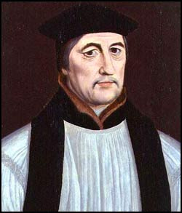
Stephen Gardiner
Stephen Gardiner (1495-1555) was a theologian, administrator and bishop of Winchester. Gardiner almost certainly went to Cambridge in 1511, and eventually went on to teach at Cambridge. His pupils at Trinity Hall included is future colleagues Thomas Wriothesley and William Paget. Gardiner was educated in a Cambridge which was already stirring to the currents of humanism.
In 1523 Gardiner was a member of a Cambridge delegation to Cardinal Wolsey, and he rapidly became indispensable not only to Wolsey but also to Henry VIII himself. The king’s Great Matter soon provided full scope for Gardiner’s talents as a canon lawyer and diplomat. Early in 1528 he was sent on embassy to the pope in the company of another rising Cambridge don, Edward Foxe (later bishop of Hereford).
After returning to London in June 1529, Gardiner moved a month later from Wolsey’s service to that of the king, as his principal secretary. Gardiner was present at Wolsey’s surrendering of the great seal in October. Yet although it was suspected in Wolsey’s circle that Gardiner had been disloyal to him, the cardinal sought Gardiner’s assistance throughout the following year. Gardiner was nominated by Henry VIII as Wolsey’s successor in the see of Winchester in September 1531.
The first crisis of Gardiner’s career occurred in April 1532 when Archbishop William Warham presented to the southern convocation the ‘supplication against the ordinaries’, which had been drawn up by the House of Commons. The task of responding to this attack upon the legal powers and privileges of bishops was entrusted to Gardiner. Henry’s response to Gardiner’s work was not welcoming. Gardiner’s letter of apology only made matters worse, as he tactlessly excused himself on the grounds that his argument was in line with Henry’s own arguments in the Assertio septem sacromentorum against Luther.
Gardiner no longer enjoyed the full confidence of his master. By April 1534 he had been formally replaced as royal secretary by Thomas Cromwell. Gardiner sought his way back into the king’s favour by writing in defence of the royal supremacy and of the execution of John Fisher. This is an example of how Gardiner was always pulled between loyalty to church and crown. Early in 1537 Gardiner once more managed to cut across Henry’s bows. In the wake of the Pilgrimage of Grace, he apparently advised the king to make concessions to his subjects. Henry’s response was furious. He accused Gardiner of returning to his old opinions, and complained that a faction was seeking to win him back to their ‘naughty’ views.
Gardiner was thus out of favour, but what paved the way for Gardiner’s return to the centre of events was the fall of Thomas Cromwell, following the fiasco of Henry’s marriage to Anne of Cleves, The extent of Gardiner’s role in Cromwell’s fate is not clear, but contemporaries saw his hand therein. In the following years Gardiner established a reputation for himself at home and abroad as a defender of orthodoxy against the Reformation. He was involved in the 1540s with plots against Thomas Cranmer, increasingly his greatest rival, although his plans came to nothing. He was involved in the examination of Anne Askew.
At the beginning of Edward’s reign, Gardiner tried to counter religious innovation with four arguments: first, he warned of the inadvisability of change during a royal minority; second, he argued that innovation was contrary to Henry’s express wishes; third, he raised technical and legal objections; fourth, he offered theological objections. His refusal to accept new injunctions led to his incarceration, confined in the Tower where he remained for the rest of Edward’s reign.
Gardiner’s long imprisonment came to an end with Mary Tudor’s triumphant entry into London on 3 August 1553. A further note of caution has to be sounded concerning the diplomatic sources where we learn much of Gardiner during Mary’s reign, namely that Simon Renard, the principal imperial envoy, was deeply and consistently hostile to Gardiner. Renard sometimes reported false information about the chancellor as well as his own negative opinions of him. The question of the queen’s marriage proved troublesome. As early as September 1533, ambassadors were reporting Gardiner’s preference that Mary should marry Edward Courtenay, and commenting that the bishop seemed to have established some sort of personal ascendancy over the young man while they were fellow prisoners in the Tower.
Gardiner’s determination to proceed speedily with the restoration of Catholicism was clear from the start of Mary’s reign. However, the outbreak of Wyatt’s rebellion in January 1554 weakened Gardiner’s position. Not only did he apparently panic, and advise the queen to flee the city, but when order had been restored, he also found that blame for the rebellion was being laid at his door on account of his enthusiasm for reversing religious change.
Gardiner was one of the giants of Tudor politics. Among the English statesmen of the sixteenth century, only Wolsey, Cromwell, Cecil, and perhaps Walsingham exceeded him in stature. Gardiner was a figure of the first rank for almost thirty years, surpassing the records of his patron, Wolsey, and his great rival, Cromwell. Moreover, as the leading English conservative of his time, Gardiner bulks large in political, intellectual, and ecclesiastical history. To the protestant martyrologist John Foxe, he was ‘a man hated of God and all good men’. Protestants hated him and Frenchmen despised him; Catholics and imperialists admired and respected him. The long-serving Chapuys held Gardiner in generally high regard.
Gardiner’s detractors often spoke of his irascibility. There is something in Elton’s observation that he ‘always made enemies more readily than friends’. Gardiner can hardly be dismissed as an opportunist. His commitment to Catholic doctrines on the Eucharist, justification, and clerical celibacy is beyond doubt. That he was arrogant is clear. But he had much to be arrogant about: learning, a ready pen, fluency in extemporary oratory, gifts as a lawyer. Few Tudor statesmen rose so far and so fast. Born of humble stock, Gardiner was bishop in one of England’s richest sees by his mid-thirties. Had it not been for the break with Rome he might have achieved under Henry the chancellorship that he attained under Mary.
Thomas Cranmer
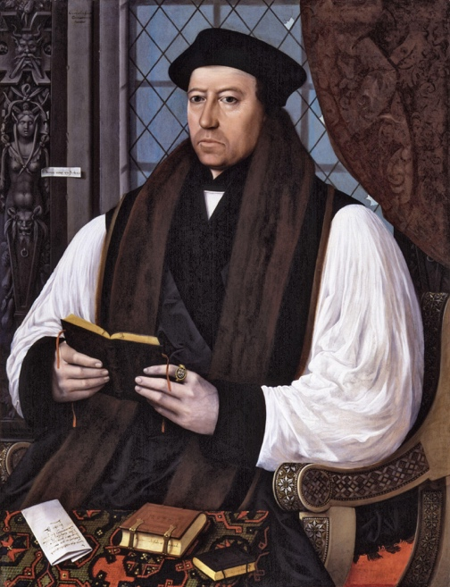
Thomas Cranmer (1489-1556) was archbishop of Canterbury. He attended Jesus College, Cambridge, and took a surprisingly long time to acquire his degree. He graduated in 1515 and soon afterwards married a girl named Joan. Little is known about the marriage, not even its precise date between 1515 and 1519. Joan died in childbirth, and the child was also lost. If they had lived, Cranmer would not have been ordained, and the course of the English Reformation would have been very different.
Cranmer came to public attention during the king’s Great Matter. In August 1529, Cranmer was lodging in the same house as Gardiner and Edward Foxe, and there suggested to them they switched their energy in the campaign from the legal case at Rome towards a general canvassing of university theologians throughout Europe. By October 1529, Cranmer was in high favour with the Boleyn family, and lodged in the entourage of Anne’s father, Thomas Boleyn. Soon after, the king’s team was now preparing material for publication to win hearts and minds at home and abroad, and one of Cranmer’s major assignments was to edit other people’s material into decent readable English. The research team produced a number of major works. One was a manuscript compilation for official use, termed the Collectanea satis copiosa, a battery of supposedly historical extracts designed to embody the king’s disillusionment with papal authority. Cranmer’s work for the king was encouraging him to question papal authority. On 30 March 1533 Cranmer was consecrated archbishop of Canterbury in the palace of Westminster.
Cranmer saw his life in terms of a life-and-death struggle against evil. On 6 February 1536 he preached the first in a series of weekly episcopal sermons at Paul’s Cross extending through the new parliamentary session; his main theme was that the pope was the Antichrist. Cranmer had clearly come to hate the papacy while working on the Aragon annulment.
Cranmer was initially unaware of the crisis that destroyed Anne Boleyn. However, he wrote the king one of his most celebrated and controversial letters, in which he frankly admitted his love for Anne, expressed his hope that the queen was innocent of the accusations against her, and also begged Henry not to abandon religious reform, even if Anne were guilty. His later part in the proceedings was the passively co-operate with Henry’s destructive fury: he saw Anne in person in the Tower to hear her confession and declared the marriage null and void, consequently making Elizabeth a bastard.
Henry VIII remained firmly wedded to the traditional theology of the mass; Cranmer and the English evangelical establishment rejected the medieval scholastic doctrine of transubstantiation, but they shared Martin Luther’s adherence to the idea that the body and blood of Christ were corporally present in the Eucharistic elements of bread and wine. However, the spring of 1539 led to the passage of the religiously conservative Act of Six Articles. As a married priest, Cranmer was directly affected by the six articles’ reaffirmation of clerical celibacy, and Margaret Cranmer (with whom Cranmer by now had at least one daughter) was forced to flee the country. This was one of Cranmer’s worst moments in Henry’s reign.
After Cromwell’s arrest on 10 June 1540 Cranmer was one of the few to make any effort to defend him to the king. The same three elements he used in his letter about Anne are there: warm praise of the victim, horror conditional on the charges’ being proved true, and pastoral concern for the king in the loss of a brilliant adviser.
After Cromwell’s death Cranmer faced many threats to his person. In March 1543 accusations were gathered against Cranmer himself, and probably shown to the king during April. Against this unpromising background the conservative revision of the Bishops’ Book which became the King’s Book was finalised in convocation. Cranmer’s reluctant acceptance of this book probably steadied the king’s confidence in him. Henry took no action at all through the spring and summer, then in early September he took an evening boat trip from Whitehall and met the archbishop at Lambeth. Against the archbishop’s protestations, the king told him to appoint himself as chief investigator of the affair and choose his colleagues in commission. In November came a final ordeal, when the king granted the conservative privy councillors their chance to present heresy charges, while that same night he secretly summoned Cranmer to his presence and gave him his personal ring.
After Henry’s death, Cranmer’s alignment with Edward Seymour was of great future significance, together with his close relationship with the principal tutors of his godson Edward. From the beginning, Seymour planned a radical break with the medieval church. Cranmer himself signalled this not only by openly acknowledging his married state, but also by growing a beard. Supposedly a sign of grief for the dead king Henry, it also represented a break with the clean-shaven appearance of most late medieval celibate clergy. At Edward’s coronation Cranmer seems to have given a short address; it was a brief but forceful statement of royal supremacy against Rome.
Cranmer’s greatest achievement, his English prayer book, was issued in March 1549. Its contents were avowedly conciliatory to conservative opinion, but evangelical insiders were privately reassured this was purely temporary. From now on evangelical ascendancy was unchallenged, and during 1550 Cranmer enjoyed unprecedented room for manoeuvre in national government. Another project reached completion in 1552: a comprehensive revision of the 1549 prayer book, authorized in a new Act of Uniformity passed in April. The book remains at the heart of all Anglican liturgical forms.
On 5 September 1553 Cranmer appeared before royal commissioners to answer questions about his role in the Jane Grey coup. Cranmer was ordered to appear in Star Chamber on 14 September. He was lodged in the Tower and only restored to the public world to stand trial for treason. The last few months of his life are illuminated by two diametrically opposed sources: Foxe’s admiring biography of Cranmer in his Acts and Monuments, and the equally polemical anti-biography, Cranmer’s Recantacyons, probably by Archdeacon Nicholas Harpsfield. In an isolation spiritual rather than physical, he cast in the role of friend and confidant the attendant guarding him, Nicholas Woodson: an Oxford tradesman and university servant closely linked to some of the most activist Catholic Oxford academics. This friendship came to be his only emotional support, and, to please the devoutly Catholic Woodson, he began by giving way to everything that he had hated. On 28 January he signed his first hesitant submission to papal authority. Amid violent mood swings, he signed a second submission and then attended the Candlemas ceremonies.
Cranmer’s last full day on earth (20 March) was oddly tranquil: he spent it preparing a final discourse for the government to publish. On the day of his death, amid growing commotion he denounced his old adversary Stephen Gardiner. In the flames Cranmer achieved a final serenity, and fulfilled the promise made in his last shouts in the church: ‘forasmuch as my hand offended, writing contrary to my heart, my hand shall first be punished there-for’. The sensational and controversial circumstances of Cranmer’s execution mocked the publicity coup hoped for by the Catholic Church.

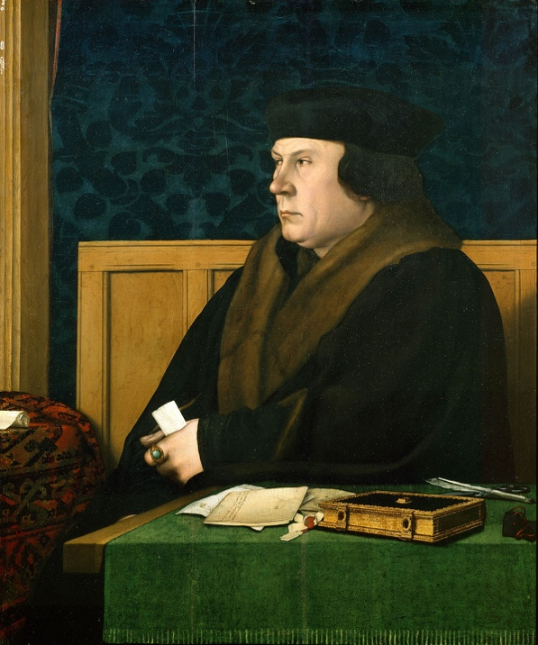
Thomas Cromwell
Thomas Cromwell was born in or before 1485 and died in 1540. He was the son of Walter Cromwell of Putney, who made his name there as a blacksmith, as well as the owner of a brewery. Despite his property and local influence Cromwell’s father drank heavily and was regularly in trouble. In 1503, Cromwell left his family in Putney to travel the continent and by 1520 Cromwell was firmly established as a London merchant and lawyer. During the next few years he came increasingly into contact with Cardinal Wolsey over legal matters, and in 1523 he entered the House of Commons for the first time, though his constituency has not been identified.
Cromwell entered Wolsey’s service in the 1520s and Wolsey was very satisfied with his work. Some time after 1526 he appointed Cromwell to his council. While Cromwell never held a senior formal position in the cardinal’s household and was rarely involved in matters of state, he increasingly supervised Wolsey’s legal affairs and exercised considerable ecclesiastical patronage. By 1529 he was recognised as one of the cardinal’s most senior and trusted advisers.
Cromwell’s anxiety that he would go down with his master was not paranoia. Wolsey had protected him from enemies, but now he faced them on his own. However, Cromwell had the option of falling back on his influence with Sir William Paulet, Wolsey’s steward for the bishopric of Winchester, As the new member of Parliament for Taunton Cromwell now had a base from which he could rebuild his career. It is possible that Cromwell took a leading role in the Commons’ campaign against the clergy which culminated in the supplication against the ordinaries in 1532. Cromwell also acted as a go-between for the disgraced cardinal and the king. It was almost entirely due to Cromwell’s intercession for Wolsey that the king eventually granted the cardinal a pardon in February 1530.
Cromwell’s entry into the king’s service is shrouded in myth. He has been credited with whispering into the king’s ear a blueprint for all the revolutionary developments of the 1530s, whereupon he was immediately offered the task of putting his grand scheme into action. In reality his progress into the royal service was somewhat more prosaic. In order to advance at court three things were necessary: the backing of a group of influential courtiers, favour from the king, and talents of obvious use in a particular task. After Wolsey’s fall he quickly set about cultivating contacts with extraordinary skill.
There is little doubt that in his support for the royal supremacy Cromwell was influenced by genuine evangelical convictions. Before he joined the court Cromwell appears to have been comfortable expressing orthodox religious beliefs. During the late 1520s Cromwell had also begun to discuss new ideas about religion with notable reformers like Stephen Vaughan and Miles Coverdale, both his close friends. Throughout the 1530s Cromwell persistently encouraged Henry to consider evangelical reforms. In early 1531, for instance, he persuaded the king to allow William Tyndale safe passage back to England only months after Henry had denounced him as a heretic. Sir Thomas More’s resignation from the council on 16 May 1532 represented a triumph for Cromwell and the reform faction at court.
From spring 1532 Cromwell was thus in a much stronger position to influence the king. Archbishop Warham’s death on 22 August 1532 removed another conservative opponent. In December Henry finally permitted Cromwell to unleash all the resources of the state in discrediting the papacy. In one of the fiercest and ugliest smear campaigns in English history the minister showed his mastery of propaganda techniques as the pope was attacked throughout the nation in sermons and pamphlets.
In April 1534 Henry confirmed Cromwell as his principal secretary and chief minister. Cromwell’s style of administration represented a marked departure from what had been before, and Hans Holbein was careful to demonstrate this in a portrait for which Cromwell had sat some time after his appointment as master of the jewels. Cromwell is depicted apparently deep in thought. He was a man drive by ideas, and his thirst for knowledge is represented by the finely bound book placed on the desk in front of him. Yet he was no unworldly academic lost in the cavities of his own mind, but a shrewd pragmatist driven to reform. Everything about the scene suggests utility. Cromwell is portrayed at work in his office, not basking in the splendour of his London home. The cap and gown he is wearing are finely made, but they are hardly the attire of an elegant courtier. Most significantly, the desk in front of him is covered with his letters, while he clutches another in his hand. Cromwell’s style of administration was very personal, and he was not always good at delegating.
The executions of Elizabeth Barton and her supporters marked a turning point in the administration of justice in the Henrician period. Cromwell controlled everything from the centre, and their fate shows that he was prepared not only to crush anyone who was perceived to be a significant threat, but also to make public examples of men and women who had become unwittingly caught up in events. Cromwell also worked in 1535 to strengthen his own control over the church. On 21 January 1535 the king appointed him royal vicegerent, and commissioned him to organize two visitations, one of all the country’s churches, monasteries and the clergy, the other limited to monasteries.
Whilst Cromwell’s success in obtaining parliamentary acceptance for the suppression of the smaller religious houses represented a significant political achievement, it also caused a clash with Anne Boleyn which threatened to undermine his position completely. Anne was angry that the proceeds of the dissolution were to be paid into the king’s coffers and not redeployed for charitable purposes. Removing Anne was unlikely to be easy, but Cromwell hatched a plan which would dispose of both the queen and the leading members of her powerful faction at court. On 30 April Cromwell arrested Mark Smeaton, one of Anne’s musicians. After rigorous interrogation Smeaton confessed to an illicit affair with her, and over the next few days the queen and several of her courtiers were rounded up and sent to the Tower. The charge of adultery was almost certainly without substance, but it was extremely effective. Cromwell had acted with ruthless determination because he was under threat.
On 27 December 1539, Anne of Cleves arrived at Dover, greeted with lavish celebrations. On New Year’s Day 1540 the king caught his first glimpse of her at Rochester. However, it was immediately obvious that she was not the beauty that Holbein had portrayed, and Henry found her physically repulsive. The wedding ceremony on 6 January at Greenwich was unavoidable and Cromwell took the blame. Cromwell’s fall cannot be contributed to any one mistake or decision, although the Cleves marriage was the single most important factor in undermining the king’s confidence in him. When he made a final desperate bid to strike out his conservative opponents Cromwell was forcing the king to decide between the two competing factions.
Until the twentieth century perceptions of Cromwell were largely coloured by religious belief. The first to attempt a full life of Cromwell, Foxe, in his Acts and Monuments, stresses Cromwell’s importance in shaping the beginning of the English Reformation. For Merriman the minister was a wholly secular figure, and as such the subservient hireling of a despotic king, with no higher motive than continuing Henry’s policy of raising the crown to ‘absolute power’. Pollard blamed Cromwell for influencing ‘Henry’s progress to despotism’. Geoffrey Elton reassessed Cromwell in 1953, arguing that Cromwell planned and introduced a new model of government, no longer controlled by the king through the royal household but directed by bureaucratic departments of state.
A public figure with a very private life, Thomas Cromwell remains strangely elusive. But he nevertheless remains a man of opposites, a pragmatic idealist who could be extremely kind or extraordinarily ruthless, depending on the occasion. It was his desire for reform, complemented by a driving ambition and a keen sense of duty, which drove Cromwell in the 1530s. Cromwell succeeded in not only enforcing the royal supremacy and strengthening the ‘imperial’ crown both politically and financially, but also in using his position to pursue his own reforming agenda.

Thomas More
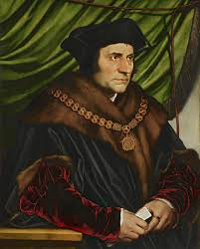
Thomas More (1478-1535) was lord chancellor, a humanist, and a martyr. More’s parents came from wealthy families with a history of service to their guilds, the city, and the crown. As More says in his epitaph on the tomb he had made for himself in the church in Chelsea, he was born not of noble, but of honest stock. The decade from the time More left Oxford about 1494 until the time he married was one of intense intellectual, spiritual, and cultural ferment and clearly set the stage for the remainder of his life. It was during this time he was brought into direct contact with the wider world or European learning through men such as Desiderius Erasmus and John Colet. An apocryphal story has it that More and Erasmus, as yet unknown to one another found themselves seated together at dinner at the lord mayor’s table, and were so impressed with each other’s wit that they exclaimed ‘You must be More or no one’ and ‘You must be Erasmus or the Devil’.
More is famous for the publication of his novel Utopia. It was a sensation and rapidly went through a number of editions. Set as a dialogue in Antwerp between a tantalizingly fictionalized More and a voyager recently returned from newly discovered lands, the work exposes the heart of More’s concerns about English and European society and parades the cautious optimism of the humanists regarding the possibilities of political and spiritual change. Utopia broadly satirizes European society for its short-sighted love of gain, its lack of true Christian piety and charity, and its unreasonableness.
More’s engaging personality, his wit, and his brilliant conversation were frequent subjects of remark among his friends. Through Erasmus’s letters, where he is depicted as a model humanist, a man of letters, whose deep and sincere piety are salted with a lively wit, More’s character became famous. His indifference to fine food, his fondness of beef, eggs, and fruit, and his carelessness about his dress were traits that supported Erasmus’s assessment that More eschewed vanity and display. More was, in effect, the model Christian layman. His household was a model of humanistic interests. The famous Holbein group sketch of his family at home in Chelsea, where they had moved by early 1526, reveals musical instruments, a relatively large number of books, and a monkey. More’s interest in educating his daughters as well as their brother was as laudable as it was rare.
More’s manor in Chelsea was a Renaissance masterpiece, and encapsulated everything about the man his contemporaries found so attractive: piety, erudition, industry, and hospitality. Suitors, guests, the poor and needy, detained heretics, even the king himself all walked through his doors. At its core, More’s position as lord chancellor was compromised from the start because he could not support the king in the very thing most pressing. Hoping that his service in other fields, including the extirpation of heresy, would suffice, and that the king’s infatuation with Anne Boleyn might resolve itself, More was led by his optimism into a struggle he could have foreseen.
More castigated Luther in 1523 as heretical, and painted Tyndale in much the same colours. But by the time he wrote against Tyndale in 1529 the heresy he combated had grown enormously in popularity and gravity. He linked Tyndale and Luther as the ‘forwalkers’ of the antichrist. Even though More criticised ignorant, hypocritical, and ineffective priests, More argued that the clergy occupied a privileged place in Christian society, not only as dispensers of sacramental grace but as bearers of correct scriptural teaching. Because they stood as successors to the apostles, they were officers of a very visible, if flawed, church.
Despite being lord chancellor, More waged a campaign against government policy on the king’s Great Matter and severed his once-friendly relationship with the king. More was asked to swear to the Act of Succession on 12th April 1534, which he refused to do because of the oath’s preamble rejecting papal jurisdiction. As a result, More was imprisoned in the Tower of London on 17 April. More’s steadfast refusal to bend to the king’s demands and the scandal of his imprisonment proved embarrassing to the government and a dangerous example to others. Various councillors, including Cromwell, made repeated attempts to cow him into submission. More’s trial took place on 1 July 1535, and its outcome was never in doubt despite the dubious ground for his indictment. When the jury had returned the expected verdict, More was at last able to discharge his conscience. He delivered a forceful and well-reasoned repudiation of temporal control over the church. Sentenced to a traitor’s death, More was executed at the Tower on 6 July 1535, his sentence being commuted to beheading out of deference to his former office. News of More’s execution shocked Europe. Tributes to More as a martyr were quickly forthcoming on the continent, where Tudor efforts to suppress outrage were ineffectual.
More’s reputation as a writer, both in Latin and English, had been long established by the time of his death, and his fame continued to grow. The later Elizabethans, removed by generations from the early Henrician struggles, were particularly appreciative of More’s wit, and ranked him with Chaucer and Plato.

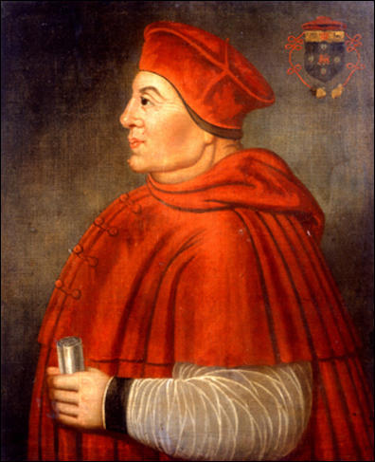
Thomas Wolsey
Thomas Wolsey (1470/71-1530), royal minister, archbishop of York, and cardinal, was the son of Robert Wolsey of Ipswich, Wolsey’s father tan a tavern in Ipswich and later traded as a butcher. Thomas’s modest beginnings later prompted biting satire from his many critics. The death of Cardinal Bainbridge at Rome in 1514 left the archbishopric of York vacant and by 5 August Wolsey had been elected. He was made a cardinal in 1515. The red hat added to his magnificence, and also had symbolic value.
Throughout the 1520s Wolsey’s household grew, as did his expenditure on building, plate and jewels, tapestries and clothing, creating the presence for which he was to be remembered. While allowing Wolsey’s evident personal interest in art and architecture, it must not be forgotten that this was more than a matter of individual taste. It exemplified the virtue of magnificence, which was a necessary attribute of any ruler or great minister. If, to the outside world, he sometimes seemed to rival the king, in personal relations he was always careful to defer to Henry.
What seems unquestionable is Wolsey’s enthusiasm for education, as manifested in his college at Ipswich and Cardinal College, Oxford. He argued that education constituted the best way to reform the clergy, and that the diversion of resources from declining monasteries to vigorous educational foundations was essential to this end. Henry and Wolsey presented themselves to Rome as vigorously anti-heretical, thereby helping Wolsey to secure a renewal of his legatine powers in the 1520s.
At the opening of 1527 Wolsey seemed at the height of his power, underlined by the magnificent banquet that he offered to all the ambassadors and nobility, and at which Henry himself turned up. By now, however, first the king’s decision to divorce Katherine of Aragon, and then the rise of Anne Boleyn, were beginning to alter the political map. According to Cavendish, when Wolsey first heard about the king’s plans, he knelt before Henry in his privy chamber for over an hour, trying to persuade him to reverse them.
In 1527, the divorce had been stalled at the curia, where the pope’s experts provided everything except what was needed, a decretal commission which would permit the case to be concluded in England. Wolsey warned Clement that if he did not co-operate the king would turn against the papacy and the Roman church, and that if he was himself dismissed because his legatine power had failed to secure the divorce, then papal power would also be diminished, but he was not believed. When the French king suggested Wolsey might be working against Henry, Suffolk and Norfolk worked on persuading the king that Wolsey had not done all that he might to secure a divorce. By early June 1529 Henry seems to have been half convinced that the cardinal was failing him.
Increasingly made the scapegoat for the king’s failure to obtain a divorce from Katherine, Wolsey was by this time deeply and increasingly unpopular. Hall records that a book containing thirty-four articles against the minister was given to the king after the failure at Blackfriars court. Anne Boleyn had now turned decisively against him, believing that he was trying to delay the divorce proceedings. The pressure exerted on the king by Anne and her supporters, together with the simultaneous failure of his foreign policy and attempts to secure the king’s divorce, combined to make Wolsey’s position untenable. In October, he was indicted for praemunire.
Wolsey’s loss of office initiated a period of several months during which he fought to recover his position and the opponents and enemies who had united to bring him down endeavoured to prevent his recovery. What did Wolsey die from? The well-known portrait shows a man grossly overweight, but although he was frequently accused of greed, this usually meant avarice for possessions. But as he aged he suffered from gallstones, jaundice, fevers, throat infections, and colic. Adult onset diabetes seems a possible diagnosis. Refusing to eat after his arrest, and his subsequent dysentery and vomiting, make a diabetic coma a likely cause of death.
Forming a judgement of Wolsey’s character, his methods and objectives demands an appreciation of the context in which he operated and of its changing parameters. Elements in his style of government are easily described – his theatricality, his blunt and colourful language, his use of threats and calculated outbursts of temper to achieve his ends.

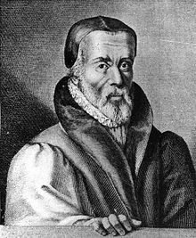
William Tyndale
William Tyndale (c.1494-1536), translator of the Bible and religious reformer was born in Gloucestershire. The first record of him, probably when he was eighteen, shows him graduating as a member of Magdalen Hall, Oxford, on 13 May 1512. Tyndale went back to Gloucestershire, and appears to have been in demand in the area as a preacher.
Tyndale went to London, already with the vocation to print the New Testament in English, and needing permission, hoped to be supported by Cuthbert Tunstall, the bishop of London. After he was denied, Humphrey Monmouth took Tyndale into his house. Tyndale now realised that there was nowhere in England to translate the Bible, so he left for Germany, probably in April 1524, supported by London merchants including Monmouth, who was in serious trouble in May 1528 because of that.
Tyndale arrived, probably late in 1525, in the safe Lutheran city of Worms, and the small printer Peter Schoeffer undertook an English New Testament, completed in 1526. This pocket-size book was printed without prologue or marginal notes. Smuggled down the Rhine and into English and Scottish ports in bales of cloth, copies circulated quickly. This immediately alarmed the English authorities and Tunstall himself sent out in October 1526 a prohibition of the book. As a grand gesture, he arranged for the burning of Tyndale’s new Testaments at St Paul’s on 27 October 1526, and himself preached the sermon on the occasion, claiming to have found 2000 errors in them.
A story told by Edward Hall in his chronicle of 1548 has been much repeated. Cuthbert Tunstall, happening to be in Antwerp, arranged with an English merchant there to go to Tyndale to offer to buy his stock of New Testaments with Tunstall’s money. Though Tyndale knew they were being bought to be burnt by the bishop, he agreed. It may well have happened: but not to Tyndale, who would never have agreed to sell New testaments for public burning.
Tyndale’s most influential book outside his Bible translations, The Obedience of a Christian Man, came on 2 October 1528. Tyndale wrote to declare for the first time the two fundamental principles of the English reformers: the supreme authority of scripture in the church, and the supreme authority of the king in the state. Tyndale was a master of English prose: his attacks make exhilarating reading. A story suggests Anne Boleyn showed a copy to her husband-to-be, who delighted in it.
Tyndale was condemned as a heretic early in August 1536, and probably the same day suffered the public, and ceremonial, degradation from the priesthood. Tyndale was brought out, and a chain was placed around his neck. He gave the cry that Foxe records, ‘Lord, open the king of England’s eyes’. Tyndale was not burnt alive: as a mark of his distinction as a scholar, he was strangled first, and then his body was burnt.

Key characters from Edward’s reign (1547-53)
- Edward Seymour
- John Dudley
- John Hales
- Robert Kett
- William Paget

Edward Seymour, duke of Somerset
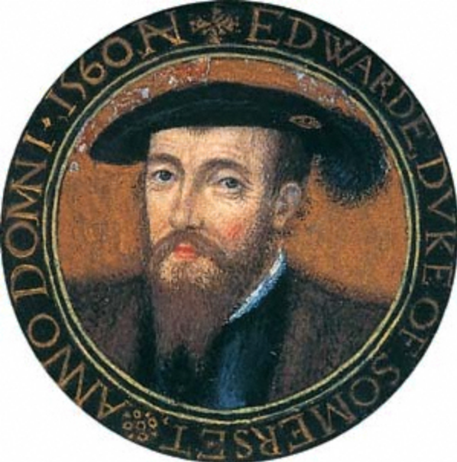
Edward Seymour (1500-1502) was the eldest surviving son of Sir John Seymour, of Wolf Hall, Wiltshire. He is said to have been educated at both Oxford and Cambridge, although there is little evidence to suggest that he was a learned man. Seymour was admitted to the council on 22 May 1537; in the same month he was among the commissioner who tried barons Darcy and Hussey for their role in the Pilgrimage of Grace. On 15 October, he carried Princess Elizabeth at Prince Edward’s baptism. Whilst the death of his sister, Queen Jane, initially diminished his influence at court, he remained prominent, particularly in military affairs, for the remainder of Henry’s reign.
Seymour not only survived the fall of Cromwell in 1540, but grew steadily more influential during the latter years of Henry VIII. In December 1543 after prolonged indecision the Scottish government broke with England and allied with France. He was appointed lieutenant-general in the north, and he demanded unconditional surrender from the Scots. He was later present at the capture of Boulogne on 14 September. Seymour is said to have secured the capture of the town by bribing the French commander. He later conducted a ‘rough wooing’ in Scotland, a campaign of systematic devastation that included burning castles, monasteries, and villages along its route.
Seymour was present at the creation of Henry’s will. Since the king may have regarded his will as provisional it was reasonable for the executors to reject the notion of collective government contained in it, and to give the new government what they saw as a more workable form. Thus Somerset established himself as Lord Protector. The magnitude of Somerset’s power, especially his use of the royal ‘we’, offended some members of the council, but their opposition was swiftly dealt with through the dismissal of Sir Thomas Wriothesley as Lord Chancellor on 6 March 1547. Authoritarian tendencies may likewise be seen in Somerset’s use of royal proclamations, on a scale which exceeded that of Henry’s reign.
Thomas Seymour felt that as Edward VI’s uncle he should have a larger role in government and demanded promotion. When Somerset refused, he married Katherine Parr, only four months after the death of Henry. Following her death in childbirth, he turned his attention to Princess Elizabeth, leading to his arrest in January 1549 and execution on 20 March 1549. Somerset’s willingness to sanction the execution of his own brother in order to protect his authority irreparably damaged his reputation.
As lord protector Somerset pursued a cautious but consistent programme of religious reform. English became the language of religious services, he introduced new liturgies, incorporated a reformed theology, allowed priests to marry, and ordered the complete destruction of religious images, whitewashing of churches, and dissolution of remaining chantries. He also introduced bold measures of social and agrarian reform. He attacked illegal enclosure, a policy intended to reduce rural poverty and at the same time to increase grain production by discouraging sheep grazing. There was harsh legislation against vagabonds which called for branding with hot irons and enslavement, although this was never enforced.
Somerset was faced by nothing less than the most extensive English risings of the sixteenth century. The western rising affected Cornwall, Devon, and Somerset, where conservative Henrician clergy resisted Somerset’s religious programme. Pacification required a substantial military force, but Somerset responded only after delays that frustrated other councillors. Meanwhile, in East Anglia agrarian rebels formed camps in July 1549 to protest against landlords who had defied Somerset’s efforts to restrict enclosure of common land and misused their control of local government. The outbreak of the rebellions brought Somerset’s social programme, especially the enclosures commission, into question. His reluctance to employ more force and refusal to assume military leadership merely made matters worse. The nobility and gentry had lost confidence in his leadership. Warwick, Southampton, Paulet, Rich, and Northampton, met in London to demand his removal as lord protector. Somerset surrendered himself on the 11th, his protectorate was dissolved on the 13th and he was lodged in the Tower of London.
The end of Somerset’s protectorate was the consequence of the disastrous and costly war with Scotland and France, opposition to his domestic reforms, growing factionalism among nobility and gentry opposed to his authoritarian leadership, and fear that his populist policies would lead to further disorder among the commons. Somerset remains controversial. Zealous contemporary clerical reformers praised him as a champion of Protestantism, but Sir William Paget, who knew Somerset well, criticized him severely for political failures. In 1900 A.F. Pollard portrayed Somerset as a liberal who believed in constitutional freedom. In the late twentieth century, historians became more critical, emphasizing Somerset’s arrogance, his aggressive and costly policy of conquest in Scotland, and his political incompetence. However, it is clear that Somerset provided strong leadership that carried England in directions pursued long after his death.

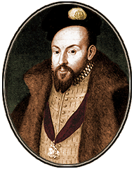
John Dudley, duke of Northumberland
John Dudley, duke of Northumberland (1504-1553) was born in London. At the time of John Dudley’s birth his father was a highly trusted servant of Henry VII. The king’s death in April 1509 led directly to Edmund Dudley’s downfall and execution on 17 August 1510. In 1521, aged seventeen, he was selected to serve in Cardinal Thomas Wolsey’s retinue during his abortive mission to negotiate peace between Francois I of France and the young emperor, Charles V. In February 1537 he was appointed a vice-admiral to keep the narrow seas. He was mostly occupied in chasing pirates.
In spite of his sea service, by 1540 Dudley had still obtained no major preferment. Dudley had been close enough to Cromwell to make it prudent for him to retire from the court for a few months. By the end of 1541 he was back at court, giving close support to Thomas Cranmer in unravelling the distasteful and dangerous story of Catherine Howard’s infidelities. In the later years of his reign, Dudley belonged to the reformist faction led by Seymour, Cranmer, and Katherine Parr. The king trusted these people, but suspected them rightly or heretical inclinations.
On 26 January 1543 he became the lord high admiral. His success was not owed to any particular opponent, but to hard political graft. He was competent, did what he was bidden, and the king trusted him. However, as lord high admiral he was a conspicuous success. In 1545-6 the structure was overhauled, the number of officers augmented from three to seven, and a professional salary structure established.
After Henry’s death, Somerset became Lord Protector. All the indications are that at that time Somerset and Warwick were working closely together in reasonable harmony. In the crisis of 1549, Somerset called upon his most trusted ally and skilled soldier, Warwick, to move against the rebel camp in Norwich during Kett’s Rebellion. Going about his task carefully and systematically he retook the city of Norwich and defeated the rebels at the so-called battle of Dussindale on 27 August. By early September Warwick was back in the capital, but he did not disband his troops, and his attitude towards the lord protector seems to have undergone a radical change. Whether Warwick was the leader, or merely the most powerful member of this rebel group is not clear, but the troops which he had retained since the Norfolk campaign proved vital to the outcome of the coup. By February 1550, Warwick had become the unchallenged leader, assuming the title of lord president of the Privy Council, and the policy of religious reform continued.
In March 1550 he sold Boulogne back to the French for the equivalent of £180,000. Later in the year he also quietly abandoned Somerset’s aggressive policy towards Scotland. Warwick also managed to restore the exchange rate, and made a start on reducing the burden of debt. The social tensions of 1549 had not gone away, but Warwick avoided his predecessor’s critical mistake. He judged that the unity of the ruling class was more important for the preservation of order. It was for this reason that he restored the Privy Council to an effective administrative body. The severe outbreaks of sweating sickness which afflicted the country in 1551 and 1552 probably helped to keep the lid on discontent. However, Northumberland was success and according to one contemporary observer, the young king would do nothing without consulting Northumberland, whom he regarded as almost a father. The responsibility for the somewhat bizarre Device for the succession has been fiercely debated. The most commonly held view is that Northumberland bullied or persuaded the dying boy to designate an heir whom he considered to be biddable and amenable to his own designs. Jane had married his son Guildford on 21 May with the king’s blessing.
Northumberland was personally unpopular, largely because he seems to have been incapable of establishing cordial relations with any of his colleagues, or indeed with anyone else apart from his wife and children. The last weeks of his life were a sad anti-climax. In the context of imminent death he took the notorious step of renouncing the Protestantism which he had long been promoting. Northumberland’s appeal for clemency fell on deaf ears. Having extracted every propaganda advantage which he was willing to give, Mary had him executed at Tower Hill on 22 August. At his death he warned the crowd to remain loyal to the Catholic Church. Beyond his own family few tears were shed for Northumberland and the ‘black legend’ of his pride, greed, and tyranny in power developed almost immediately, not least because he became a convenient scapegoat for all those who had accepted Jane, and because Mary had to find excuses for those whom she wished to employ.

John Hales
John Hales (1516?-1572) was an administrator and Member of Parliament. Largely self-taught, by 1535 he had come into Thomas Cromwell’s service. After the dissolution of the monasteries Hales acquired confiscated ecclesiastical property in Bishopsgate, London and extensive lands around Coventry.
In 1547, with the accession of Edward VI, Hales became justice of the peace for Middlesex and Warwickshire, and an MP for Preston. While in parliament, he became an outspoken champion of social, economic, and religious reform. In June 1548, Hales was appointed by Protector Somerset to a six-member commission to investigate enclosure practices in the midland counties. When rioting in support of the commission broke out in Buckinghamshire, Hales was blamed by the earl of Warwick for inciting rebellion. With the fall of Somerset in October 1549, Hales was sent to the Tower of London.
Hales was sometimes called Club-foot Hales, supposedly because of a walking impairment he received from an accidental, self-inflicted dagger wound to the foot.

Robert Kett
Robert Kett (1492-1549) was a rebel, Little is known of Kett’s early life. Although his immediate family was no longer gentle, he was a man of some wealth. The shards of evidence that exist suggest that Kett exercised a role and authority in his immediate surroundings commensurate with his wealth and that known to have been exercised by the middling sort of the period.
In July 1549 rebellion broke out in Norfolk, to which Kett lent both name and leadership. The risings beginnings have traditionally been dated to celebrations to commemorate St Thomas Becket in July. Among the enclosers attacked there was John Flowerdew. Flowerdew, a successful lawyer, was locally unpopular because at the dissolution he had partially demolished the abbey at Wymondham which served also as the parish church. When Flowerdew paid his attackers to throw down Kett’s enclosures, Kett was said to have agreed to their destruction and to have offered himself as leader of the protesters. The number of protesters has been estimated between 16,000 and 20,000.
The scale and discipline of the rising have been attributed to the qualities of Kett’s leadership. Most famously, Kett was said to have dispensed justice beneath a tree, which came to be called the ‘oak of reformation’ on both disorderly followers and unpopular local gentlemen. Kett’s refusal of a royal pardon and the defeat of the royal army at the end of July marked a decisive change in the politics of the revolt. Late in August the arrival of another royal army, under the command of the earl of Warwick, led to his defeat after a fierce and bloody battle and to widespread repression. Kett was captured the day after the battle. By early September he and his brother William were prisoners in the Tower of London. On 7 December 1549 Kett was hanged from the walls of Norwich Castle.

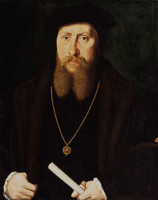
William Paget
William Paget (1505/06-1563) was a diplomat and administrator. Paget went to Trinity Hall, Cambridge, during the mastership of Stephen Gardiner. In June 1528 Paget suffered an attack of sweating sickness, but recovered to take up his first appointment as one of the four clerks of the signet, and in 1529 he was elected to parliament for an unidentified seat. By 1536 Paget was well established and starting to accumulate a gentleman’s estate. On 10 August 1540, following Cromwell’s execution, Paget was appointed clerk of the privy council, with the duties of maintaining its journal and engrossing bills. On 15 July 1541 he was also appointed clerk of the parliament.
Paget was appointed in April 1543 as one of the two principal secretaries of state and admitted to the privy council. In January 1544 he was knighted. Meanwhile Paget had become one of the most powerful office-holders in the kingdom. He spoke for the monarch, controlled considerable patronage, and was the linchpin both of Henry’s diplomatic correspondence and the national intelligence network. It was Paget’s job to sift out from the intercepted mail and oral communication real plots from imaginary or invented ones, to distinguish reliable from double agents.
When Henry was in his last illness Paget conversed with him night after night, and he became a key figure in the politics surrounding Henry’s death. The king looked to him to secure the condemnation of the earl of Surrey for high treason. It was Paget who made an agreement with Edward Seymour, earl of Hertford, in the gallery outside the death chamber, that the provisions in Henry’s will for a council of state should be amended to admit the earl as protector for his nephew and that in return he would be Seymour’s principal adviser. It was Paget also who kept the notes of the promotions and grants that Henry was alleged to have planned and which were implemented within days of the king’s death.
In 1547 Paget was made both a knight of the Garter and high steward of Cambridge University. Over time, however, Paget found the protector heeding him less and less. By 1548 he was increasingly concerned for England’s position both abroad and at home. Paget avoided publicly defecting to Warwick, but although he was at Windsor with Somerset, the king, and archbishop Cranmer on 6 October, he was already preparing to mediate and was principally responsible for the conciliatory wording of the letter sent by the protector to the London lords.
Paget hoped that Warwick would pay more heed to the council than Somerset had done. Warwick certainly did restore the council to a central place in government, and the rules about the signing of the warrants which had been established at the end of Henry VIII’s reign were reinstituted.
Mary appointed Paget to her privy council, and honoured hum with the role of carrying the sword of state before her at her coronation, but she did not fully trust him. Paget was the principal negotiator of Mary’s marriage to Philip of Spain in the latter months of 1553. Philip found Paget’s temperate advice essential.
Despite general expectations that Elizabeth would give him a post, the new queen set Paget aside. His illness was a convenient excuse and he remained undisgraced, offering advice from his sickbed to Sir William Cecil and Sir Thomas Parry about peace negotiations. William Paget’s subsequent reputation has always been that of ‘politique’, albeit one endowed with considerable ability and presence. Historians disagree about whether he should be seen as a statesman or merely a pragmatist. But his political and administrative skills have been usually, though not invariably, acknowledged.

Key characters from Mary’s reign (1553-58)
- Edmund Bonner
- Edward Courtenay
- John Knox
- Lady Jane Grey
- Reginald Pole
- Simon Renard
- Thomas Wyatt

Edmund Bonner
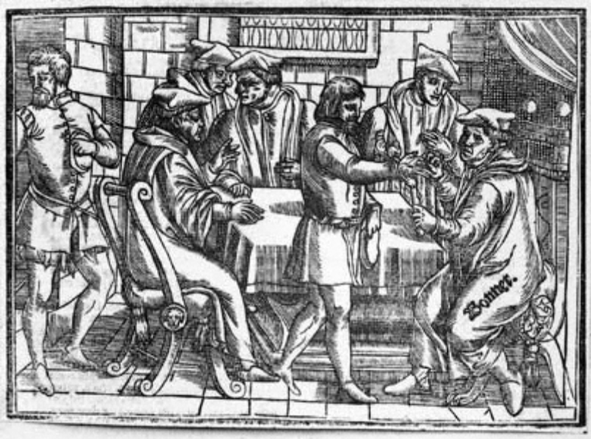
Edmund Bonner, bishop of London, was probably born in Hanley, Worcestershire. After training as a lawyer, by 1529 he was a chaplain to Cardinal Wolsey. Wolsey’s downfall in 1530 did not arrest Bonner’s progress, and he became a loyal servant to Thomas Cromwell. He was known for his anti-papal sentiments, and it was only after Cromwell’s fall in 1540 that he became more clearly associated with the conservative elements of the Henrician reforms.
In the Edwardian regime, Bonner remained broadly conservative in doctrine. Defying the king, he preached in support of the doctrine of transubstantiation, and omitted to emphasize the authority of the king. He was committed to Marshalsea prison after enquiry by two royal commissions was deprived of his bishopric on 1 October 1549. He remained confined in the Marshalsea, without allowance for food or clothing, for the remainder of Edward’s reign.
Edward VI died on 6 July 1553 and Bonner was immediately reinstated as bishop of London. The altars of his cathedral had been torn down during Edward’s reign, and he immediately set about having them restored. Bonner enjoyed the royal favour from the outset, and in January 1554 he was sent as one of the queen’s ambassadors to meet Phillip of Spain at Portsmouth. Bonner commenced a visitation of his diocese on 3 September, ending on 5 October 1555. Bonner’s visitation was a model of thoroughness in its inquiries into the morals, beliefs, and practices of the people of his diocese.
It was during the Marian years that Bonner gained a reputation for fierceness in his prosecution of heresy, earning him the title Bloody Bonner. His diocese had a long history of Lollardy, and the capital tended to draw itself to those most active in promoting new ideas. However, in the early years of the reign Bonner was reluctant to proceed in this matter with much vigour. His image as a bloody persecutor of the godly derived from his later actions, after his earlier misgivings had been overcome by pressure from government. Of 282 burning recorded in this period, 232 took place in the dioceses of London, Canterbury, Norwich, and Chichester; half the burnings in these four dioceses took place in Bonner’s see of London.
The reputation of Bonner as persecutor of heretics was widespread in the reign of Elizabeth I. There is a story that when the bishops were presented to the new queen after her accession she declined to offer him her hand to be kissed on account of his actions in the previous reign. He was offered the oath of supremacy on 30 May, which he refused, and was deprived of his bishopric.
The image of Bonner as a cruel, even sadistic, man is drawn largely from Foxe’s interpretation of his actions. While it is true that he could be short-tempered, insolent, and tactless, he was also an able lawyer, quick-witted in argument. He seems to have become more violent as he grew older. It is possible that some of his reported excesses of behaviour were intended to frighten heretics into recantation and so to save them from the flames.
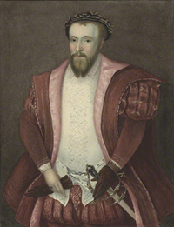
Edward Courtenay
The great-grandson of Edward IV, Edward Courtenay (1526-56) was regarded as a serious dynastic threat. In November 1538, the twelve-year-old joined his mother and father in the Tower of London, and he was specifically excluded from the pardon at the beginning of Edward VI’s reign.
He was released from the Tower immediately on Mary’s entry to the capital on 3 August 1553. He won plaudits for his civility and bearing, and there was much enthusiasm for his intellectual accomplishments and musical interests. He was the obvious candidate for those who wished Mary to marry within the realm. During, his imprisonment he had befriended the new Lord Chancellor, Stephen Gardiner, referring to him as his father. However, Mary had no intention of marrying him and she saw very little of him in the first few weeks of the reign. Mary harboured suspicions that he was consorting with loose women.
In October, Sir James Croft, Sir Peter Carew, Sir Thomas Wyatt, and the duke of Suffolk hatched a conspiracy for multiple uprisings against the Spanish marriage in the West Country. A part of the plot included replacing Mary with Elizabeth who would then marry Courtenay. Wyatt’s defeat put the earl in a highly exposed position once again. A man ‘born to spend his life in prison’ (MacCulloch) he returned to the Tower on 12 February 1554. His years of imprisonment had not equipped him for politics, and his attempts to play both sides led to his being widely distrusted and politically ineffective.

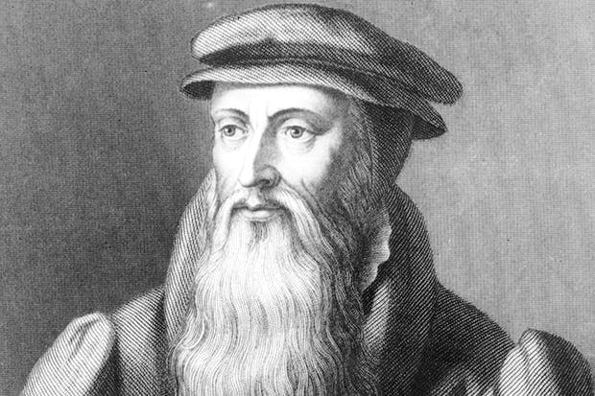
John Knox
John Knox (c.1514-1572), religious reformer, was born in Haddington and studied at St Andrews University. Although Mary’s regime strongly encouraged the departure of all foreign Protestants, Knox did not immediately leave the country in 1553. He returned from London to the north in the final months of the year, but was too well known to stay there long. Early in the New Year, he went into exile. Knox’s four-year exile from Marian England crystallized his ideas and he developed much of the radicalism traditionally regarded as the chief characteristic of his thinking.
During winter 1557-8 Knox used his enforced leisure in Dieppe to write. He had been exiled from Frankfurt by the followers of Richard Cox, and he composed his most famous tract, The First Blast of the Trumpet Against the Monstrous Regiment of Women. It is the best-known, and least understood, of Knox’s writings. The thinking of the English exiles, especially those based in Geneva, had been radicalized in response to the burnings of Protestants by the Marian regime which had begun in 1555. In the sixteenth century the assertion that women should not wield political authority at any level was neither novel nor particularly controversial. Several aspects of Knox’s book, however, caused a considerable stir when it was published. Knox presented his case in stark black and white terms, permitting no idle ground. He declared it was the law of God and of nature that women must not rule. Most unusually, instead of relying exclusively on the Bible, Knox cited as wide a range of authorities as he could muster to support this claim.
Its main target was Mary Tudor, the Roman Catholic queen of England. Scotland was also experiencing female rule with the regent, Mary of Guise, governing on behalf of her daughter, Mary, queen of Scots. Knox’s arguments were regarded as a direct attack upon each of these women. In one sense this was not what he had meant, as he later tried (unsuccessfully) to explain to both Elizabeth and Mary, queen of Scots. The predicament arose because of Knox’s general tendency to get carried away by an idea in the heat of writing, without pausing to consider all of its ramifications. Towards the end of his book he poured forth his denunciation of Mary’s idolatrous reign, and was surprised when later queen Elizabeth did not accept that he had written primarily against her half-sister.

Lady Jane Grey
Lady Jane Grey, noblewoman and claimant to the English throne, was the eldest surviving child of Henry Grey, and Frances, daughter of Charles Brandon and Mary, younger sister of Henry VIII. Jane was thus a cousin of Edward VI and about the same age, being born in Leicestershire in October 1537. The circumstances surrounding Jane’s life and death inevitable made her an icon as a protestant martyr. Probably the only completely reliable and dispassionate contemporary account of her last days, however, is to be found in the so-called Chronicle of Queen Jane, written by an anonymous eyewitness.
Jane showed early promise of exceptional academic ability, and when she was sent to join the household of the widowed queen Katherine Parr in the spring of 1547 and was able to benefit from the educational opportunities then available in court circles for girls as well as boys. Jane’s reputation for scholarship grew as she began to communicate with various German and Swiss Protestants.
After the fall of Protector Somerset, the duke and duchess of Suffolk threw in their lot with John Dudley, duke of Northumberland. Then, as the king’s health began to fail, they connived with the plot being laid to exclude the princesses from the succession. In order to secure his hold on power, Northumberland had arranged with the Suffolks that Jane should marry his own son Guildford Dudley. Jane at first tried to resist, but her protests were overborne and her submission extorted ‘by the violence of her father, who compelled her to accede to his commands by blows’.
The marriage took place on 21 May 1553 at Durham House, and Northumberland soon told her that the king was dying and she must hold herself in readiness for a summons at any moment, because he had made her his heir. According to her own account, Jane did not take this seriously. After Edward died on 6 July, Jane was informed he had been nominated to succeed him. According to her own account, later given in a letter to queen Mary, Jane was ‘stupefied and troubled’ by the news, falling to the ground weeping and declaring her ‘insufficiency’.
Nevertheless, Jane was proclaimed queen at the Cross in Cheapside. It was noticeable that there were no signs of rejoicing over the new reign, none of the usual bonfires and bell-ringing. After Mary had defeated Northumberland, she was willing to be merciful with Jane, telling a disapproving imperial ambassador that her conscience would not allow her to have Jane put to death. However, after Thomas Wyatt’s rebellion, in which the duke of Suffolk was foolish enough to take part, Jane’s fate was sealed. Although the rebellion was principally directed against Mary’s forthcoming marriage to Philip of Spain and no one ever suggested that Jane had any foreknowledge of it, her very existence as a possible figurehead for Protestant discontent made her an unacceptable danger to the state.
Jane died on 12th February 1554. Mounting the steps of the scaffold, she turned to address the small group of onlookers. She admitted she had done wrong in agreeing to accept the crown. She asked those present to witness that she died a good Christian woman and to assist her with their prayers while she was alive.

Reginald Pole
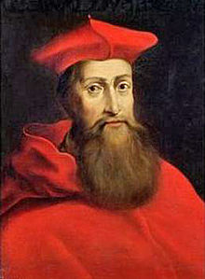
Reginald Pole (1500-58), cardinal and archbishop of Canterbury was born in Staffordshire. Pole went to Oxford, where he was a member of Magdalen College from 1512 until 1519 and in 1521 he went abroad to Padua. He arrived back in England in 1527, though in 1529 he was sent to Paris in order to secure a favourable opinion from the university doctors on Henry’s divorce. Pole would later make it appear that he had tried to avoid the assignment, but the evidence does not support his version. In fact Pole succeeded completely in his errand and returned home in the summer of 1530 to great expectations. Probably in May 1531 Pole gave Henry an analysis of the political difficulties in the way of a divorce, and he left England again January 1532 without promotion. Pole was soon claiming that he had given the king his negative opinion about the divorce, but this seems unlikely.
People quickly saw Pole’s potential, especially the imperial ambassador, Eustace Chapuys, who tried as early as 1533 to persuade the emperor of Pole’s usefulness against Henry. Chapuys suggested that Pole marry Princess Mary and draw on his family’s base of support in Wales. It was probably this dynastic threat which gave most concern to Henry. On 22 December 1536 Pole was made a cardinal and shortly thereafter, in February 1537, appointed legate. The pope wanted Pole to assist the Pilgrimage of Grace.
Pole was made Archbishop of Canterbury under Mary, although it took him a year to return to England after she became queen. However, on 30 November 1554, Pole formally reconciled the realm to the papacy. In 1554 and 1555 Pole was involved at the trial and condemnation of Archbishop Cranmer, although it was Mary and not Pole who insisted on Cranmer’s death.

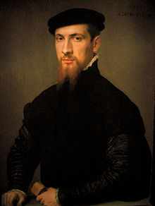
Simon Renard
Simon Renard (1513-1573) was a diplomat who served under queen Mary as the imperial ambassador, He later claimed that his skill was instrumental in dividing the English council and facilitating Mary’s victory. Whether this was true or not, Renard quickly established a confidential relationship with the new queen and became her most trusted adviser. In September 1553 Renard embarked upon his most spectacular and successful negotiation, the promotion of a marriage between Mary and Philip of Spain. There was widespread resentment to this in England, though Renard had some allies on the council, notably Lord Paget.
This was the high-water mark of Renard’s influence. He failed to persuade Mary to execute either Edward Courtenay or Princess Elizabeth for their complicity in Wyatt’s rebellion.

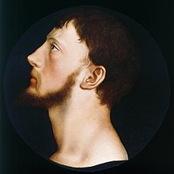
Thomas Wyatt
Sir Thomas Wyatt (b. in or before 1521, d.1554) soldier and rebel, was the only surviving son of Sir Thomas Wyatt. By the beginning of November 1553 rumours were circulating of Mary’s desire to marry Philip. Several among Mary’s privy councillors, led by the lord chancellor, Stephen Gardiner, bishop of Winchester, promoted the alternative candidacy of Edward Courtenay, earl of Devon, recently released from the Tower, but Mary never seems to have seriously considered this feckless youth. Wyatt was among the group of disaffected gentlemen who turned to the idea of a military coup to avert the marriage. He was present at a meeting in London on 26 November with other members of the Edwardian establishment. Wyatt was not their leader, and the instigator of the conspiracy was more probably a different gentleman.
By 22 December the conspirators decided on a plan for a fourfold rising scheduled for Palm Sunday. According to the later indictments of the rebels, the plotters planned to marry Courtenay to Princess Elizabeth, and to place them on the throne, but it is not clear how well developed this plan was, or even how far it commanded assent among the rebels. Throughout his rising Wyatt maintained that he meant no harm to Mary, that his rising was only for resisting of strangers, and for the queen to appoint better privy councillors. This may well have been, as the Catholic sources suggest, a deliberate ruse to maximize his movement’s appeal, but it might have reflected Wyatt’s uncertainty about what he was to do when he captured the queen’s person.
The conspirators undoubtedly had some contact with Courtenay and Elizabeth. Elizabeth, whose ties to the conspiracy the government was particularly keen to disentangle, was careful to commit nothing to paper, but apparently sent a message of probably unspecified goodwill towards Wyatt. However, the Marian establishment found out about the planned rebellion, and on 21 January, as news broke in the capital of the rising in Devon, Wyatt had no choice but to act quickly. Norfolk was sent to crush Wyatt, but he ignored warnings about the likelihood of betrayal by his own troops. As Norfolk advanced against Wyatt, one of his captains urged the troops to join the rebels.
Wyatt never had more than 3000 men and he had not succeeded in generating a large-scale popular mobilization. There was no mass insurgency in the capital, either because the Londoners had rallied around the queen after her dramatic bid for their loyalty in her appearance at the Guildhall on 1 February, or because the aldermen had taken effective police measure against the rebels, or because the citizens feared looting.
At Wyatt’s trial he stood firm in the claim that he had not conspired the queen’s death. Wyatt went to the block on 11 April 1554. His scaffold speech showed the penitence customary on such occasions, as God had given his judgement against the rebellion, but he was determined to exculpate Courtenay and Elizabeth. After his death, many dipped their handkerchiefs in Wyatt’s blood; and within a few days his head had been stolen as a martyr’s relic.
It is true that Wyatt’s propaganda played down Protestantism. When one of his supporters expressed the hope they would restore Protestantism, Wyatt told him ‘you many not so much as name religion, for that will withdraw us the hearts of many.’ It is also true that many protestants refused to support the rising. Wyatt’s reticence about the cause of religion was probably tactical. He was part of a co-ordinate movement which hoped to mobilize support in areas not normally regarded as being in the vanguard of Protestantism. Furthermore, most of his fellow conspirators were decidedly evangelical in outlook.

Key characters from Elizabeth’s reign (1558-1603)
- Bishop John Jewel
- Bishop Edmund Grindal
- Bishop James Pilkington
- John Foxe
- Matthew Parker
- Robert Dudley
- William Cecil

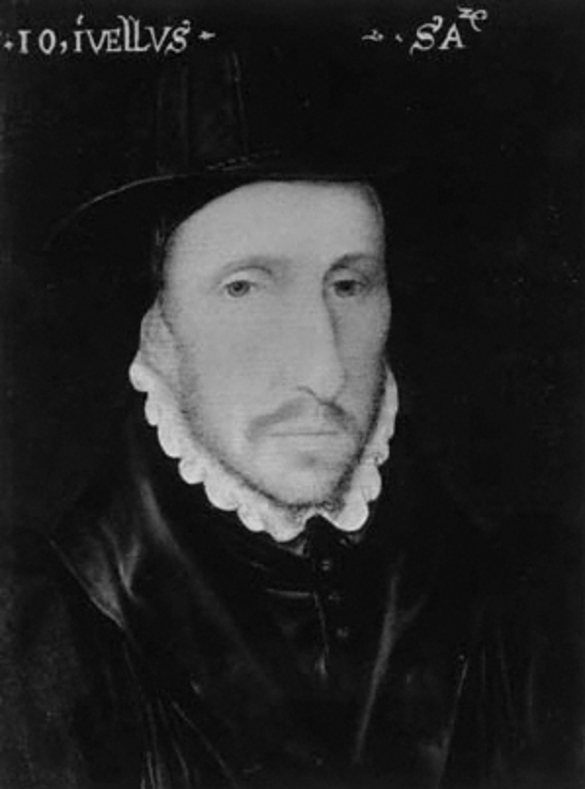
Bishop John Jewel
Bishop John Jewel was renowned for applying himself to his studies and his career with a single-minded zeal that gained him his reputation and a number of enemies. It is not surprising that there were those who felt threatened by this self-disciplined, serious minded young humanist who reputedly rose at four and was occupied with his books until ten at night.
In exile in Zurich during Mary’s reign, Jewel returned to England after her death, arriving in London on 18 March 1559. On 21 January 1560, he was consecrated as Bishop of Salisbury. He proved to be an exemplary bishop. Central to his work was preaching. He even had two portraits in his bishop’s palace inscribed with the biblical phrase “woe to me if I do not evangelize”.
There was more than a touch of the ascetic about Jewel. Unmarried, lean in body and face with a thin beard, probably arthritic, prone to sickness and personally ambitious, in a previous age he might have made a superb monk. His devotion to the Church, his studies, and his willingness to be spent in the cause of reform often left him exhausted and no contributed to his early demise in 1571.
Jewel’s most famous publication was an official defence of the newly established Elizabethan Church, co-ordinated by secretary of state William Cecil and both aided and approved by Archbishop Matthew Parker in the face of the rumours circulating on the continent about the new church and its clergy. It was published in 1562 and it was called the Apologia pro Ecclesia Anglicana. The Apologia was a brief Latin treatise in which Jewel defended the Church of England against the charge of heresy and systematically set forth the grounds of its doctrine and practice against the church of Rome.

Bishop Edmund Grindal
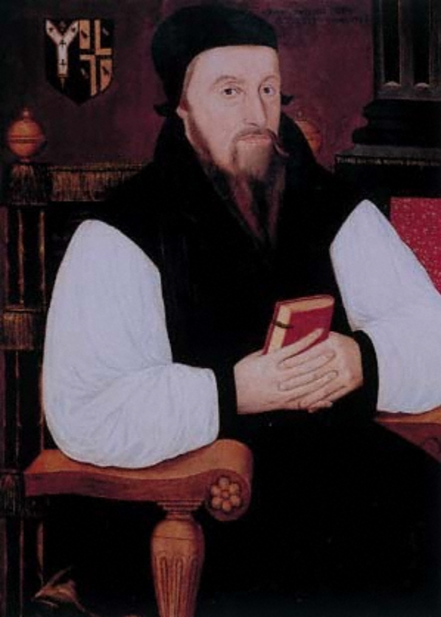
Edmund Grindal was born in either 1516, 1517, or 1520, and died in July 1583. Like many talented boys, he escaped his impoverished northern environment in Cumberland by climbing the educational ladder into an ecclesiastical career in the more prosperous south.
In Mary’s reign, he went into exile in Strasbourg, where he arrived no later than August 1554. He was almost certainly with Richard Cox and spent time helping Foxe compile his book of martyrs. He arrived back in London on the very day that Queen Elizabeth was crowned on 15 January 1559. Grindal preached at court in Lent 1559 and played a leading role with other exiles in the set-piece disputation against the bishops in Westminster Abbey. On 22 July 1559 he was nominated as bishop of London, after Edmund Bonner had been forced out of office.
Grindal was unworldly and unmarried and spent the years of Elizabeth’s reign trying to balance his own private and more extreme Protestant beliefs with his duty and role as a bishop in the Anglican Church. He was concerned with two major sticking points from the Elizabethan Religious Settlement: crosses and altars. After much deliberation, Elizabeth kept a cross in her private chapel, but altars throughout the country were pulled down.
In January 1565 it was decided – whether by the queen herself, or Cecil, or Parker is far from clear – to clamp down on nonconformity, especially in respect of ecclesiastical vestments and other items of prescribed clerical costume, principally the surplice and the biretta, the ‘pope’s attire’ according to those who denounced these concessions to unreconstructed religious conservatism. 37 London clergy who refused conformity were suspended, including some of Grindal’s choicest clergy.

Bishop James Pilkington
James Pilkington (1520-1576) was the bishop of Durham in the reign of Elizabeth I. He was in exile during Mary’s reign, but returned to England in July 1559, when he was appointed master of St. John’s College, Cambridge. He was a prolific author and preacher, both at Cambridge and London. He preached sermons before the queen and at Paul’s Cross. He contributed to the prayer book of 1559, the Thirty-Nine Articles, and the Book of Homilies.
In 1562 he was consecrated as bishop of Durham. His arrival in Durham was undoubtedly something of a culture shock. He complained bitterly to Cecil about the disordered state of the diocese, comparing himself with biblical characters forced into exile or obliged, against their will, to carry out impossible tasks. Issues that faced him including Catholic survivalism, pluralism, and non-residence.
Despite his acceptance of high office in the Elizabethan church, Pilkington was uneasy about certain aspects of the settlement of 1559 which did not satisfy his protestant convictions. Pilkington probably saw his chief contribution to Protestantism being made by means of education, which he always promoted earnestly.

John Foxe
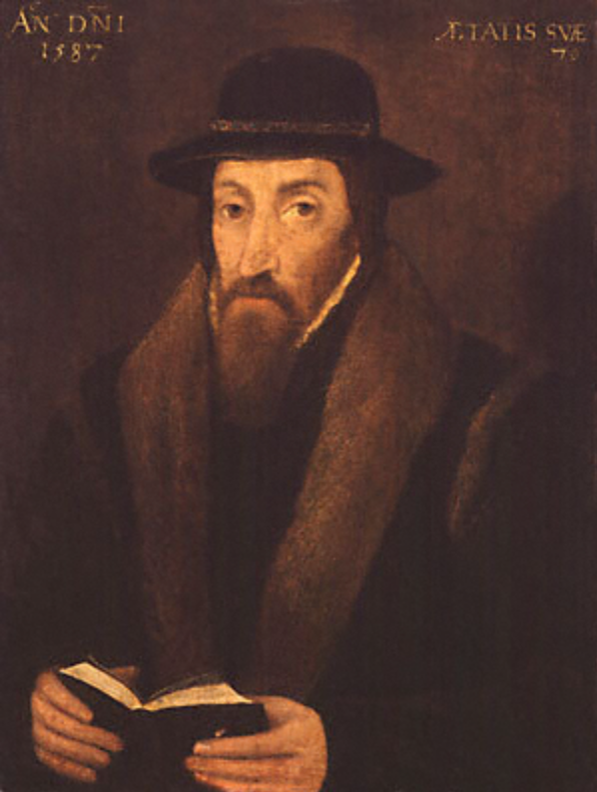
John Foxe, martyrologist was born in Lincolnshire in either 1516 or 1517 and died in 1587. Fixe went to university at Oxford, where he became part of a network of Oxford evangelicals. After university, Foxe became a tutor to the children of the duchess of Richmond, which facilitated his entry into the ranks of England’s protestant elite. His lifestyle of teaching and writing came to an end with Mary’s accession in July 1553.
In the late winter of 1553, Foxe and his pregnant wife emigrated to Strasbourg, and later to Frankfurt. The English exiles in Frankfurt had split into two factions: one, headed by John Knox and a second faction, led by Richard Cox. Foxe supported Knox.
Foxe is most famously known for his martyrology, Acts and Monuments (immediately and universally referred to as Foxe’s ‘Book of Martyrs’) which was first published in March 1563. The bulk of the work covers church history from John Wyclif until the accession of Elizabeth but an introductory section provides an overview of church history, particularly from the year 1000. The work was large because of the range of sources on which it was based. Foxe drew extensively from protestant authors like Bale and Flacius, the writings of the Marian martyrs, and an enormous amount of oral testimonies and eye witness accounts. Foxe’s most important archival sources were the London episcopal registers, though he also drew on ecclesiastical records. In 1563, this range of sources was unprecedented in English historical writing.
The second edition of Acts and Monuments was printed, in two volumes, in 1570. It was rewritten so thoroughly as to constitute a separate and distinct work. Although English history still predominated, a real effort was made to cover the events in Europe. Foxe’s second edition also far surpassed any previous English historical work in the range of medieval chronicles and histories on which it was based. Archbishop Parker saw an opportunity to use Foxe’s work to demonstrate his own interpretation of history in which the English church was corrupted by the papacy. The most significant development in Foxe’s use of sources was his greater reliance on oral evidence. Some of this was gathered by Foxe himself, who pumped even casual acquaintances for information. The 1570 edition was rigorously proof-read and impeccably cross-references. Even more remarkably, isolated errors were corrected by hand in the individual copies before they left the print shop.
In his lifetime, John Foxe was one of the most prominent members of the Elizabethan church. He is most remembered for his Book of Martyrs, and even though no sixteenth-century book could hope to be read by more than a minority of the population, the diffusion of Foxe’s work into the parish churches got seriously underway in the seventeenth century. It would be rash to forget that Foxe was not only himself an assiduous researcher into oral and documentary sources, but he was in addition able to draw on the work of other scholars and on networks of informants. But it would also be imprudent to overlook that Foxe was an accomplished rhetorician with powerful motives for shaping and editing his materials. It was rare, though not unknown, for him to invent material. But he edited, amended, and even rewrote his sources with alacrity. Foxe presents crucial evidence and tells one side of a story which must be heard. But he should never be read uncritically, and his partisan objectives should always be kept in mind.

Matthew Parker
Matthew Parker (1504-1575), was archbishop of Canterbury during Elizabeth’s reign. Parker went to Corpus Christi College, Cambridge, probably in 1520. There is no evidence that Parker went to university as anything other than a traditionally pious Catholic. The summer of 1521 saw the beginning of the English campaign against Martin Luther, though this development did not deter the growth of a small and clandestine Cambridge community interested in Lutheran ideas. There were a few in Cambridge who were attracted to new ideas, and this religious position has been designated by J.F. Davis as ‘evangelism’. This included justification by faith alone, primacy of scripture, and stressing the importance of preaching. Evangelism might well provide a fitting definition for Parker’s beliefs in the late 1520s.
Parker came to the attention of queen Anne Boleyn, then arguably the leading English lay evangelical, and her circle. He was called to court in March 1535 and was thereafter appointed one of the queen’s chaplains. In a conversation that occurred only days before her arrest in May 1536, she commended Elizabeth to Parker’s spiritual care. Whatever the real significance of Anne’s words they were the last she addressed to him, and a powerful sense of obligation, to both mother and daughter, stayed with hi, for the rest of his life. Parker survived Anne’s fall, and in February 1537 he was ordered to court to be admitted one of the king’s chaplains.
In 1547, aged forty-three, Parker took a momentous personal step. Since about 1544 he had been living with Margaret Harleston, and in June 1547 they married, well before the legislation of December 1549 legalizing clerical marriage. They had four sons. Then in June 1549, while visiting Norfolk, Parker was caught up in Kett’s rebellion. Entering the rebel camp on Mousehold Heath outside Norwich he courageously preached submission to the authorities for the sake of the common good.
Although Parker had no real involvement in the duke of Northumberland’s attempt in 1553 to divert the succession away from Mary Tudor to Lady Jane Grey, he suffered as a married clergyman from the repeal of the Edwardian religious legislation. Both queen Mary and Reginald Pole, archbishop of Canterbury, died on 17 November 1558. On 9 December, Sir William Cecil, the new queen’s principal secretary, sent Parker an informal summons to London. Parker knew what this overture portended, and in a lengthy reply declared that his abilities were not commensurate with such responsibilities. Cecil again ordered Parker to London in two further letters; his compliance is suggested by his preaching before the queen at Paul’s Cross on 10 February 1559.
Archbishop Parker has all too often been represented as a man whose passionate early concern for reform fizzled out somewhere along the road, leaving behind a wary determination to find a middle way between the extremes of Catholicism and some form of Protestantism. In fact he retained impeccable reformist credentials. Although he did not go into exile under Mary and return ‘radicalized’, as many did, he was well informed about continental religious developments. For him, as his colleagues, the Elizabethan church settlement represented a starting point, not a terminus. The Edwardian regime provided two alternative models to be followed. One, personified by Cranmer, stood for gradual protestant reform, willing to make concessions initial to conservative opinion. The other, represented by John Hooper, stood for rapid and decisive change, without concessions to popery.
The tensions between them erupted in the vestiarian controversy of 1565-6. In fact there was always a danger that, in attempting to please everybody through equivocation and compromise, the Elizabethan regime would end up pleasing nobody. Parker is usually hailed as one of the chief architects of the Elizabethan religious settlement. From the Roman Catholic side the government faced the threat of papal excommunication, the opposition of the remaining Marian bishops, and the possibility of foreign invasion which might coincide with domestic risings on behalf of the old faith. On the protestant side, where memories of recent martyrdoms were fresh, the ranks were divided between men, like Parker himself, who had lived in retirement under Mary, those who had reluctantly conformed to Catholicism, those who had belonged to underground protestant congregations, and those who had gone into voluntary exile. Though undoubtedly protestant by education and conviction, Elizabeth was conservative in her religious sympathies.

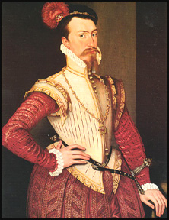
Robert Dudley, earl of Leicester
Robert Dudley (1532-1588), courtier and magnate, was the fifth son of John Dudley, duke of Northumberland. He was also queen Elizabeth’s favourite. Dudley is not seen in the public record until 1549, when he and his brother Ambrose Dudley accompanied their father in the campaign against Kett’s rebellion. He was arrested after Mary came to power and in spring 1554 the numerous prisoners from Wyatt’s rebellion joined Dudley in the Tower, among them Elizabeth. Elizabeth was only there for two months and under quite tight restrictions. Contact between Dudley and Elizabeth cannot be ruled out, but its significance may be doubted.
It was only in April 1559 that Robert Dudley’s peculiar relationship to Elizabeth began to attract comment. This relationship – which defined the rest of his life – was characterized by her almost total emotional dependence on him and her insistence on his constant presence at court. Dudley did not become a member of the privy council until October 1562.
The sudden death of his wife in September 1560 was almost as important as Elizabeth’s favour in shaping his future. No obvious explanation as to how she came to break her neck could be found, and whil some worried about suicide, the verdict of the coroner’s jury was death by misadventure. Dudley retired to Kew in a state of shock, provided his wife with a full funeral, and went into mourning for six months. His letters reveal his concern to have her death fully investigated, but possibly more with an eye to the damage it might do to him that from grief at her loss. The inconclusive verdict on his wife’s death haunted Dudley for the rest of his life. Even if innocent of her murder, he may well have been guilty of abandoning her.
There is absolutely no evidence that Elizabeth and Dudley were ever lovers – or that Elizabeth lost her virginity to anyone. Nevertheless, there were strong personal objections to Dudley as a potential husband. These were less birth and his father’s treason, more that marrying someone who was technically her servant and whose wife had just died in compromising circumstances would tarnish if not destroy Elizabeth’s reputation.

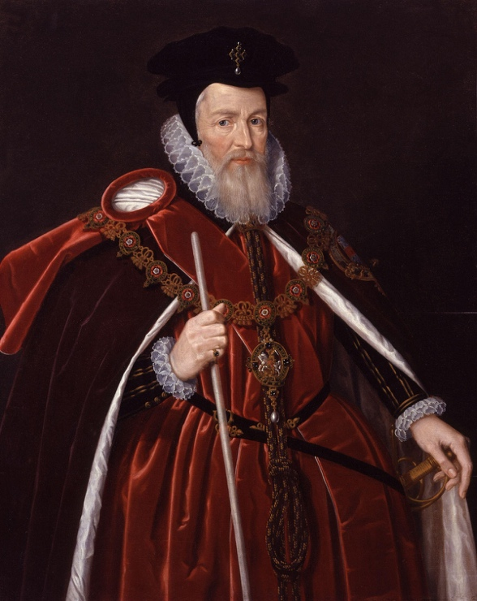
William Cecil
William Cecil (1520/21-1598) was royal minister to queen Elizabeth. He entered St John’s College, Cambridge, in 1535. These Cambridge years, when the university was full of the ferment of humanist learning, shaped Cecil’s thoughts about political society and his personal role in it.
By 1558 a personal relationship of confidence, trust, and mutual respect had grown up between Cecil and Elizabeth. On 17 November 1558, the first day of her reign, she appointed him secretary of state and he took the lead in conducting all public business. Cecil played an important role in the first two pieces of government business, the making of peace with France and Scotland and the re-establishment of a reformed polity in the church, the latter largely a matter of re-enacting Henrician and Edwardian statutes which repudiated Rome and replaced the mass with the English liturgy of 1552, slightly modified. Cecil’s exact role in the struggle to pass the Uniformity Bill is unclear, but he clearly saw eye to eye with the queen as to the shape of the new ecclesiastical regime, firmly anti-papal but retaining enough of the formal structure of worship to conciliate those of conservative habits.
The first major challenge to Cecil came in 1559. England stood in unprecedented danger; the ancient enemy, France, had an armed force in Scotland while the queen of that country (and of France) publicly laid claim to the English throne. In spring 1559 a band of Scottish nobles who had taken up arms against both the old religion and the alien regime appealed to the English government and specifically to Cecil for assistance. In the treaty of Edinburgh (July 1560) Cecil won, with some uncovenanted assistance from a winter storm which hurled back the French relief force, a complete victory for his policy: expulsion of the French and a native, protestant, regency, while acts of the Scottish parliament ended Roman jurisdiction and abolished the mass.
At home the queen’s nearly fatal smallpox attack in 1562 focused attention on the awkward problem of her marriage and the succession. It would absorb Cecil’s attention for the next two decades and was from his point of view the gravest item on his list.

