Were the Roses always at war?

1) Henry V was an effective king. He was born in 1387 and ruled in 1413-1422. He was ruthless, ambitious and very serious. He crushed his enemies at home and then set sail for France, where he won the great Battle of Agincourt (where for every 1 English death, there were 9 French deaths!) Henry won lots of battles but died when he was only thirty-five.

2) Henry VI was born in 1421 and became king when he was only nine months old. Important nobles fought for power whilst Henry was too young to make decisions. Although Henry was kind, he chose useless advisors, never led his troops into battle and in the 1450s he lost all the lands that his father had won in France. Then he began to go mad.

3) Edward of York decided he would make a better king than his cousin Henry VI. He thought he had a stronger claim to the throne – he was descended from Edward III’s third son, whereas Henry was only descended from his fourth son. A war broke out between Henry’s family (‘the Lancastrians’) whose badge was a red rose, and Edward’s family (‘the Yorkists’) who wore a white rose. There were several battles in 1460 –Eventually Edward won and the Lancastrian army was crushed in 1461.

4) Edward became Edward IV. He was tall, handsome and vain, drank too much and loved parties where he would neglect his kingly duties for weeks. But he was a brave general and was very good at making money, enforcing good laws and dealing with foreign countries in the 1460s.

5) Then Edward married Elizabeth Woodville, a beautiful (but not very noble) woman. Edward’s advisors had wanted him to marry a French princess, so they were furious when Edward gave jobs to Elizabeth’s ‘common’ family. So some nobles joined forces with Margaret (Henry VI’s wife) and put Henry back on the throne through fierce fighting in 1470.

6) Henry VI was back on the throne but within a year, Edward returned from exile in from France and defeated Henry VI, who was murdered in the Tower of London. With Henry out of the way, Edward tried to make a good job as king – he made lots of money and pleased the people by not asking for too many taxes. England became rich in the 1470s. But then Edward died and his son Edward V became king.

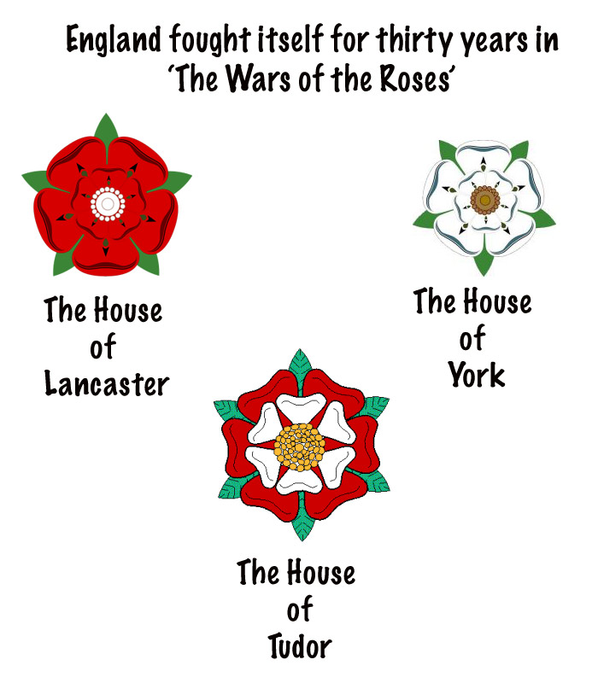
7) Edward V was only twelve when he became king. His uncle Richard of York locked him and his little brother in the Tower of London. 3 months later, the two boys were murdered. Richard became Richard III – he was talented and brave, but many English people could not forgive his treatment of his nephews. Richard’s only rival for the throne was a distant cousin called Henry Tudor who had been banished to France. Henry was related to the Lancastrians, who were now all dead. Two years after Richard was crowned, Henry landed in Wales in 1485 with a small army. People rallied to Henry’s standard (flag) and at the Battle of Bosworth Field, Richard was killed.
Henry Tudor became Henry VII and married Elizabeth of York – this united the House of York and the House of Lancaster. The red and white roses were combined to form the Tudor rose.

