Were the Roses always at war?

1) Henry V was an extremely effective king. He was born in 1387 and ruled in 1413-1422. In his teens, he went out drinking night after night, got into lots of fights and had lots of girlfriends. But when he became king, he became ruthless, ambitious and very serious. He wanted more than a kingdom – he wanted an empire. He crushed his enemies at home and then set sail for France, where he won the great Battle of Agincourt (here, the English use of the longbow meant that the French lost about 8,000 men whereas the English lost only about 100). Henry won lots of battles but died when he was only thirty-five.

2) Henry VI was born in 1421 and became king when he was only nine months old – he couldn’t even put his own crown on! How was he supposed to give orders if all he could do was gurgle? So although most people wanted him on the throne as he was the great Henry V’s heir, the nobles squabbled over which of them should be the next ruler and fought for power whilst Henry was too young to make decisions. Henry VI was very serious and religious, leaving the room when one of the lords brought women with bare bosoms before him. Although Henry was kind, he chose useless advisors, never led his troops into battle and in the 1450s he lost all the lands that his father had won in France. Then he began to have fits of madness that were so bad that he couldn’t run the country.

3) Edward of York decided he would make a better king than his cousin Henry VI. He also thought he had a stronger claim to the throne – he was descended from Edward III’s third son, whereas Henry was only descended from his fourth son (the issue of hereditary mattered in Medieval times!) A war broke out between Henry’s family (‘the Lancastrians’) whose badge was a red rose, and Edward’s family (‘the Yorkists’) who wore a white rose. There were several fierce battles in 1460 – many of them led by Henry’s wife Margaret, who was much tougher and more determined than her weak husband. Eventually Edward got the upper hand and entered London in triumph. Henry and Margaret fled to Yorkshire, where their army was crushed in 1461.

4) And so Edward became Edward IV. He was tall, handsome and vain, drank too much and loved parties where he would neglect his kingly duties for weeks. But he was a brave general and was very good at making money, enforcing good laws and dealing with foreign countries in the 1460s.

5) Then Edward fell in love with a woman called Elizabeth Woodville, a beautiful young widow but not from an important noble family. Edward’s advisors had wanted him to marry a French princess, but Edward married Elizabeth, and so his noble advisors were furious because Edward gave jobs to Elizabeth’s family. So some of the leading English nobles joined forces with Margaret (Henry VI’s wife) and put Henry back on the throne through fierce fighting in 1470, whilst Edward fled back to France.

6) Henry VI was back on the throne but within a year, Edward had returned from France and defeated him, killing Henry’s son. Henry VI was murdered in the Tower of London. With Henry out of the way, Edward knuckled down and tried to make a good job as king – he made lots of money and pleased the people by not asking for too many taxes. England became rich through trade throughout the 1470s. But then Edward died and his son Edward V became king.

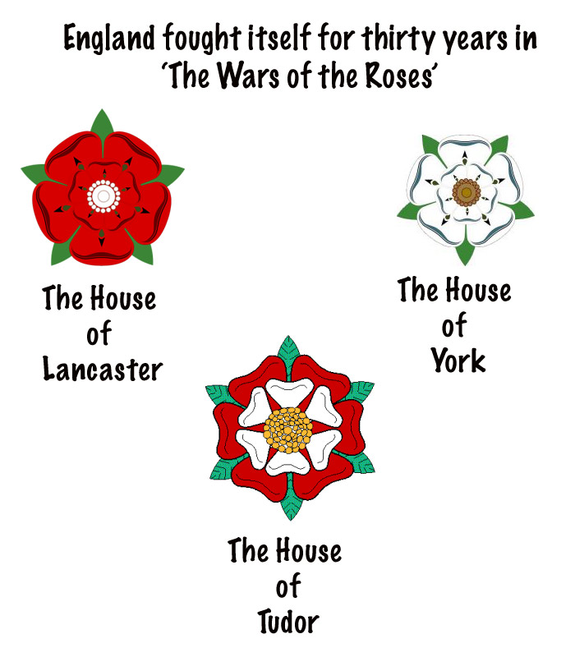
7) Edward V was only twelve when he became king. His uncle Richard of York locked him and his little brother in the Tower of London, and three months later, the two boys were murdered. Richard became Richard III – he was talented and brave in battle, but many English people could not forgive his treatment of his nephews. Richard’s only rival for the throne was a distant cousin called Henry Tudor who had been banished to France. Henry was related to the Lancastrians, who were now all dead. Two years after Richard was crowned, Henry landed in Wales in 1485 with a small army. People rallied to Henry’s standard (flag) and at a battle of Bosworth Field, Richard was killed. Henry Tudor became Henry VII and married Elizabeth of York – this united the House of York and the House of Lancaster. The red and white roses were combined to form the Tudor rose.

