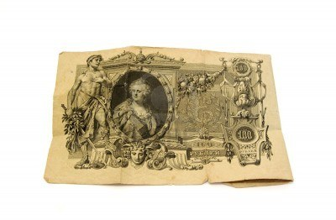
INSTRUCTIONS AND RULES

- In groups of 3 or 4 you will decide how to rule your empire, as Tsar and advisers. The winning group will be the one with the largest Imperial Fortune at the end. Throughout the game, try to identify all the different causes (reasons) as to why the Tsar’s rule collapsed into revolution.
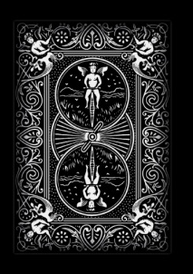
- The point of the game is to rule the Russian Empire well. You must stay alive and stay rich (you need money to sort out all your problems!). You get more money by making the right decisions, and by receiving taxes. You will need money though to pay and equip your army and secret service! The amount you pay will change – e.g. if it is wartime.
- You will hear a news flash at the start of each round, which will help you to make your decisions. Listen carefully as it will not be repeated! When you have decided, select the correct ‘Action Cards’ and place them in front of you. You are only allowed to do what you can afford. Thoughtful action points will lead to bonus points, and poor actions will lead to penalties. You die if you ever have 4 more penalties than bonuses.
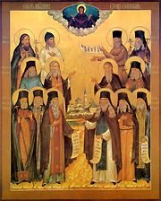
- You can make any action in any round. After Action Cards have been played, you will hear the consequences of your decisions. Actions only count for a single round. 1 coin will be subtracted from any groups talking through the news flashes.
- Tsars can die as the result of assassination or lose their thrones if they go bankrupt. If this happens, the group must select a new Tsar who starts ruling immediately with a personal fortune of 8. Dead tsars can still give advice and help through dreams and prophesies as revealed by the ‘Startsy’ (the Holy men)
BACKGROUND AND ADVICE
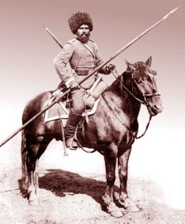
- General Advice- Try to anticipate troubles and take action to avoid them. Your life is in constant danger- be careful. When things go well, prepare for bad times ahead. Try to keep the loyalty and love of your people
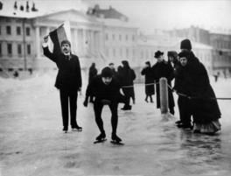
- The Cossacks– You have a fairly large army to protect a large empire. You must protect Russia’s borders, and deal with invasions and in-fighting. The fierce Cossacks are leaders of the army. Peasants can be troublesome when they don’t have enough food and workers’ strikes need to be crushed. Make sure you pay your Cossacks generously to keep them loyal.
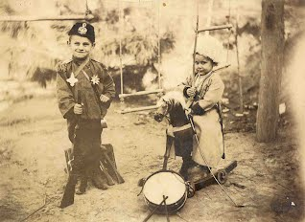
- The people of St. Petersburg– they live at the centre of your Empire, and expect you to rule wisely and fairly. They spend a lot of their free time discussing you – make sure they have enough food and vodka so that good things are said! Many of the upper classes want Russia to keep pace with other European countries, so they are interested in industrialisation.
- The colonies– these are the areas which have been conquered by your army at the end of the nineteenth century. The people living here pay you taxes and expect to be treated and governed fairly. It is important that they are kept happy, but don’t hesitate to crack down on them if problems become serious.
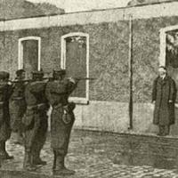
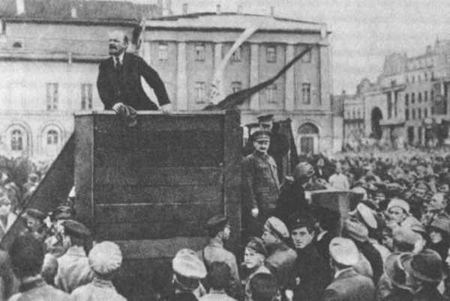
- Revolutionaries abroad– there are people living outside the Empire who have new ideas like ‘democracy’ and ‘freedom of speech’. You have no control over them. Their ideas do a lot of damage when they encourage people in your empire to be critical about your absolute power. When their ideas are found to be influencing people in your empire, don’t be afraid to exile revolutionaries to Eastern Siberia to do forced labour.
- The Okhrana– Your secret police, involving a network of spies who protect and advise you. They crack down on any opposition to your government and deal swiftly with any criticism.

