BRITISH FASHION IN THE EIGHTEENTH CENTURY (1700-1800)
INTRODUCTION: The 18th century saw the end of the Stuart period and the beginning of the Georgian age. During this period, British artists and designers were increasingly influenced by other cultures, including Europe, the ancient civilisations of the classical world, and Asia. It has often been said that the eighteenth century was an age of elegance. Never in European history do we see the upper classes so elaborately artificial, so far removed from natural appearance. This epoch was an extravagant explosion of amazing hairstyles, a reaction opposed to the modesty and shyness of former centuries.
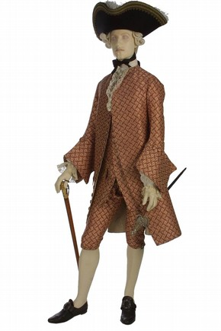
What upper class men wore: A typical outfit (see right) consisted of a full-skirted knee-length coat, a vest or long waistcoat, a linen shirt with frills and linen underdrawers. Lower legs showed and were an important part of the silhouette. Men wore silk stockings and leather shoes with stacked heels. The whole ensemble would have been topped by a shoulder-length full-bottomed wig and a tricorne (three-cornered) hat with an upturned brim.

As the century progressed, the male silhouette slowly changed. By the middle of the century, the wig was usually tied back. By the end of the century it was out of fashion altogether, except for the most formal occasions.

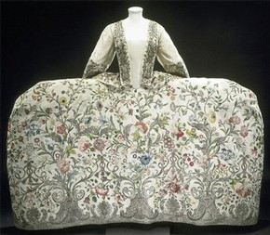
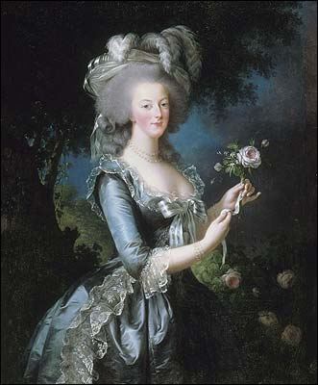
Upper class Women's Dress: in the early 18th century women wore a dress known as a ‘mantua’ (here) for formal occasions. This was an open-fronted silk or fine wool gown with a train and matching petticoat. A hoop petticoat and several under-petticoats were worn beneath the outer petticoat. To give the figure the required shape a corset was worn under the bodice. This was fastened with lacing down the back which could be laced tightly to give an upright posture to the torso and to emphasise the waist.
As with many fashions, it is hard to say exactly why such a cumbersome outfit was popular. One reason might have been that it displayed the richly embroidered cloth of the skirt that indicated the wearer's wealth. From 1770, women started wearing wigs. And, as the years were going on, women wigs were being made taller and more sophisticated, especially in France (see Marie Antionette, left). Men's wigs were generally white, and women's wigs were generally made in pastel colors, like pink, violet or blue. Wealthier people could afford expensive wig designers and better materials. They were made in general with human hair, but also with hair from horses or goats. The countess of Matignon, in France, paid the famous hairdresser Baulard 24.000 livres a year to make her a new headdresses every day of the week.

What of the working classes? The historian Styles tells us that the working classes have always been considered too poor to acquire the means to be fashionable. Yet, as we know well today, style is not simply about affluence. Styles shows us that poor people interested in fashion wore simplified versions of elite styles, closest in form to the clothes worn by their social superiors when in the country or at home as morning wear. Silk and muslin were beyond their reach, but advances in cotton manufacture made fancy prints cheaper. The poor cared about such things and saved for them.

BRITISH FASHION IN THE NINETEENTH CENTURY (1800-1900)

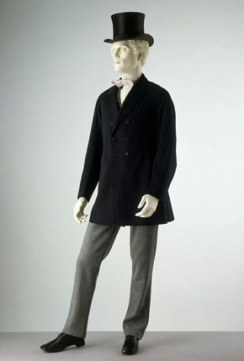
INTRODUCTION: Near the end of the eighteenth century, the grandiose and exuberant style of the European nobility was criticized by the Enlightenment's philosophers. This led to a simpler design of clothes.
What upper class men wore: In the early 19th century, some dandies wore boned corsets to give them a small waist. Gradually, men wore long trousers rather than knee breeches. Trousers became more fashionable. At first they were only worn for day and informal dress, but by the 1820s they were acceptable for evening wear. K
The tall hat from the late 18th century was still worn and developed into the top hat which was worn for day and formal dress throughout the 19th century. Hair was carefully styled into a windswept look or worn short and curled. Hair was still styled but by the late 19th century it was short and cut close to the head. Many men had beards and moustaches.
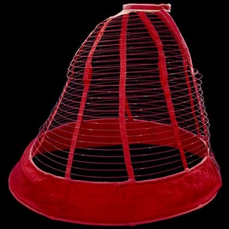
What of the working classes? The huge increase in textile production (especially cotton, but also wool) at this time meant that it was possible for the lower classes to buy and wear more clothes, rather than relying on homemade clothes. They continued to copy the styles of their social superiors, yet used cheaper fabrics and had fewer clothes.

Upper class Women's Dress: As the 19th century progressed, women's dress gradually revealed the actual form of the body. In the 1820s and 1830s the waistline deepened, returning to its natural position. As the natural waist returned the bodice required a tighter fit and in contrast the skirt became fuller and bell-shaped. Corsets continued to be worn. A crinoline ‘cage’ (see right), as well as several layers of petticoats with frilled hems, sometimes of horsehair, were worn to support the full skirts. This all restricted movement, and made the woman very hot. It was rather unhygienic in summer.

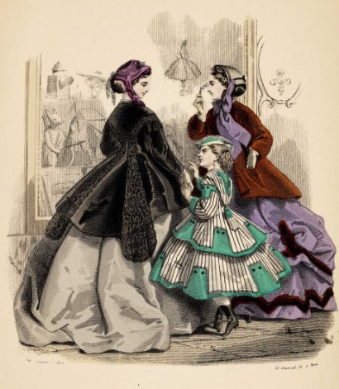
Bonnets or hats were worn outdoors and linen caps indoors. Small hats decorated with birds and feathers and artificial flowers were fashionable. In 1890, a Parisian invented the hair dryer, first becoming available in hair salons, that grew up in the late nineteenth century. The 1870s to 1880s introduced styles that revealed the natural silhouette. A popular style was the `princess line' dress, which was made without a waist seam to reveal the figure.
By the 1880s an elite group of women began to adopt simpler and easier styles that were known as `artistic' dress. Artistic dress was cut much more loosely than conventional attire and did not require restrictive corsetry to be worn. Towards the end of the 19th century, the rate at which the fashionable silhouette changed quickened. The increasing popularity of paper patterns and the growth of women's fashion periodicals encouraged home dress-making during the second half of the 19th century.

BRITISH FASHION IN THE TWENTIETH CENTURY (1900-2000)

INTRODUCTION: By the 20th century, the pace of change in the fashionable silhouette became ever more rapid as the expanding fashion industry, in conjunction with the media, became more effective at stimulating demand for a constant flow of new styles. Cross-cultural and historical influences had a profound impact upon fashion design. The styles and materials of other cultures became more accessible to designers as improved travel and communications enabled continents to be crossed with ease.
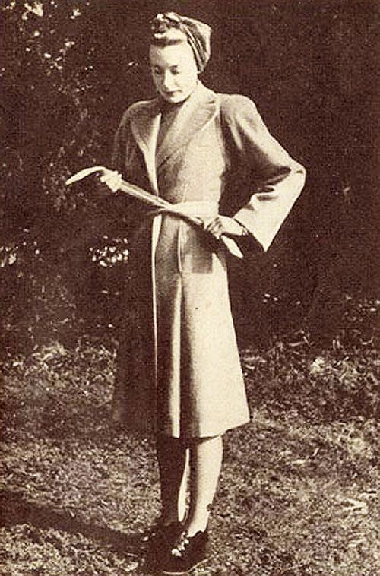
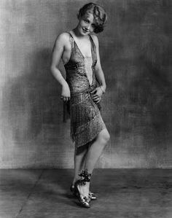
The First World War (1914-1918) had ended in victory for Britain; peace had returned and with it, prosperity. During the war, many women had been employed in the factories, giving them a wage and therefore a certain degree of independence. Women felt more confident and empowered, and this new independence was reflected in the new fashions, which were enjoyed by all classes except for the very poor. Hair was shorter, dresses were shorter (like the one worn by a ‘Flapper’ girl, left), and women started to smoke, drink and drive motorcars.
During the Second World War (1939-1945), clothing was subject to design restrictions that aimed to conserve scarce resources while also retaining some element of style. These clothes, produced within the ‘Utility’ scheme in Britain, do not reveal any marked historical or cross-cultural influences. The 1940s marked a high point for hand knitting. Due to the scarcity of resources and clothes rationing (much was secured for the war effort), and problems with imports due to the Germans blockading British ports, women did things like draw lines up the backs of their legs and stain each leg with tea, so it looked like they had tights on!
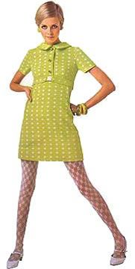
In 1947 Christian Dior launched his New Look collection which, in direct contrast to wartime clothing, revelled in the unashamed luxury and corsetted styles of the late 19th century. The New Look was a resounding success among the war-weary population, for whom it embodied hopes for a better future. More affordable fashion labels copied Dior’s designs, and wearing fashionable clothes was opened up to nearly everyone.
The 1960s was a period of huge change in the fashion world. Whereas fashion had previously been aimed at a wealthy elite, the tastes and preferences of young people now became important. In Britain, musical taste and styles of dress were closely linked. By the mid-sixties, the flared A-line was in style for dresses, skirts and coats. Slim fitting, brightly coloured garments were sold cheaply in boutiques all over 'Swinging London' and had tremendous influence throughout Europe and the USA. Men's suits became sleeker and were often accessorised with bright, bold shirts and high-heeled boots. The flamboyant look was in, signalled by wider trousers and lapels.
From the 1970s onwards, fashion has changed at a breakneck speed, and British fashion is now influenced by countries from all over the world, due to what some have called ‘globalisation’.

