
E.H. Carr: Causation in History (a summary)
If milk is set to boil in a saucepan, it boils over. I do not know, and have never wanted to know, why this happens; if pressed, I should probably attribute it to a propensity in milk to boil over, which is true enough but explains nothing. But then I am not a natural scientist. In the same way, one can read, or even write, about the events of the past without wanting to know why they happened, or be content to say that the Second World War occurred because Hitler wanted war, which is true enough but explains nothing. But one should not then make the mistake of calling oneself a student of history or a historian.
The study of history is a study of causes. The historian continuously asks the question 'Why?'; and so long as he hopes for an answer, he cannot rest. The great historian - or perhaps I should say more broadly, the great thinker - is the man who asks the question 'Why?' about new things or in new contexts.
Herodotus, the father of history, defined his purpose in the opening of his work: to preserve a memory of the deeds of the Greeks and the barbarians, ‘and in particular, beyond everything else, to give the cause of their fighting one another'. He found few followers in the ancient world, but in the eighteenth century Montesquieu stated that it was absurd to suppose that 'blind fate has produced all the effects which we see in the world'. Men were not governed by their fantasies; their behaviour followed certain laws or principles derived from 'the nature of things'. For nearly 200 years after that, historians and philosophers of history were busily engaged in an attempt to organise the past experience of mankind by discovering the causes of historical events and the laws which governed them.
Nowadays, however, we no longer speak of historical 'laws'; and even the word 'cause' has gone out of fashion, partly owing to its supposed association with determinism (where ‘laws’ of history create results that some see as ‘inevitable’). Some people therefore speak not of ‘cause' in history, but of ‘explanation' or 'interpretation'. Let us begin by asking what the historian in practice does when he is confronted by the necessity of assigning causes to events.
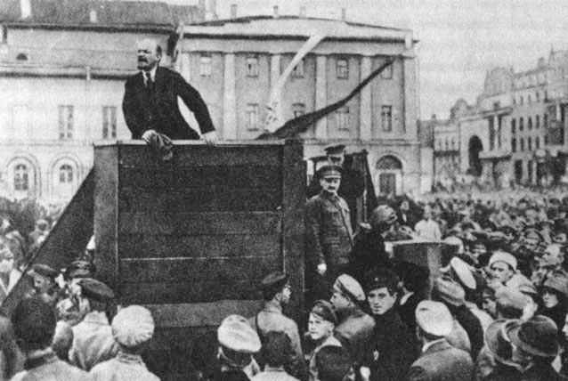
The first characteristic of the historian's approach to the problem of cause is that he will commonly assign several to the same event. Marshall, the economist, once wrote that 'people must be warned off by every possible means from considering the action of any one cause ... without taking account of the others whose effects are mingle with it'. The examination candidate who, in answering the question 'Why did revolution break out in Russia in 1917?', offered only one cause, would be lucky to get a third class. The historian deals in a multiplicity of causes. If he were required to consider the causes of the Bolshevik revolution, he might name Russia's successive military defeats, the collapse of the Russian economy under pressure of war, the effective propaganda of the Bolsheviks, the failure of the Tsarist government and the concentration of a poor and exploited working classes in the factories of Petrograd.*

In short, historical study produces a random jumble of economic, political, ideological, and personal causes, of long-term and short-term causes. Categorising causes is a second aspect of an historian’s approach to explaining why events happen in history.*
But this brings us at once to the third characteristic of the historian's approach. The candidate who, in reply to our question, was content to set out one after the other a dozen causes of the Russian revolution and leave it at that, might get a second class, but scarcely a first; 'well-informed, but unimaginative' would probably be the verdict of the examiners. The true historian, confronted with this list of causes of his own compiling, would feel a professional compulsion to reduce it; to order, to establish some hierarchy of causes which would fix their relation to one another, perhaps to decide which cause, or which category of causes, should be regarded 'in the last resort' or 'in the final analysis' (favourite phrases of historians) as the ultimate cause, the cause of all causes.* This is his interpretation of his theme; the historian is known by the causes which he invokes. Gibbon attributed the decline and fall of the Roman empire to the triumph of barbarianism and religion. Gibbon ignored the economic causes which modern historians have moved into the forefront. Every historical argument revolves round the question of the priority of causes.*
The historian, by expanding and deepening his research, constantly accumulates more and more answers to the question, 'Why?' The expansion in recent years of economic, social, cultural, and legal history have enormously increased the number and range of our answers. Yet the historian, in virtue of his urge to understand the past, is compelled, like the scientist, to simplify the multiplicity of his answers, to subordinate one answer to another, and to introduce some order and unity into the chaos of happenings and the chaos of specific causes.
At this point I must reluctantly turn aside to deal with two red herrings which have been drawn across our path - one labelled 'Determinism in History, the other 'Chance in History; or Cleopatra's Nose'.
First then let me take determinism, which I will define - I hope, without controversy - as the belief that everything that happened has a cause or causes, and could not have happened differently unless something in the cause or causes had also been different. Determinism is a problem not of history, but of all human behaviour. The human personality is based on the assumption that events have causes, and that enough of these causes are ascertainable to build up in the human mind a pattern of past and present that can serve as a guide to action. Everyday life would be impossible unless one assumed that human behaviour was determined by causes.

As you go about your daily affairs, you are in the habit of meeting Smith. You greet him with a cheerful, but pointless, remark about the weather, or about school; he replies with an equally cheerful and pointless remark about the weather or school. But supposing that one morning Smith, instead of answering your remark in his usual way, were to break into a violent criticism of your personal appearance or character. Would you shrug your shoulders, and treat this as a convincing demonstration of the freedom of Smith's will and of the fact that everything is possible in human affairs? I suspect that you would not.

On the contrary, you would probably say something like: ‘Poor Smith! You know, of course, his father died in a mental hospital,' or 'Poor Smith! He must have been having more trouble with his girlfriend.' In other words, you would attempt to diagnose the cause of Smith's apparently causeless behaviour, in the conviction that some cause there must be. Now let us look at the historian. Like the ordinary man, he believes that human actions have causes which are in principle identifiable. Historians, like other people, sometimes speak of an occurrence as 'inevitable' when they mean merely that the series of factors leading one to expect it was overwhelmingly strong.
BIG QUESTION ONE: CAN CAUSES BE INEVITABLE? Was it inevitable that the Russian Empire would collapse? E.H. Carr thinks that nothing in history is inevitable…What do you think?
As a historian, I am perfectly prepared to do without 'inevitable', 'unavoidable' and 'inescapable'. Life will be drabber. But let us leave them to poets.
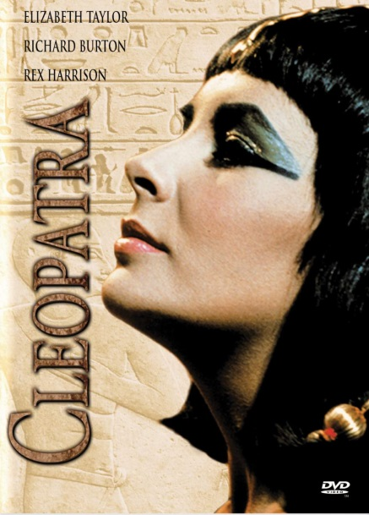
Last term I saw a talk to some society advertised under the title 'Was the Russian Revolution Inevitable?' I am sure it was intended as a perfectly serious talk. Suppose, it is said, that Russia had not gone to war, perhaps the revolution would not have occurred. These suppositions are theoretically conceivable; and one can always play a parlour game with the might-have-beens of history. Yet this game is a purely emotional and unhistorical concept. Let us get rid of this red herring once and for all.*
The other red herring is the famous crux of Cleopatra's nose. This is the theory that history is, by and large, a chapter of accidents, a series of events determined by chance coincidences, and attributable only to the most casual causes. The result of the Battle of Actium (where the Emperor Octavian beat Mark Antony, overthrowing the Roman Republic and creating the Roman Empire) was due not to the sort of causes commonly given by historians, but to Antony's infatuation with Cleopatra, who would go to any lengths to please her, including risking a battle without much hope of success.
Antony's infatuation with Cleopatra was just as much causally determined as anything else that happens. This view of accidents causing history, like the view that examination results are all a lottery, will always be popular among those who have been placed in the third class. It is unnecessarily discourteous to Cleopatra's beauty to suggest that Antony's infatuation had no cause. The connection between female beauty and male infatuation is one of the most regular sequences of cause and effect observable in everyday life. These so-called accidents in history represent a sequence of cause and effect interrupting the sequence which the historian is primarily concerned to investigate. Bury, quite rightly, speaks of a 'collision of two independent causal chains'.*
The role of accident in history is nowadays seriously exaggerated by those who are interested to stress its importance. Equally inadequate is the view that accident in history is merely the measure of our ignorance - simply a name for something which we fail to understand. This no doubt sometimes happens. The planets got their name, which means 'wanderers', when they were supposed to wander at random through the sky, and the regularity of their movements was not understood. When somebody tells me that history is a chapter of accidents, I tend to suspect him of intellectual laziness.
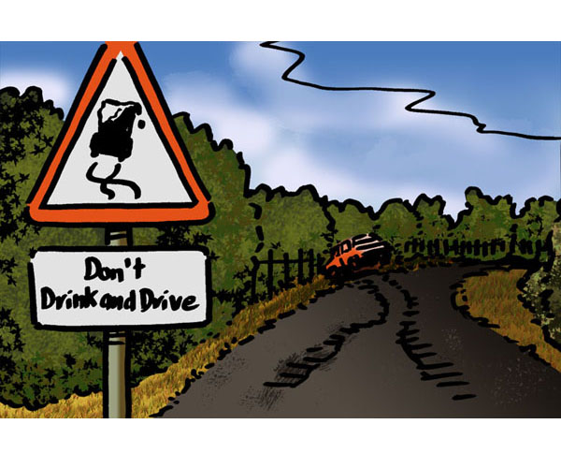
Jones, returning from a party at which he has consumed more than his usual ration of alcohol, in a car whose brakes turn out to have been defective, at a blind corner where visibility is notoriously poor, knocks down and kills Robinson, who was crossing the road to buy cigarettes at the shop on the corner. After the mess has been cleared up, we meet - say at local police headquarters - to inquire into the causes of the occurrence. Was it due to the driver's semi-intoxicated condition - in which case there might be criminal prosecution? Or was it due to the defective brakes - in which case something might be said to the garage which overhauled the car only the week before? Or was it due to the blind corner - in which case the road authorities might be invited to give the matter their attention?
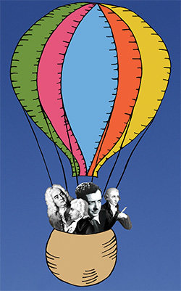
While we are discussing these practical questions, two distinguished gentlemen - I shall not attempt to identify them - burst into the room and begin to tell us, with great fluency, that, if Robinson had not happened to run out of cigarettes that evening, he would not have been crossing the road and would not have been killed; that Robinson's desire for cigarettes was therefore the cause of his death; and that any inquiry which neglects this cause will be a waste of time, and any conclusions drawn from it meaningless and futile. Well, what do we do? As soon as we can break into the conversation, we edge our two visitors gently but firmly towards the door, we instruct the janitor on no account to admit them again, and we get on with our inquiry. But what answer have we to the interrupters? Of course, Robinson was killed because he was a cigarette-smoker. It is perfectly true and perfectly logical. It has the kind of remorseless logic which we find in Alice in Wonderland and Through the Looking Glass. But it has no place in history.
BIG QUESTION TWO: CAN CAUSES BE ACCIDENTAL? E.H. Carr thinks that nothing in history is an accident, and all can be explained…What do you think?
Is it possible to argue that the Russian revolution was caused by the accident of the Tsar’s son, Alexis, having haemophilia, leading the royal family to associate themselves with a controversial, unpopular man (Rasputin), who they thought could cure Alexis? Did haemophilia cause the Russian Revolution?!
In conclusion, History is a process of selection in terms of historical significance. Sequences of cause and effect have to be rejected as accidental, not because the relation between cause and effect is different, but because the sequence itself is irrelevant. The historian can do nothing with it; it is not amenable to rational interpretation, and has no meaning either for the past or the present.

