Rethinking History? A History of History
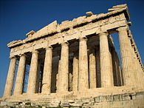
What is Historiography? Put simply, it is the study of how history is ‘created’ – from the selection and interpretation of sources through historical research, to the writing up of the historian’s findings into grand ‘narratives’ or essays. It looks at the techniques used by the historian to create his or her history. Debates have raged for centuries over what those techniques should be.
And so history has a history.
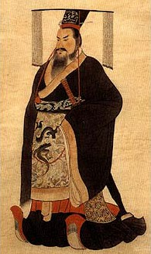
In Ancient Greece, the earliest historians whose individual works have survived, such as those of Herodotus (c.484-424 BC), focused on military exploits. They wished to recount the military campaigns of their society. They were historians rather than storytellers because they were concerned for the authenticity of their accounts. Herodotus compared different sources about the same battles, using his cross-referencing to try to establish exactly what happened, and strove to place the wars they discussed in their historical context. He asked the basic historical question: why did events happen when they did? Herodotus and his contemporaries traced the answers to a variety of causal factors, and their analysis of both the causes and consequences of wars made them forerunners of the modern historical discipline.
In China, too, similar questions were asked about History. China's ruling houses had a tradition of recording important events under each emperor. Sima Qian lived in c.145-c.87 BC, and his Shiji (Historical Records) was to be a comprehensive history of China, but it also sought to draw out moral lessons for its readers. It is the template for most histories that followed in China and the surrounding areas. Clearly, historical writing was developing simultaneously in East and West, and much of it focussed upon politics and kings.
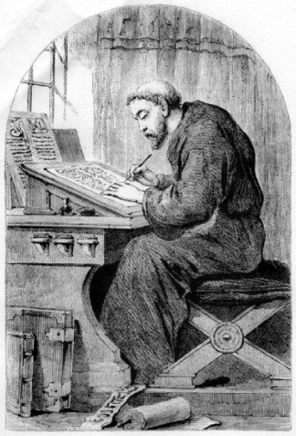
During the Middle Ages, historians faithfully recorded events and, as monks, often focused on the concerns of the church. The Ecclesiastical History of the English People, written by Bede (c.673-735 AD) is a good example of this. History was often formed of biographies, that were usually hagiographic (which refers to a ‘Great Man’ approach to History that focusses on the ‘great’ lives of saints and Church leaders). Elsewhere, historians of Byzantium such as and Anna Komnene offered dynastic histories (c.1154) that did not simply focus on theological explanations, while the Islamic historian Ibn Khaldûn (1332-1406) explored the possibilities of universal history.
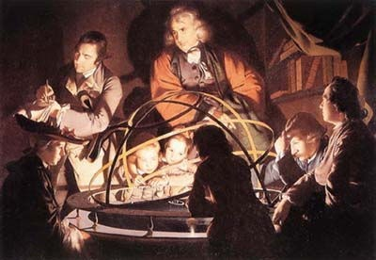
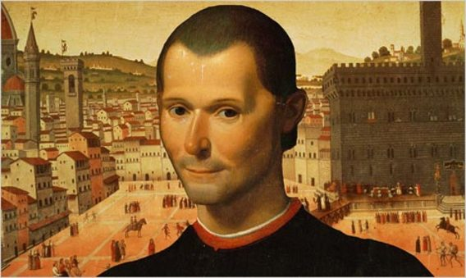
It was the Renaissance that fostered a new way of looking at the past. Although still concerned mostly with politics and kings, the analysis shifted more and more to the question of historical causation. This new view sought to understand the complexities of man as an historical actor – what impact could a man have on how events in history unfold? There was also a small but growing public interest in works of history. Renaissance humanist writers such as Machiavelli (1469-1527) wished to make a break with the descriptive chronicles that had come to be accepted as historical writing during the medieval period. Instead, they harked back to ancient writers such as Livy (59 BCE-c.17 CE). History was seen as something that should be written in service to the state, often commissioned by a noble patron. The attempt by historians to interpret the past did not always make them popular, and Guicciardini was under constant surveillance by the civil authorities as he wrote his history of Italy.
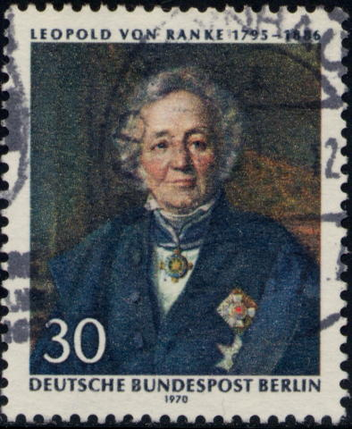
The 18th-century Enlightenment equipped history with the values of scepticism, rigour and empiricism (a theory of knowledge that emphasises the need for evidence that can be proven through systematic observation). This was true of David Hume's History of England (1754-62) and of what must be the most influential of histories written before the 19th century: Edward Gibbon's The History of the Decline and Fall of the Roman Empire (1776-88). Gibbon’s multi-volume masterpiece contained not only a strong narrative backbone, but also an analytical framework. Because of its emphasis on objectivity (trying to avoid bias) and heavy use of primary sources rather than relying on hearsay or other historians’ accounts, at the time its methodology became a model for later historians. The complex historical questions posed by Gibbon set the stage for a revolution in historical research during the 19th century.
A nineteenth-century German writer took the idea of objectivity further. If history had been primarily a form of literature up to this time (‘telling stories’), the modern discipline of history was characterized by an emphasis on precision. The research of Leopold von Ranke (1795-1886) ushered in a new period when scientific methods became increasingly popular amongst historians. Ranke's innovation was in his use of sources. He travelled from archive to archive, then still controlled by the ruling houses, families, and religious bodies that had created them. He searched for tangible proof of what had happened in the past, trying to establish undisputed or at least rigorously tested facts. He and his fellow positivists dominated 19th-century historical writing, and scholars became used to sifting through European archives and employing a scientific approach in order to come to a final account of history – to show how ‘it really was’ in order to find a ‘final version’ of events. Most historical accounts at this time were still concerned with high political history. In the 19th century, as the idea of nationalism spread, historians increasingly found a role in making sense of what a nation was, and providing it with a past and an identity.
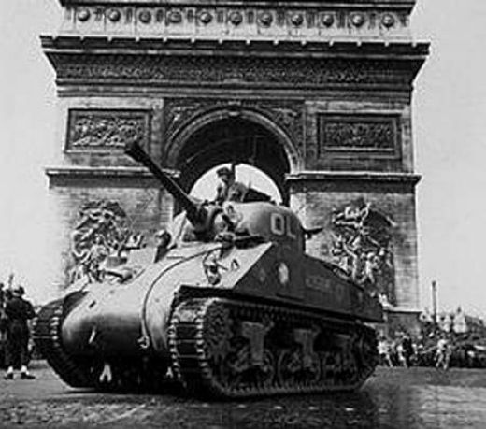
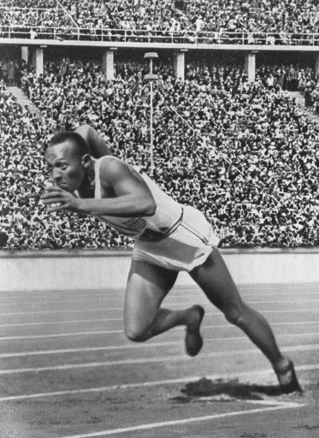
By the beginning of the 20th century, historians began to look beyond the ideologies of state-building to ask if they had considered all the reasons for historical change. Historians raised questions about sectors of society that had been overlooked. W.E.B. Du Bois (1868-1963) offered an early study of African Americans and their place in US history. Du Bois discovered widespread racism in the American Army, and concluded that the Army command discouraged African Americans from joining the Army, discredited the accomplishments of black soldiers, and promoted prejudice. In the first few decades of the 20th century historical interpretations were repeatedly challenged, but the older tradition of empirical (‘scientific’) history steadfastly held its ground.
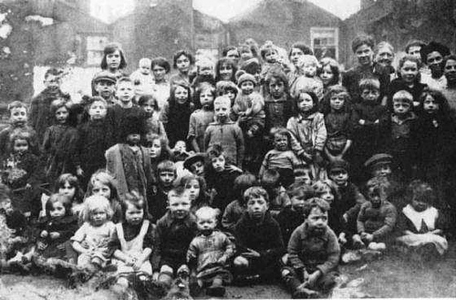
Since World War II that situation has changed. The emphasis on high politics has retreated as new questions and methods have emerged, and as different cultures came into contact more frequently. In the turmoil of the 1920s and 1930s, scores of intellectuals moved around the globe, carrying with them different notions of historical study, and also a rich body of knowledge about their home cultures. History had mostly been about elites, great men and the way in which they shaped their societies. Post-World War II saw the emergence of the most influential branch of history in the 20th century: social history.
Social history generated an approach known as “history from below” (also known as “bottom-up” history or the “history of everyday life”). The struggles of the common man moved centre stage, from the study of Brazilian slavery to the English middle-classes. G.M. Trevelyan, for example, wrote a multi-volume ‘English Social History’, which he said was ‘history with the people put back in’. Social history seeks to understand how groups find a voice and how structures shape people's lives. From a focus on class, it has more recently embraced questions of race and gender to broaden readers' understanding of a range of cultures.
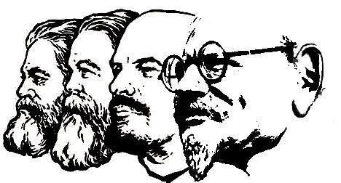
Underpinning the new social history was the growing influence of Marxist theory. It was not necessary to be a Marxist in order to be a social historian but Marxism was frequently responsible for setting the terms of the debates. The ideas of Karl Marx (1818-1883) about modern capitalist society were anchored in historical study. Undoubtedly the most influential of the new historians working in the Marxist tradition was E.P. Thompson (1924-1993), whose The Making of the English Working Class (1963) inspired researchers around the world. Thompson suggested that workers (rather than just world leaders) helped historical change to happen, and readers extracted from it a dignity for men and women often portrayed earlier as faceless and powerless.
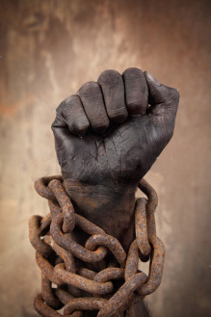
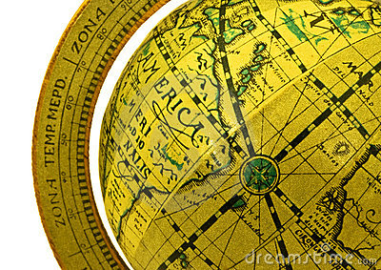
Meanwhile, across the channel, the Annales School emerged in the first half of the twentieth century in France and was centered on the academic journal Annales. Social and economic history were knitted together in the writings of Braudel in his history of the Mediterranean (1902-1985). His work focused on la longue durée, that is, change over a long period of time, but it also reached beyond conventional boundaries to examine the inter-relatedness of regions. He argued that historians must move beyond national borders in order to understand the past – looking at geography as an agent of historical change.
New Sources. What is clear is that although historians have increasingly employed theories from a broad range of disciplines they have also clung to the use of evidence in their exploration of the past. But the areas that counted as evidence also expanded in the twentieth century. Before, high politics had demanded a consideration of the correspondence between ministers and ministries, yet now, historians were eager to explore arrest reports, postmortems, censuses and parish records. African American history was transformed by the use of folk-tales, oral history and songs as well as plantation records.
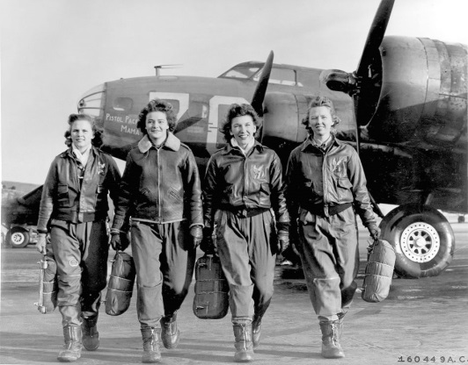
Minority History. This broadening of the definition of evidence was part of the expansion of study of marginal groups that was a characteristic of the 1960s and 1970s. In America, the civil rights movement sparked a new interest in non-elite groups. Black history began to emerge, first focusing on the world of the African American slave. Similarly, women's history emerged at the same time. For historians used to exploring archives for evidence, both groups presented challenges, yet women's history in particular has established that historical sources about the female sex can be found in a range of materials, that reveal male attitudes towards women, if they cannot tell us about the women themselves. Joan Wallach Scott helped to expose the exploitation and mistreatment of women by men through looking at sources and evidence with a fresh perspective.
A debate then began to arise about how sources should be interpreted. From Ranke onwards many historians thought that reading a source was a matter of some skill, but that the sources themselves were relatively uncomplicated. Twentieth-century historians have questioned this in two ways. First, there has been the emphasis on the historian and on how his or her concerns can affect the way evidence is read. Carl Becker argued that historians were not neutral readers of texts. Instead they brought with them their own concerns and they interpreted the past through the lens of the present. For Becker, most historians came to their subjects because of some present-day concern. History therefore was not necessarily an objective pursuit and was caught up in the great 20th-century belief: relativism.
Relativism places an emphasis on the problem of the historian as interpreter, who has his own agenda, assumptions and purposes. Relativism provided an explanation for why different generations of historians could examine the same events and documents and develop different interpretations. History depended on the historian's point of view. This position was most influentially expressed by E.H. Carr in What Is History? (1961). Postmodernists took the debate further, arguing that we can never really recover the facts about an event, leading some historians to deny that the past can ever be really known!
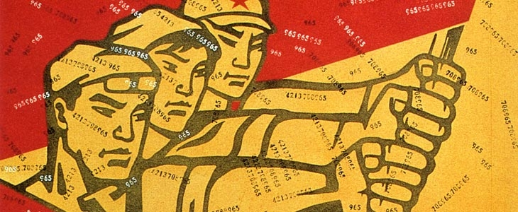
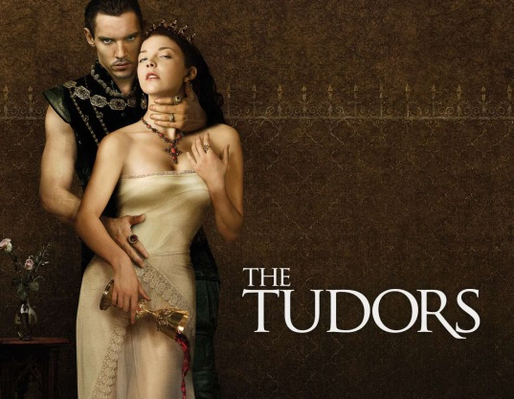
Conclusion. Historiography is the blanket term for thinking about methods of historical research. The movements and methods above have their supporters and critics, and debates continue to rage within the historical profession. As the new millennium begins where does the writing of history stand? One of the great merits of history is that it remains accessible to the general reader. Popular history continues in books (particularly biographies) but it also has found a niche on television. History is clearly far from dead.

